

kmit.in/emagazine

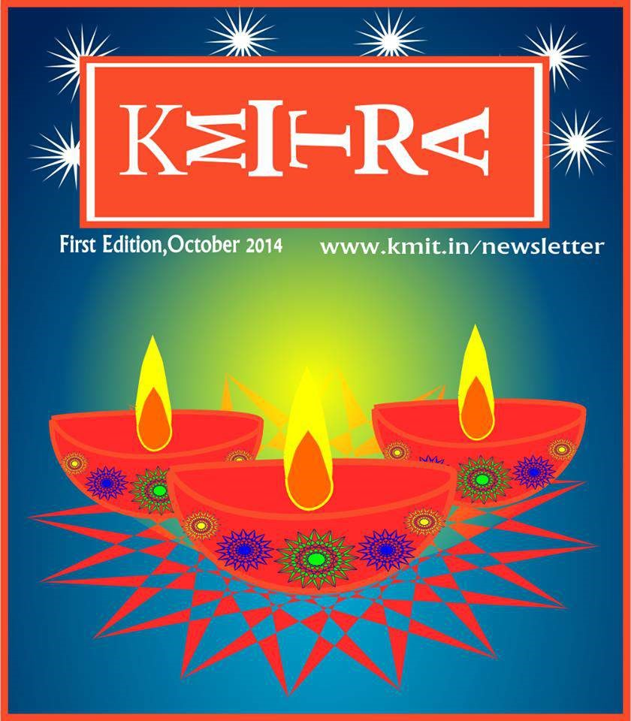

# Class Apart

**— Aditi Ghotikar**



Welcome to kMITRA, a monthly online magazine about all things KMIT and beyond. Far from being a regular college among many, KMIT has carved a niche for itself. As its students, we wanted to contribute to it while creating a certain something that we’d always be glad we were a part of.

That certain something is our all new e-magazine – kMITRA. The name is a nod to the college life that redefines friendship. We want kMITRA to be the beginning of something special. kMITRA caters to the interests of the sartorialists, the movie buffs, the tech gurus, the foodies and everybody else! We aim to make this a forum where transcendental thoughts are discussed and deliberated.

We hope that the effort we’ve put in, shows. We believe that when you’ve got something to tell, tell it uncanny. Tell it silly. Tell it remarkable. Tell it, a class apart.

Aditi Ghotikar, Editor.

**15 things every KMITian can relate to!**

**— Nithya Gubbala**



Keshav Memorial Institute of technology what we fondly call KMIT, in all its glory is loved by all of us. No matter how unsure you are of it in the beginning, it will show you reasons why you were wrong. Here are a few things about our KMIT that I feel all of us can relate to.

## 1. Desi Names

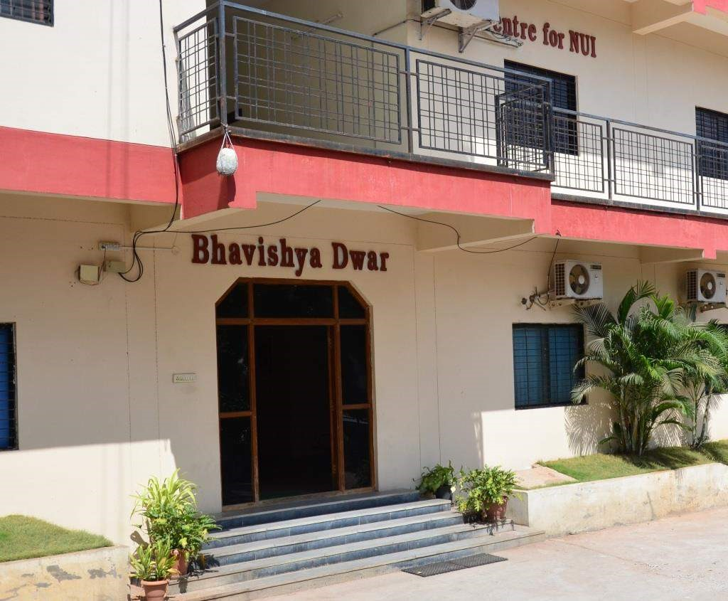

Be it Bhavishya Dwar, Granthalaya, Trishul or Aavishkara, KMIT does it in style yet has the Sanskrit touch to it.

**Fest?**

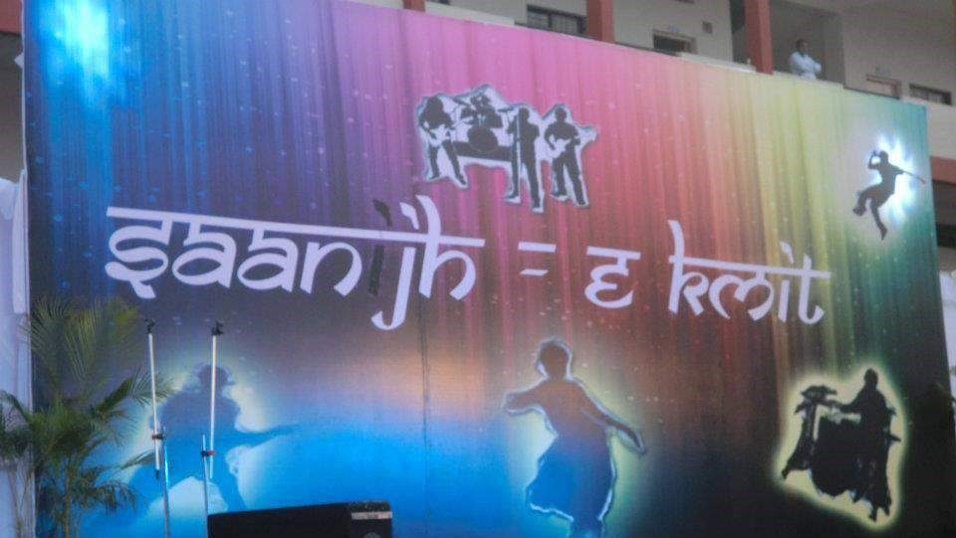

Sorry folks we don’t do these so called “FESTS”. We at KMIT have the knack of having fun unlike any other college in town. PATANG UTSAV, our kite fest and Saanj-e-KMIT, our annual day and of course, Dandiya Night are the much awaited events on campus.

***Neil Gogte*, the man himself!**

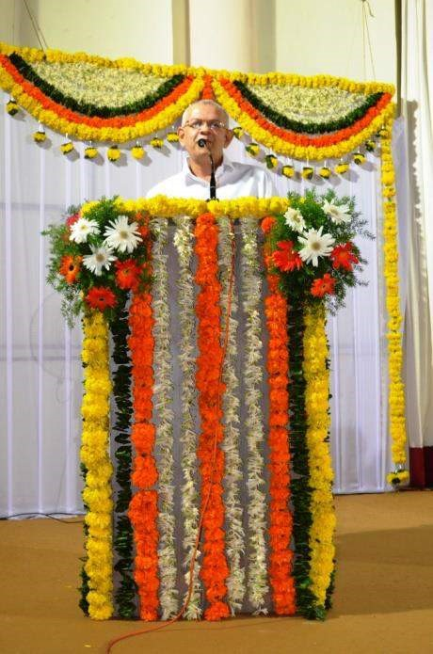

Unmistakably the soul of KMIT is Neil Sir. Remember the first time you listened to his lecture? His wit, his eloquent speech, his technical expertise makes you wonder if you have seen such a brilliant teacher, ever! If you have attended his classes regularly, you will agree with me, that polymath is an understatement for Neil Sir.

## The Facebook Pages

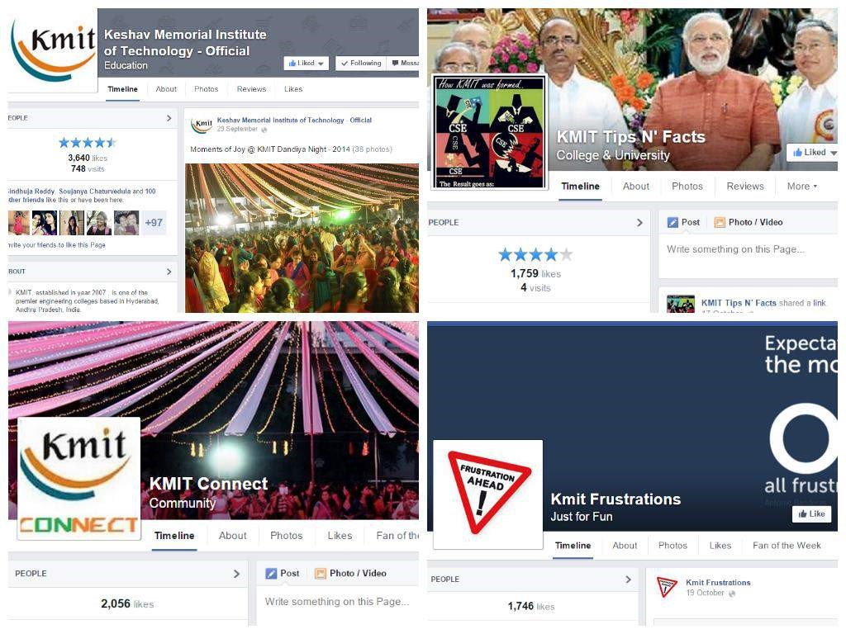

KMIT Tips N’ Facts, KMIT Connect, KMIT Frustations, KMIT Confessions and of course the official Keshav Memorial Institute of Technology page – thanks to the admins, we have these amazing FB pages that we can look up to for any latest information. Also for some campus humor.

## The overloaded Canteen, in lunch time

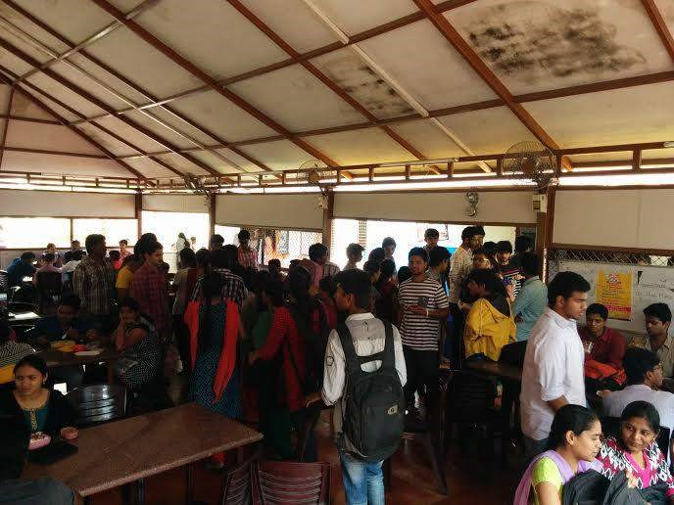

You do the math and it’s 2400 students on campus to be precise. If you have seen the canteen during the lunch hours, you know what I mean. For those of you in 4th and 3rd years, remember our old canteen, mates? You will agree that the new version of our canteen is a God sent saviour.

## FS (Freaking Special)

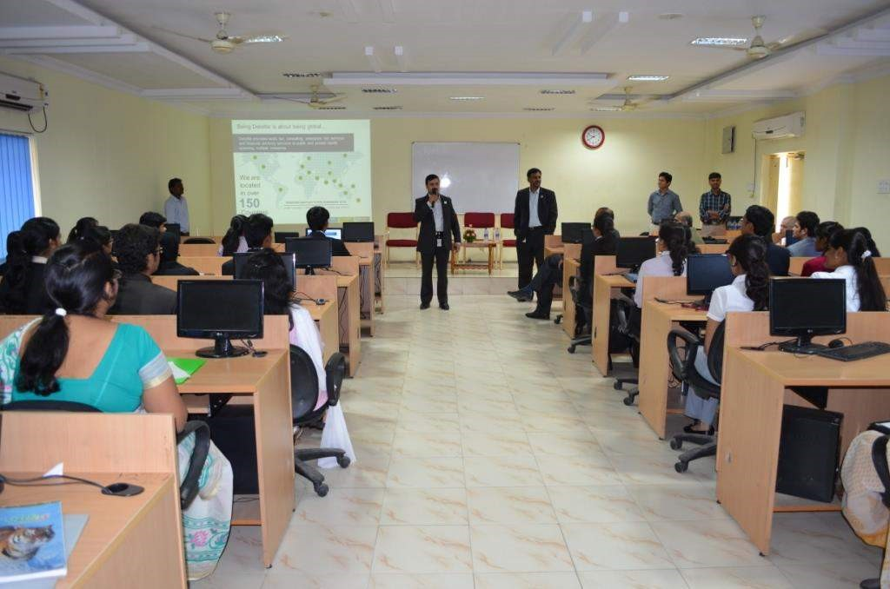

“FS is the key word for your placement” is the Universal Truth at KMIT, but you know the brightest side of it? You get to sit in AC even during power cuts! That’s not all, charging your phone and surfing the internet are other perks of being an FS Student.

## Engineering Workshop (Mechanical Lab)

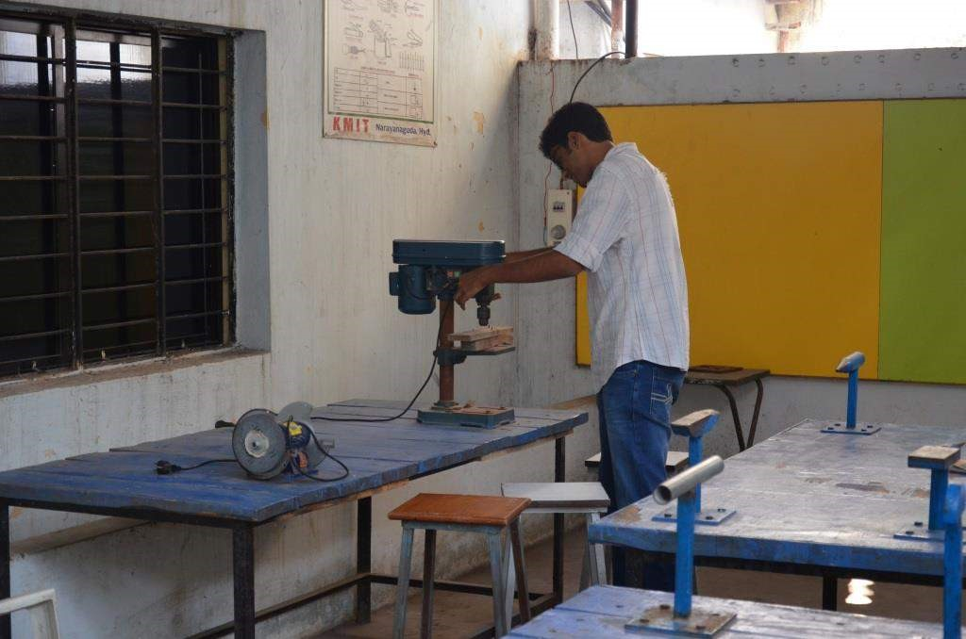

Remember that lab in first year, where once in a fortnight you had so much fun? I can barely recollect the names of the “experiments” but it was so much fun with wood and metal. For those of you in first year, be ready to hurt yourself with the tools.(Only joking!)

## Speed Breakers

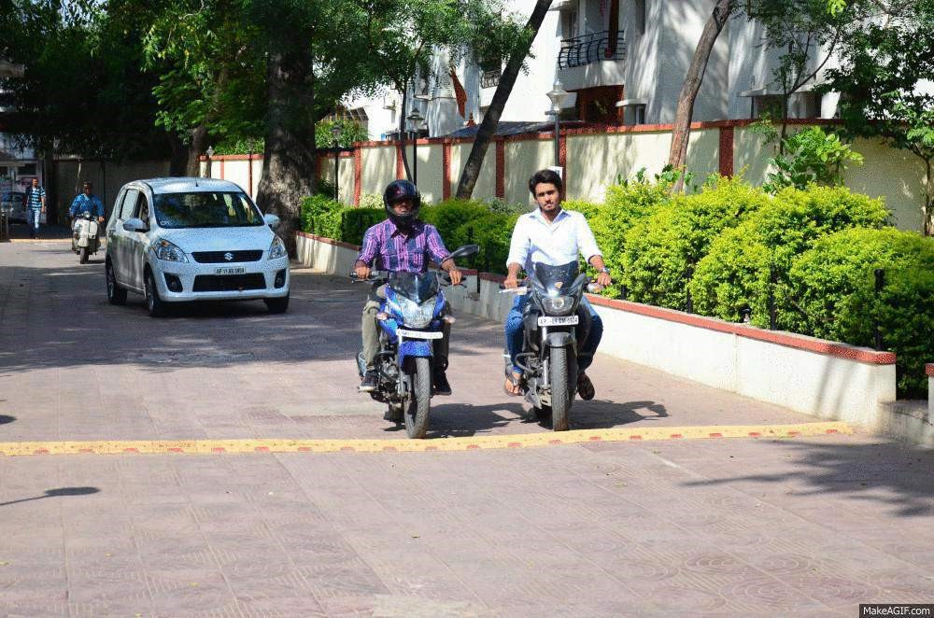

We get a bumpy ride from the gate to the parking, *every single time*. But the truth is our management is extra cautious when it comes to our safety.

## SMSes college sends us

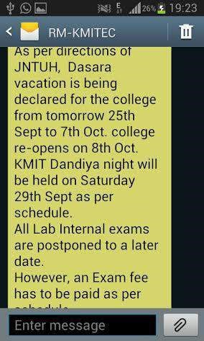

By mistake you go on a holiday for a week and your parent’s inbox is filled with those texts from college. They don’t leave you a single opportunity to bunk, if at all you want to without letting your parents know. What can I say about the messages in which they send you, your attendance!

If you’re a 4th year, like me you can end up thinking that there’s no FS class today, simply because it’s 1pm and you haven’t received the SMS from college that says “ FS class will be held today at 2pm in Auditorium”. On a serious note, the management does a fab job by sending these texts when you are clueless about the day’s schedule.

## The YUM food in and around KMIT



Be it Dadu’s Pav Bhaji, the most famous “Manchuria” in the canteen or the canteen wala bhaiya’s Paani Puri your tummy is always happy when you are a KMITian!

## 11.The Friendly Faculty

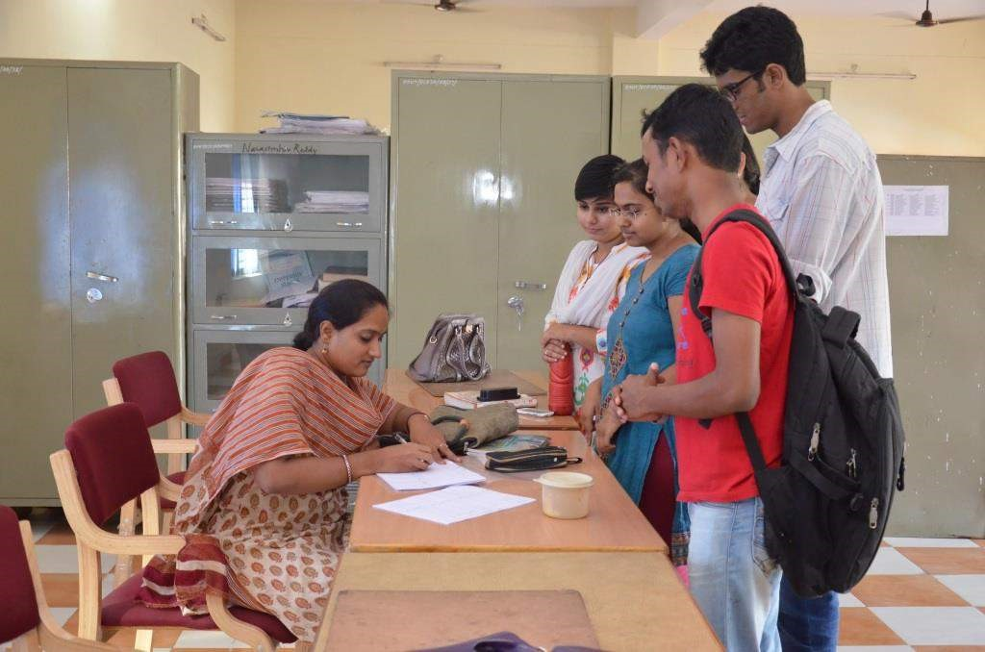

You can hate them for the assignments and internals, but all the Departments have very friendly and understanding lecturers. Don’t agree with me? At the end of the sem you will.

## The ordering of Finishing School Labs



We all know that there are 7 FS labs, but can you locate each and every one of it in a blink of the eye? Well let’s see, I cannot!

The first time you are supposed to attend a lab, you ask everyone where exactly the lab is, don’t you?

## Gate Pass

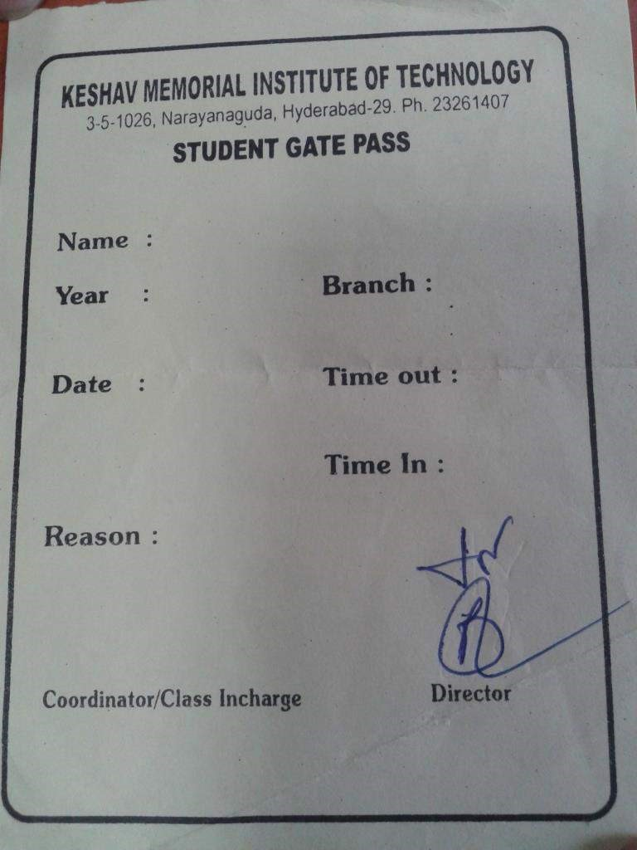

Don’t we nail it completely by giving vague reasons to bunk college and which actually satisfies the receptionist to give the most precious, Gate Pass!

## LAB INTERNALS



You know it’s that time of the year when the record papers become your most treasured possession, when you make sure you own a pen or two, LAB EXAMS! That one week before the lab internals no one’s having a gala time around the campus, everyone’s busy writing records or preparing for VIVA.

## The First Year Block

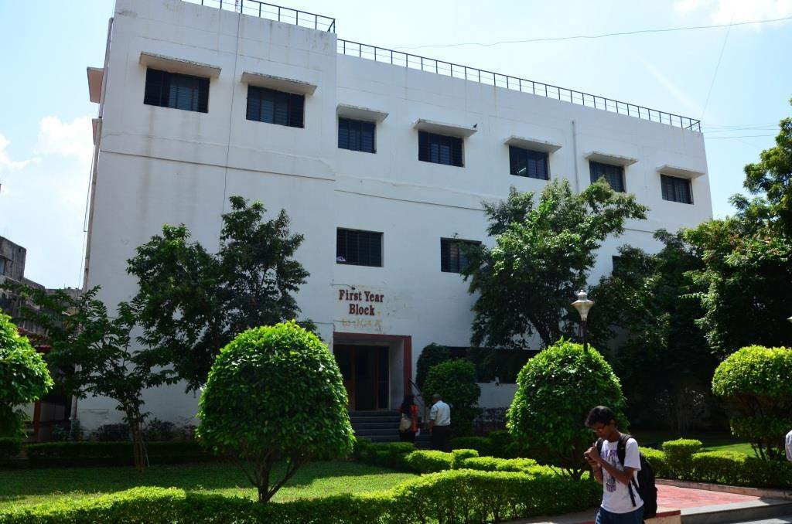

The place where you made friends forever, where you learnt some important life lessons, where you did so many things for the first time in Engineering. It gives you just too many memories when you look back.

First years, makes moments cherishable.

**Honorary Mention to the Sardar Patel Statue!**

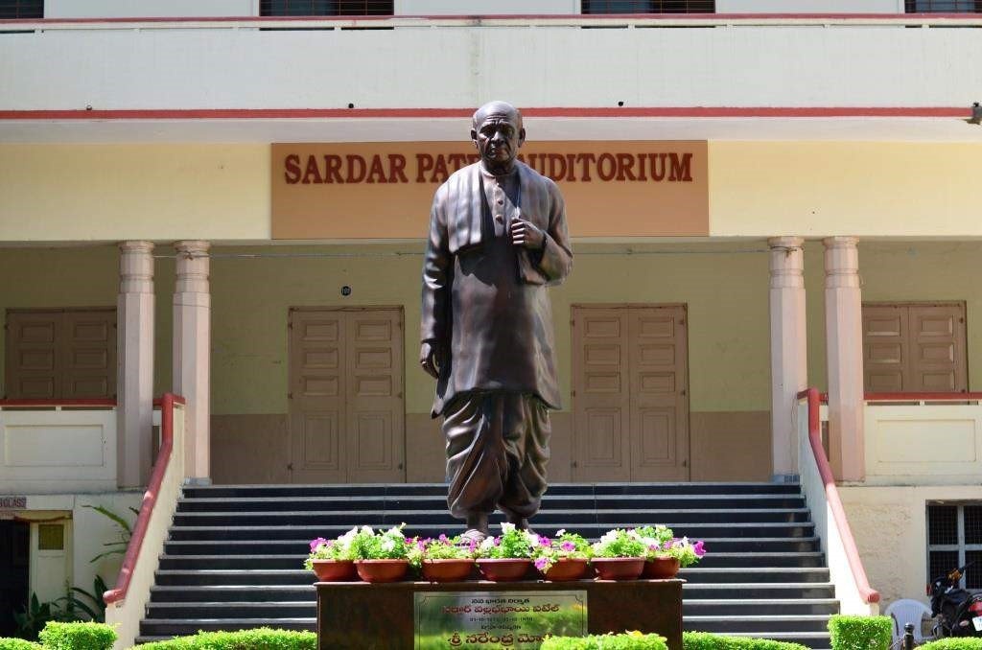

One of the most influential leaders of India, Sardar Vallabhbhai Patel delivered a speech in our very own Auditorium which was later named Sardar Patel Auditorium, don’t you take pride to stand in that very place where the eminent personality once stood?

Picture credits to [Sachin Varma Polakonda](https://www.facebook.com/svfotoflicks?ref=ts&fref=ts)

## Neil Gogte’s Message

— Professor



It is very heartening to note that we are creating a magazine for the KMIT students.

I hope that this initiative will continue forever.

At the outset , I would like to wish all the students a Happy Deepavali. In a few months we will wish farewell to the 2014-2015 batch and welcome a new batch in our midst. It is perhaps a good time to think about the 4 years we spend in an engineering college. What does one want at the end of four years? Is it a good percentage, a good job or simply a good time? I am sure all of you will agree when I say that we want all the three. But is that all we want from the 4 years at KMIT? I would say the most important accomplishment I would seek from these four years is the building up of character , a confident person should emerge from within you, ready to take up the challenges of the new digital economy ; a person who is committed to honesty and integrity and powered by passion and zeal.

India is a nation which is having a rebirth. There is new government, a new ideology and of course a new set of challenges.

You as students must see in this new rebirth a new opportunity and strive to become substantial contributors to this new awakening. We need many of you to become entrepreneurs and lead this country toward its destiny. A destiny in which India will be a nation where unemployment, hunger, violence will be removed from the center stage of social discourse and we can become a truly developed economy.

Neil Gogte,

Director, KMIT.

### Jane Eyre by Charlotte Bronte

**— Praharshita Krishna**



The Bronte sisters were the first of all female writers paving their own path… Virginia Woolf has aptly captured in her essay ” A room of one’s own” that the mindset of men and

women are completely different and that we must adapt our own opinions and our way of thinking than trying to sound androgynous.

The Bronte sisters had made a splash with “Wuthering Heights” and “Jane Eyre”, when they so efficiently and completely captured the women’s perspective on life.

Jane Eyre is one classic that is definitely worth reading.

It may be a emotionally wringing read, it is one of those books that will stay with you.

The character is a self-confident and self-respecting woman in England in the 18th century, an orphan who faced much emotional and physical abuse at the hands of her aunt and her cousin.

Her job as a governess at Thornfield Hall comes as a boon for she wasn’t able to make ends meet.

There she comes across Edward Rochester, her employer, who is mysterious and the embodiment of perfection, but she will not under any circumstances accept her blossoming feelings for him and shuts down any advances he makes.

However, there is a dark secret that lurks the halls of Thornfield…

A mentally challenged wife who is unaware of the outside world locked up in a tower moving about in the darkness attacking people. As the story evolves, we understand that there is an additional depth to the characters for when she becomes aware about his marital situation she leaves without a word to take on the world.

A character which seemed weak and timid (for a lack of better words) turns out to be strong and principled. Case in point –

It is vain to say human beings ought to be satisfied with tranquility: they must have action; and they will make it if they cannot find it.”

While this might seem common place, it is hard to put into perspective that women didn’t move freely in society and the jobs that they could get were generally related to child care.

To add to this, they were denied access to libraries, and information that would uplift them from their pathetic situation. Charlotte Bronte captures every emotion and makes the reader feel this anguish, makes us relate to the characters and though it may seem morbid at times it does have a relatively happy ending.

These books were the start of a paradigm shift in how women were viewed in

literature, and is definitely a must read for budding feminists…

## OS X Yosemite : The Cycle is Complete

**— Gaurav Patil**





Back in June 2014, Apple announced OS X Yosemite, a powerful new version of OS X redesigned and refined with a fresh, modern look, powerful new apps and amazing new continuity features that make working across your Mac and iOS devices more fluid than ever.

On its October 16th event where Apple usually launches the new iPads they made the latest version of their desktop operating system available as “Free” Upgrade.

I was notified with the update for my Mac Book within a few hours of the announcement and I did download and install the mammoth 5.16GB update this morning and boy was it worth it.

Owning Apple products has never had so much value before this update because of the fact that now your IOS 8 devices can talk to your Macs running Yosemite. The integration is seamless.

“OS X Yosemite : Every bit as powerful as it looks” – Apple

Overview of the top features that Yosemite brings to the table.

### **Look and Feel**

The Look and Feel of Yosemite is completely different from

Mavericks(Predecessor). Everything now follows a new design language which is now basically a “Industry Standard”. Flat Minimalistic user Interface. It might not be a drastic overhaul like iOS7 was from iOS6 but it is quite different than its predecessor.





From the dock to the “minimize” button within the apps, everything in OS X has a more flatter, more modern aesthetic. The menu bar now sits flush against the rest of the desktop — not that it was ever in the way. Inside apps, there’s a narrower toolbar up top, with buttons either hidden or arranged in a single row. Make no mistake: There’s a big emphasis on tidiness here, not to mention space savings. So basically everything 3D looking is gone.

For the first time in the history of OS X, Yosemite features a new typeface. The classic Lucida Grande font has been replaced with Helvetica Neue. If you’re an iPhone user, you will already be familiar with Helvetica Neue, as it was introduced to the iPhone some time ago. It has also slowly crept into Apple’s software over the past two years, showing up in apps like GarageBand and iPhoto. Now Helvetica Neue can be seen throughout Yosemite, bringing all iOS devices together and sharing the same recognizable font.

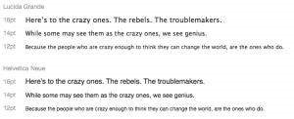

**Continuity and HandOff**

Yosemite is more than just a Visual Overhaul.

Start writing a Document or an Email on one device and continue finishing it on another device. This amount of integration and communication between Apple devices really adds value to buying an Apple product over a competitor product.

The integration is better than any other competitor operating system including Android – Chrome OS or Windows – Windows Phone.

You can also make make and receive phone calls and text messages on Mac provided your iPhone is in close proximity.



**Mail Drop**



What if you want to send a 4GB file via Email? It cannot be done directly. So,

What you do is upload the file to your DropBox and then send the Link. Well Mail Drop sort of works in the same way except there is no manual uploading or link generation. Just attach your file and Yosemite will take care of the rest.

How this works is your file is uploaded to your iCloud and if the recipient uses iCloud the files will be automatically downloaded if he uses Windows they will receive a download link much like Dropbox or OneDrive.

**Notification Center**

The Notification center and its design was pretty much ported from iOS to Yosemite. Now all your notifications, weather information and Stocks appear in the universal notification center.



**Should You Upgrade?**

Well, It comes down to this question “Do you use your Mac to make money?” If your answer is ‘Yes’ then you should hold onto your horses until all of your “Money Making Software” is updated to run smoothly with OS X 10.10. Will it bog my Computer down? A general observation is that it is not recommended for users owning a Mac which released before 2009.

In my general observation Helvetica Neue the new type face is optimized for viewing on a Retina Display so you may come across readability issues when you run Yosemite on a Mac lacking a Retina Display. If you do own iPhone or an iPad running iOS 8 then upgrading your Mac to Yosemite will add great amount of convenience in performing your everyday tasks.

**Bottom Line “Yosemite Completes iOS 8”**

### Festive Fashion

— Vineetha Rachamallu



Now that the Diwali season is finally here and so are the celebrations and parties of the season, it’s time for you to be in your ethnic best and make a few heads turn.

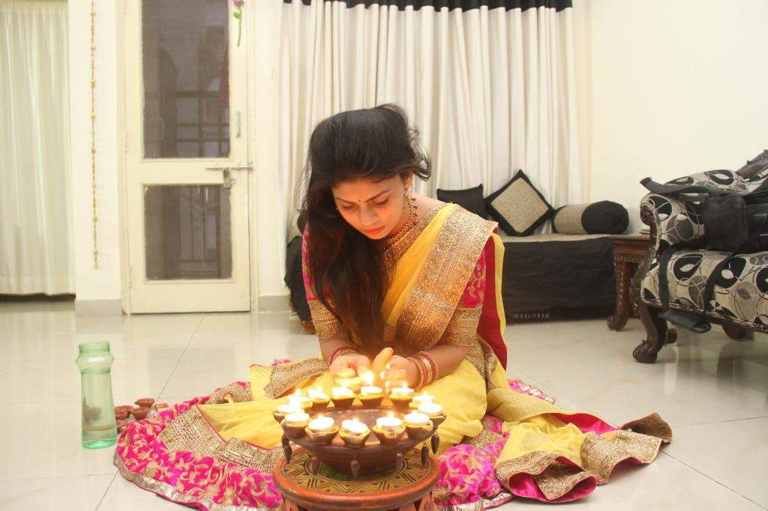

Here are a few tips that would help you get the perfect look, whether it’s for one of those fun family get-togethers or for a party at your friend’s place. Diwali is a time of happiness and gala. So, the palette for this season is a mix of vibrant hues like *rani* pinks, peacock blues, lime green and crush orange. It’s all traditional and ethnic that’s in this season, be it the exotic anarkalis, the crystal blouses or the lehengas and saris in chiffon. All of these give you an elegant and a sophisticated feminine look.



Coming to the fabrics, velvet is making a super comeback and georgette is in too. Chiffons, raw silk, lace and net are also trending. However, ensure that you go for pure fabrics as synthetic ones might catch fire easily.

Statement accessories grab the limelight this season.

Necklaces are beady, long and plentiful. Hoops and beads are dangling in the earring category. Gold and *kundan* jewellery are back in vogue. A little gold goes a long way, so make sure you don’t overdo it. Footwear like mojris or heels in metallic shades of bronze, gold or silver, would add the Indian touch to the look. Here are a few options you could never go wrong with:

– Team up a gorgeous crush orange or lime green raw silk *bandhini* with a flowy gown or a *lehenga*.

-A pink brocade gown with a hint of sheen or a cream print gown complimented with stunning loop earrings.

– Be a head turner this Diwali with a gorgeous peacock blue net brocade*anarkali*.

A gold clutch and statement earrings complete the look.

– Go classic with a gold and cream anarkali or a lemon yellow lehenga



Hot tip: Keep one item in the overall look grand; let that be a magnificent piece of statement jewellery or an extravagant accessory like a clutch.

Picture Credits Ponnam Rahul

### Roman Holiday

— Saylee Bhide

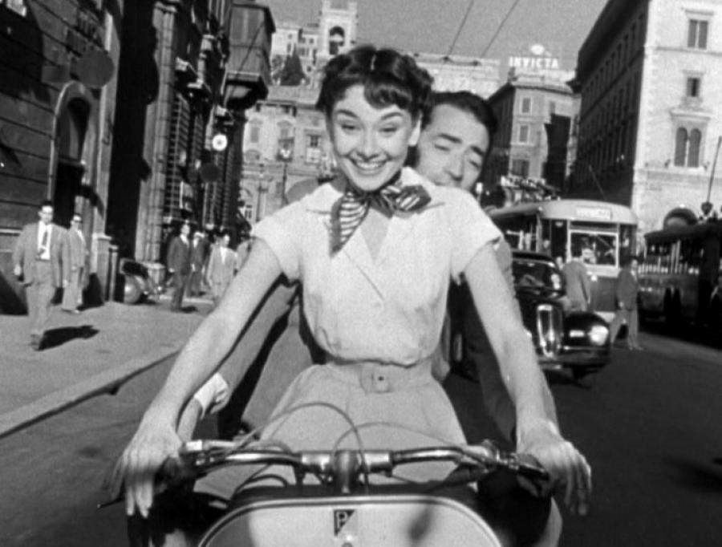

William Wyler’s 1953 classic “The Roman holiday” comes as a pleasant delight for people who have a fetish for rom-com movies. Roman holiday exudes an adorable romance between a princess (Audrey Hepburn) and a press correspondent Joe Bradley (Gregory Peck) in the backdrop of a picturesque Rome. Here is what the movie has to offer to us.

Tired by her extremely claustrophobic ,overprotective and “under the scanner” lifestyle Princess Anne runs away from her palace in the desire of doing what she always wanted to do. Exhausted and drowsy, she dozes off on a park bench somewhere in middle of Rome. Joe Bradley encounters the sleeping princess and takes her to his apartment for safety reasons where she spends the night in his room. Joe Bradely believes her to be a drunken girl and treats her roughly until he discovers that she is the Royal Highness, Princess Ann who was apparently taken ill last night.

Joe Bradely, accompanies the princess on her “once in a lifetime” outing with the furtive motive of taking an exclusive interview which he had promised to his boss for an extravagant sum of 5000 dollars. His friend, Iriving, a photographer joins him and photographs the princess from his deceptive cigarette lighter camera. Ann frolics in the streets of Rome, enjoying her fairy tale, incognito under the name “Anya”. As Ann and Joe spend more time together, his affection for her grows and desire for the extravagant reward wanes off. When her fairy tale finally comes to an end, Ann is caught between her love for Joe Bradely and her royal duties. Contrary to the viewer’s predictions, Joe and Ann seal their romance with a smile and she walks off into her palace, wiser and more sensible

[*“Princess Ann:*](http://www.imdb.com/name/nm0000030/?ref_=tt_trv_qu) *I have to leave you now. I’m going to that corner there and turn. You must stay in the car and drive away. Promise not to watch me go beyond the corner. Just drive away and leave me as I leave you.*

[*Joe Bradley:*](http://www.imdb.com/name/nm0000060/?ref_=tt_trv_qu) *All right.*

[*Princess Ann:*](http://www.imdb.com/name/nm0000030/?ref_=tt_trv_qu) *I don’t know how to say goodbye. I can’t think of any words.*

[*Joe Bradley:*](http://www.imdb.com/name/nm0000060/?ref_=tt_trv_qu) *Don’t try.”*

And subtly shows the coming of age of the princess-

[*“Princess Ann:*](http://www.imdb.com/name/nm0000030/?ref_=tt_trv_qu) *Your Excellency, I trust you will not find it necessary to use that word again. Were I not completely aware of my duty to my family and to my country, I would not have come back tonight… or indeed ever again!”*

Later in the press conference, Ann is stunned seeing Joe and Irving standing with the press. In lieu of selling the photographs for money, Iriving gifts them to Ann and Joe conveys to her that her secret is safe with them. Ann expresses her love and gratitude towards Joe implicitly in her generalized speech and leaves the conference. Joe lingers around the hall for a while and leaves us with tearful eyes and overwhelming surge of empathy.

“Roman Holiday” is subtle, classy and elegant. Audrey Hepburn’s innocence and Joe Bradley’s magnetism weaves together a beautiful story of love without any intimation of vulgarity. There are moments when we are amused as well as attracted to the naivety of Audrey Hepburn. Her slender, delicate body compliments to that of the character of Anne. Gregory Peck’s charming voice and killing looks keep our eyes riveted on him. Though Gregory Peck has a notable screen presence, Audrey Hepburn steals the show and overpowers him throughout their shared screen space.

A splendid storyline, not pushed too far, realistic and simple, lays the foundation for this all-time classic movie. Topped with a top notch cast and a picturesque milieu- what else can anyone ask for?

This movie surely goes into the “must watch list” as it offers to us , the best cast, the best setting and the most colourful yet heart-breaking tale of classic love written in the times of “black and white”.



### DIWALI : A BLEND OF DEVOTION AND CELEBRATION

**— Abhishek Bele**



If there’s one place that knows how to celebrate a festival, it’s India. From Grand city events to simple village ‘*melas*’, India’s festival calendar is rich and diverse as its tradition and topography.

Diwali entails religious and regional variations in the way it is celebrated. It is a composite festival and different parts of India have their version to explain the legends associated with Diwali. According to mythology, Diwali commemorates the triumphant return of Lord Rama to his kingdom after an exile for fourteen years. Keen to make Lord Rama’s return as swift and safe as possible his subjects illuminated the way with masses of twinkling ‘diyas’. It is for this reason the lighting of ‘diyas’ has become a key component of the Diwali festival. The tradition of fireworks during Diwali is a favourite among kids & elders, men & women. Here is a satellite image of India during the Diwali night.

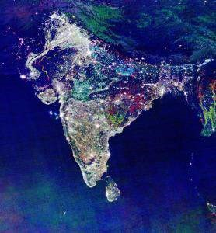

Yes !! It leaves an overwhelming impression in your mind as this festival symbolizes the replacement of darkness with inner light.

Diwali is celebrated over a period of five days. The five days of Diwali have different legends and sagas to talk about.

Day 1- Dhanteras

Day 2- Naraka Chaturdashi

Day 3- Deepawali

Day 4- Padwa

Day 5- Bhaubeej

In 2014, the main festival of Diwali falls on the eve of Thursday, October 23. Celebrated with vigor and gaiety all over the country, the magical effect of Diwali creates an atmosphere of joy and festivity. Innumerable lamps are lit on the roofs and windowsills of houses thus giving a divine look to the whole scenario. It is said that Lakshmi, the goddess of wealth roams the earth on this day and enters the house that is pure, clean and brightly illuminated. Therefore, people , before exchanging gifts and bursting crackers offer prayers to the deity.

Indeed spirituality lies at the heart of Diwali thus making it a perfect blend of ‘Devotion & Celebration’. Worshippers pray for prosperity and wellbeing for the time that lies ahead, with fireworks and crackers proffering plenty of celebration when devotional formalities come to a close.

Another prominent attribute associated with Diwali is the ‘Mithai’. Shops are filled with spectacular array of sweets specially prepared for this festival from thickly cut squares of ‘barfi’ , soft syrupy ‘gulab jamuns’ & spongy ‘rasgullas’ being the favourites. Indeed if there’s ever time to experience India at its sweet – and convivial- best, it’s during Diwali!!

For the common love we have, The Love for Food!

**— Satwik Reddy**



What’s any festival without Food?

You can hate food, you can hate eating but you cannot hate sweets! So, this Diwali there are a few specially picked sweets which are a treat to your taste buds, literally!

Name : Kaju Chaco Roll

Place : Almond House, Road Number 3, Banjara Hills

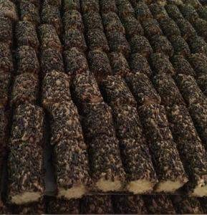

Description : Chocolate garnished on a sweet. Do I have to say more?

Name : Kaju Karanji

Place : Balaji Ratanlal, Kachiguda



Description: Karanjis are crunchy! You’ve got to try it for this diwali.

Name : MotiChoor

Place : Agrawala, J.N Road, Abids

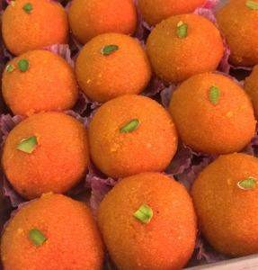

Description: How can I talk about sweets and not mention MotiChoor Ladoo? But the thing about Agarwala’s MotiChoor is different altogether.

Name : Paneer Jalebi

Place : Dadus, Himatnagar



Description: Never heard of a sweet paneer jalebi but this is suddenly my all new favorite.

Name : Rasgulla

Place : Tiwari Sweets, Khairatabad

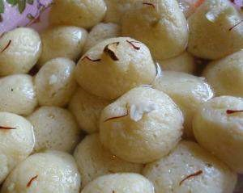

Description: “Miniature pearls of exquisite delicacy” – an apt description. If you haven’t tried it yet, get going right now!

### Designer Diyas

**— Medha Ch**



The ‘festival of lights’ spiritually signifying light over darkness, knowledge over ignorance, good over evil, and hope over despair. Diwali is one of the favourite festivals celebrated in the country.

It is a full- 5 day package of cleaning, renovating and decorating homes, dressing up in new clothes, cooking the best sweets for the puja, and ofcourse, lighting the diyas!

Ladies spend time together lighting up diyas all over the inside and outside of their homes in the nights of the festival-week. There are a variety of diyas available in the market.

Now that the season is back here, why not make the lighting-the-diya tradition more interesting? You can design your own diyas by decorating simple diyas, making them more colourful and attractive. Here is a Do-It-Yourself tutorial with simple steps to decorate your diyas at home.

Stuff needed: Diyas, Paint, Glitter, Fevicol, Kundan.

1. To start with, take your diyas, some bright paint colors, preferably orange, yellow, green, a paint brush, a few small kundans, all set to get the new- designer look

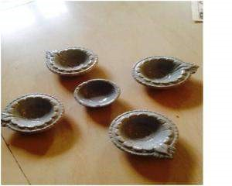



1. Decide different colors that you can put on different parts of your diyas, as per me, I have preferred yellow inside the diyas as it is an elegant color, and silver on the borders of my diyas.

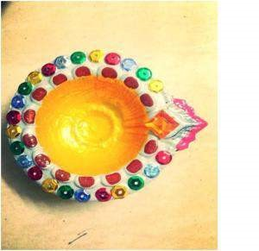

1. Next, you can add a few kundans or just paint any other parts of your diya with other bright colors like red, purple or green. If kundans used, fabric glue is preferable as it sticks easily and stays strong even after oil is poured on the diya



1. Different types of decorative kundans can be used to make your diya look more colourful.



1. Now leave them to dry for about 2-3 hours and your self-designed diyas are all ready to be lighted this Diwali!



### Music Timer using IC 555

**— Shriram Pydimarri**



We all love music!

It was always a fantasy to see how piano and musical keyboards work.That’s how we set out to do a basic music instrument using IC 555 timer chip.

To make this instrument, we require some basic components :

* IC 555 timer chip – 1
* Resistors : 51 ohm-1, 1 kilo ohm-1, 6.8 kilo ohm-1,33 kilo ohm – 5 (or) 10 kilo ohm – (5)
* Capacitors : 0.1uf-1, 100uf electrolytic capacitor-1
* A 9V Battery
* Piezo buzzer
* Breadboard
* Connecting Wires
* A Sheet of paper and a pencil(graphite)

Now connect the circuit as shown in the circuit diagram.

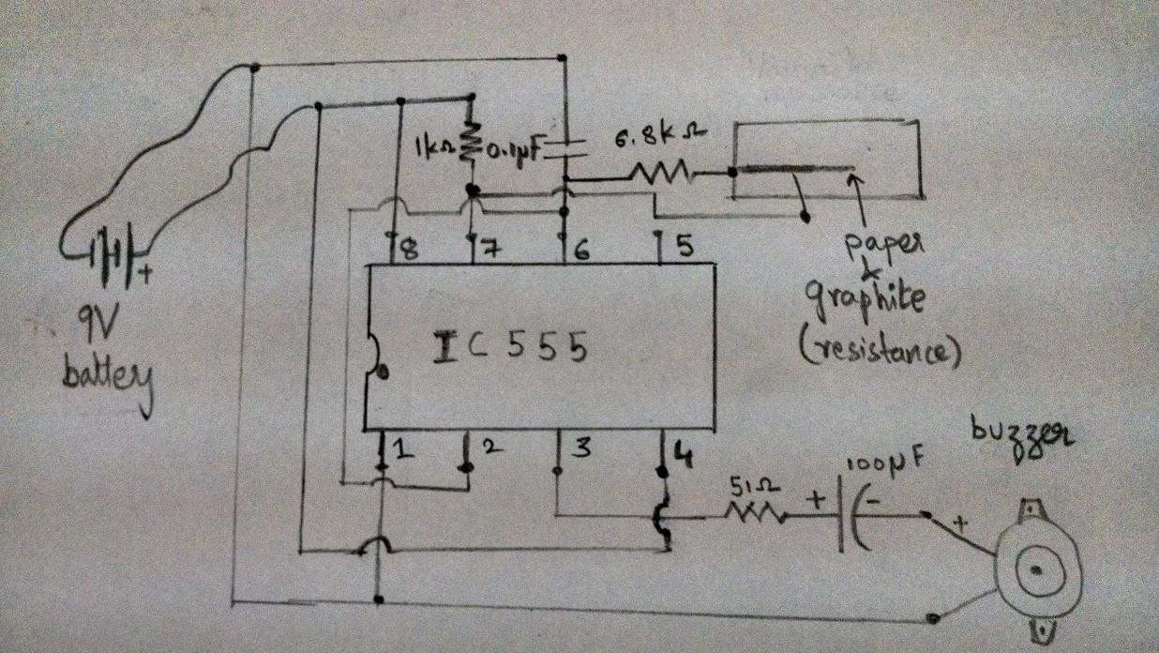



If you observe closely, IC555 timer has 8 pins. The corner of the IC555 timer has a round dot and that dot means the pin at the left bottom corner is pin 1and the one next to it is pin 2 and so on.

Working :

The IC555 timer chip sends square wavesto the buzzer which causes the buzzer to make the sound. The frequency of the square wave could be high, low or anything in between. The frequency is controlled by number of components in the circuit. One could control the frequency by varying the resistance between pin 7 and pin 6 where the 6.8 kilo ohm is present. The higher the resistance value, the lower the frequency and the lower the resistance value, the higher the frequency. Basically apart from the 6.8 kilo ohm which is already present between pins 6 and 7, we could also put different ranges of resistances in series with the 6.8 kilo ohm to vary the sounds on the buzzer.

It is interesting to know that we could play different musical notes by varying the frequency. These frequencies can be generated using different resistance values.

Few of the musical notes with their corresponding frequencies are given below.

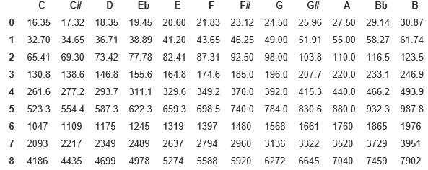

We have arranged five 33 kilo ohm resistors in series with the 6.8 kilo ohms and observed the variation in frequencies. And this is how it sounds!

There are various methods as to vary these resistances in order to produce different sounds. For example, the resistance can be altered by using a graphite-pencil. We know that graphite is not a good conductor of electricity and it resists the flow of current. You can use a sheet of paper and pencil to make a variable resistance sheet. If you put the varThe longer you move along the pencil mark, the lower the frequency we observe. This is because the resistance offered by the graphite increases with the distance. Thus you can make a music sheet and play different notes. This is just one of the many methods to alter the frequency and listen to various musical notes.

https://www.youtube.com/watch?v=3oClDbieUcU

This Article was contributed by

Anirudh, Shrutha, Kiran , Shri Ram of 3rd year ECE.





## Book yourself before you bore yourself…

**— Praharshita Krishna**



Reserve the quietest reading nook in your house people because the KMIT book club is in town.

We’ve got classics like Hitchhiker’s Guide To The Galaxy for the science fiction afficionados out there.

To Kill A Mockingbird for the social analysts, and the Perks Of Being A Wallflower for all the whiny teenagers….

Just kidding, all the books are the top three on any book clubs reading list, but what will be interesting is that it won’t be just any book club…

The members are expected to take part in lively debates, analyse the characters and role play..

We are in for a treat…

To add to the fun we’ve also got the KMIT theatre club coming soon, which will help us shake off the nerves and lose our inhibitions while working on our improve acting…

I wonder if this might get as interesting as the popular sitcom “Who’s Line Is It

Anyway?”

This one will definitely draw an audience for all the obvious reasons… There is also a chance of a debate club opening up soon, where we would thrash out every opinion till our motion is infallible at the expense of the class decorum if need be.

Outside of a dog, a book is a man’s best friend. Inside of a dog it’s too dark to read.

-Groucho Marx

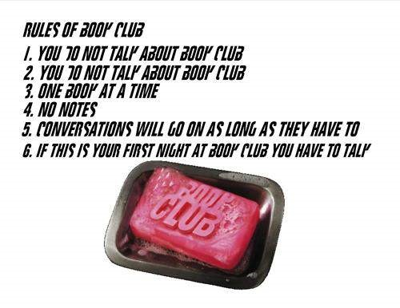

## Don’t Panic…

**— Praharshita Krishna**



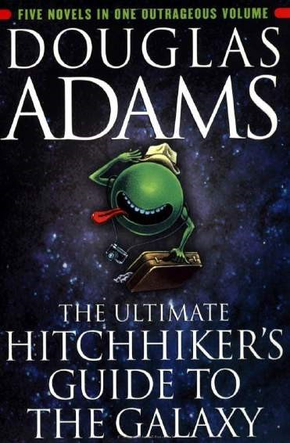

Hitchhikers Guide To The Galaxy -Book Review

The Hitchhiker’s Guide To The Galaxy, is not just one of those books you read… It’s one of those books that you fall in love with, get obsessed with, repeat all the arguments in your head, thoroughly masticate and digest every idea in the book while enjoying the delightfully whimsical yet beautifully crafted novel that it is…

Although I am a huge fan of Zooey Deschanel (partly because of her name…), I must say that the movie did not come close to the brilliance it took to write the book, but movies rarely do…

The plot is so amazingly twisted that you cannot help but fall in love with every character in it.

We’ve got Arthur Dent, who is a scared ape-descendant (Hitchhiker talk for *Homo*

*Sapien*)who finds himself in a particularly unfortunate set of circumstances, or fortunate depending on whether you are a glass half empty or glass half full person…

His planet, Earth has been destroyed but he is saved by his alien friend (Ford

Prefect) who tells him of the universe he isn’t aware of, and his database is the

Hitchhikers Guide To The Galaxy which is not like any other compendium like the Encyclopedia Galactica, but is actually a very interesting and useful book, rather a travel guide for hitchhikers, and after reading this book you might like to pretend that your e-reader may be one in disguise, or so you may wish…

Zaphod Beeblebrox is one hoopy frood…

He is on a mission to find the ultimate question to the ultimate answer that is “42”,what he and Arthur along with Trillian and Ford find out instead is so incredible, you might just want to believe it yourself…

Humans are the third most intelligent beings, the first and second species will tickle your funny bone…

And I must mention the utterly miserable and extremely intelligent robot-Marvin…

He has the perfect amount of sassiness I would expect of a robot with GPP,

Genuine people personality…

What stood out the most for me were the following lines-

“All through my life I’ve had this strange unaccountable feeling that something was going on in the world, something big, even sinister, and no one would tell me what it was.”

“No,” said the old man, “that’s just perfectly normal paranoia. Everyone in the Universe has that.”

Vogons are delightful creatures who will read you beautiful poetry whilst saving you and your planet from its impending doom…-and that’s a lie…

Of Course you would have to read the book to find out whether I can be trusted, which is my intention ,for anybody in their right mind, i.e. science fiction lovers will immerse themselves in this beautiful novel in a tiny earth second.

“Resistance is useless”

I hope this doesn’t reflect too badly on my credibility…

If you are going to read the book, I assure you that I will read and write reviews for the rest in the series, the next being The Restaurant At The End Of The Universe… I think this is getting bigger than Harry Potter…

I must stop for I see myself in the peril of being lynched by the HP fan club… Till then “Don’t Panic”!

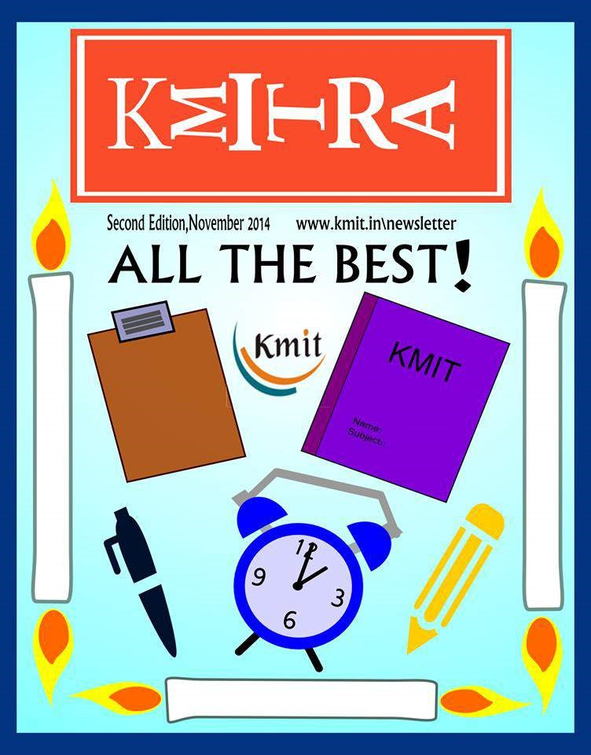

Winter Wonderland!

**— Neeharika Palepu**



It’s that time of the year again where snuggling into the duvet feels oh-sogood! Granted, we didn’t have the best weather this year but let’s make the most of what we’ve got and judging from how my nose feels right now I think it is safe to say that WINTER has arrived!



Sweater weather!

The long sleeves which have been sitting in the back of your closet gathering dust should finally be out. This is undoubtedly my favourite time of the year, weather wise & fashion wise. The parties get more jovial, the weather gets nippy and you can safely begin to layer your clothes! Winter is a time where we love being cozy and comfortable with what we wear and this is perfect for those lazy days where you just don’t want to take the effort.

Here are a few winter looks that can never go wrong :

### 1. **Sweaters** (duh!)

Basically anything long enough to snuggle your fingers underneath and be a happy soul! Here’s how you can make them more appealing

-get an oversized sweater and let the aura of snugness spread around

-add a collar or wear a collared shirt underneath to give it a more sophisticated look

-layer a chunky scarf on top for a weekend casual look.

-add a statement necklace to give it a boost in the evening





### **2.** **Hoodies**

Hoodies are foolproof garments when it comes to warmth and comfort. The trick that makes hoodies work is layering.

-layer it with a t-shirt or a sweater vest

-team it up with jeans or cozy leggings and you are good to go!

-you can also team it up with beanies and scarves



### **3. Cropped Knits**



From slouchy knitted cardigans to toughly shredded pullovers, there’s something for anyone that’s looking for a warm cover-up this time of the year. The cable knit sweater is an age old classic that’s undeniably preppy and that’s why it is so fun to reinvent it to fit our own personal style. If the Christmas spirit is creeping upon you, you need to get your hands on oversized Christmas jumpers!



### 4. **Socks**

And this does not mean you need to put on the boring old black and dark blue ones. If winter isn’t the time to go crazy on garish, cute and colorful socks then when is the perfect time? It’s okay to go a little overboard on these because – lets be real – they keep your happy little feet nice and cozy. If you feel too festive try getting the snowman or reindeer socks!



### 5. **Boots**

It’s time to put those flip-flops back in the shelf and bring out boots and shoes. You can try over-the-knees, or riding shoes or simply put on those old converse ones. To keep your look more neat and clean go for simple leather Dr.Martens. To get a funky chic look try on the neon shades of green, purple, red, orange converse.



***COLORS –*** the colors you need to try out this winter!

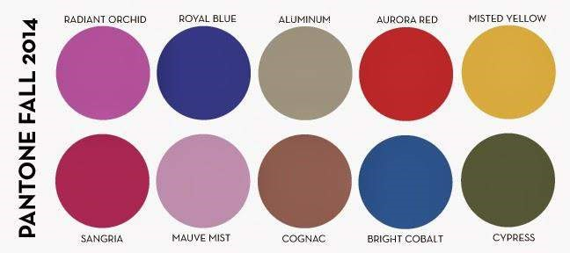

No silly..we are not abandoning black, it *is* a major winter color. But here are few others and every color has its story

-Sangria, an exotic red with a touch of pink that evokes a sense of glamorous adventures

-Aurora Red, a more sophisticated shade that adds verve and spark

-Mauve Mist, a romantic and elegant purple shade, reminds us of the deco era and an enhanced sense of empowerment

-Radiant Orchid, a captivating and adaptable shade that enchants the entire spectrum

-Royal Blue and Bright Cobalt to compliment the seasonal blues

-Cognac, a classy cultured brown takes a typical fall color to sumptuous realm, making the shade unexpectedly ideal for evening wear

And adding a bit of sunshine, Misted Yellow alludes to the promise of spring to come.

### ***WINTER ESSENTIALS***

As the air outside gets crisp and cold your skin starts to dry. It’s really important to hydrate your skin using a moisturizer or body butter. Cold makes your lips all dry and chapped so using a chapstick or a lip-balm is never wrong! As catching a cold is very common, use alcohol free sanitizers. Pamper yourself with hot baths and to make them more fun throw in a bath bomb or a fizzer. If you love hot baths, then visit *The Lush and The Body Shop* store in Inorbit mall and you are in for a treat!



***WINTER WONDERLAND***

And here are a few things we absolutely love about winter wonderland!

-hot chocolates/hot coffee/chai: In fact, we stop counting the number of cups during winters. The schedule goes like this morning-chai-breakfast-chai-lunchchai-snacks-chai-dinner-chai-and some more chai.

-evenings getting darker

-scented candles

-comfort food

-salted caramel being IN SEASON



-enjoying the snugness of bonfires

-horror films

-fireworks

-sparklers

From the sound of leaves crunching beneath your foot to being cozily tucked up in bed with a mug of hot chocolate, don’t we love everything about winter?



Are we eating food ?

**— BTW Baba**



Food as we know it (and by definition) is something we consume to fill the nutritional requirements that our body has.

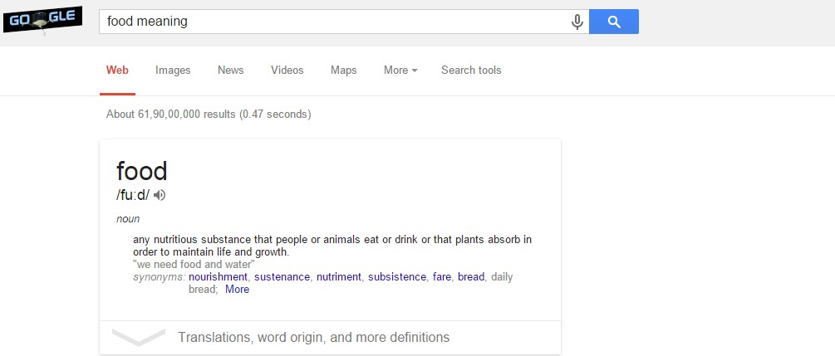

But, food has evolved from just being food to being something which we no longer eat to just quell our hunger- it has become a source of happiness, pleasure and something that we socialize over. You will agree with me when I say that we no longer just stuff it in our mouths! We no longer eat what we were supposed to eat. Humans, as animals in the food pyramid, eat what they want not what they ought to.

Homo Sapiens, as we know, are omnivorous. But there’s no longer a need for the species to hunt down an animal and eat it. In fact, we have not even evolved enough to eat meat as our staple diet but we still tend to do it because we are slaves to our tongues.

We no longer judge the food based on its nutritional value but we judge it based on the taste and the pleasure it gives while eating it. We don’t care about what happens afterwards i.e., how it affects our body.

That is exactly what I am going to tell you now.

Irresponsible eating – as I call it – or eating just for the sake of it is now the world’s largest cause of human deaths. Diet related deaths kill more people in a month than smoking, drinking and road accidents combined in a year! Diet habits have been changing so rapidly and have been becoming so unhealthy from generation to generation that we now have the highest meat eating population by ratio in entire human history. We also have the highest obesity ratio – the figures are getting worse year by year.

Just take a look at this video where John Oliver explains about the sugar consumption in US.

#### Sugar by John Oliver:<https://www.youtube.com/watch?v=MepXBJjsNxs>

And we have so many misconceptions about food. The majority of what we consume today is branded and labeled as refined. This is where the problems really start. Our rice is so polished that all the bran which contains fiber is removed and only the stuff rich in carbs remains. The same is the case for almost all the eatables – the more refined it is the less healthy it is.

#### Hungry for Change trailer:<https://www.youtube.com/watch?v=3MvAM97VDE8>

People have become so habituated to the fast food restaurants and food chains like McDonald’s, KFC etc. that it has become hard to find somebody who hasn’t been to one before. Although the food that gets served there technically can be called food; it doesn’t meet any standards that certify it as safe for consumption. In fact, you’ll understand more once you watch this video.

MCDonald’s 4 years old burger:

<https://www.youtube.com/watch?v=4IGtDPG4UfI>

The issue is not only about what kind of food but also about the type of food. To put things into perspective:

To produce 1kg of potatoes around 500 liters of water is spent.

To produce 1kg of wheat around 600 liters of water is spent.

To produce 1kg of rice around 2000 liters of water is spent.

To produce 1kg of beef around 100,000 liters of water is spent.

So, eating vegan diet is safer for both – you, as a human, and the environment.

With your food choices you can:

Become healthy.

Help avert climate change (since meat production is one of the largest polluters).

Save water.

Reduce starvation.

Save biodiversity.

Align with your values of compassion.

And, here are some of the facts:

1. 1 billion people can be saved from starvation if Americans ate just 10% less meat.
2. There are now 20 billion livestock on earth- about triple the number of humans.
3. Total number of land animals killed for food each year is 70 billion, that is, the food choices you make is directly responsible for death of 10 animals for every single person living on earth
4. It takes 12-16 kilos of grain to produce 1 kilo of meat or milk.
5. A non-vegetarian needs 16 acres of land for sustenance whereas a vegan needs just 0.5 acres.
6. 260 million acres of virgin forests are cleared for cropland to support meat centric diet

Jamie Oliver TED speech – Teach Every Child About Food: <https://www.youtube.com/watch?v=jIwrV5e6fMY>

So, dear readers, I leave it to you to ponder upon your food choices. Health is Wealth. Remember:

***We are what we eat, what we eat is what gets reflected in our nature.***

## Halloween

**— Neeharika Palepu**



Come sit by the fire, for the night is long and I have a strange and a curious tale to tell. It all started when we were walking towards it and the ground which was roaring till then was abruptly draped in silence. We were certain that someone was watching us. It was too late to back out, we knew that this climax was inevitable! Woooo too much Halloween spirit there!

To those who have no idea what I was rambling on about, let me brief you guys on what halloween is. Halloween, also known as *All hallows eve* , is a yearly celebration observed in a number of countries(western). It is that time of the year which is dedicated to remembering the dead, including saints (hallows), martyrs, and all the faithful departed believers. Basically a festival of the dead, people believe that it is that one night of the year when the souls of the dead are said to revisit their homes.

Candles are be lit and prayers formally offered for the souls of the dead. After this the eating, drinking, and games begin. These candles also have a significance-it is said that candles burning in every room were to guide the souls back to visit their earthly homes. These were known as “soul lights”. In the old English culture, candlelit processions would be carried out and barns and homes were blessed to protect the innocent from the evil. It is now widely celebrated by people of all social, racial and religious background.

Coming to the fun part, on this day people dress up in scary costumes and parade on the streets. The annual New York Halloween Parade in New York City, is the world’s largest Halloween parade. Most of these costumes are influenced by supernatural and horror characters like Dracula, Frankenstein’s monster, The Mummy etc.

Trick-or-Treating is a must for children on this day; they dress in costumes and go from house to house asking for candy with the question “trick or treat?” People visit haunted attractions (Yep!Annabelle is trending today!) Jack-o-lanterns are placed outside the houses. These are basically pumpkins whose top is cut off and the flesh inside is scooped out and then a monstrous face, is carved out of the pumpkin’s rind to expose the hollow interior. To create a lantern effect a glowing candle is placed inside. In folklore, Jack-o-lantern is used to represent a soul whose entry has been denied into both hell and heaven and is said to roam on the earth forever. It used to scare off evil spirits. (Don’t go to the grave yards carrying a pumpkin, silly! It doesn’t work 😉

KMIT hosted a pumpkin carving competition on the occasion of halloween and it was amazing! Many students turned up excited to embrace this western tradition. With a good ol’ pumpkin in our hands, a sense of competition and an intention to have an absolute smashing time, we rolled up our sleeves, laid out the newspaper, got out our best knives and scooping spoons and let creativity work take over. With a deadline of 40 minutes and with no clue what our pumpkins would look like, we started carving. And look what we made!

All the jack-o-lanterns turned out to look amazing. Some of the pumpkins donned cute little hats, had scary teeth and even had leaves coming out of their heads. For first timers, this was not that bad actually!

We weren’t fighting for the prize, we were fighting for who has the best fun! And on the basis of that everybody won. After the competition, our jack-o-lanterns were displayed in front of Block-E.

And coming to the winners, science took the first prize.

1. First prize -Aishwarya Reddy and team for *classic half moon eyes and science*.



1. Second prize- Medha and team for their eight inch screw drilled jack-o-lanterns.

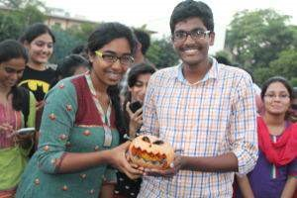

1. Third prize -Sudhanshu and Chandrashekar for the *tribal style pumpkins*.

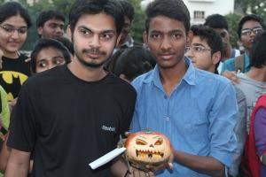

Shadows of a thousand years rise again unseen,

Voices whisper in the trees, “Tonight is Halloween!”

*does a dramatic evil laugh*

### ***Photo Courtesy: Vishnu Chaitanya***

Procrastination!

**— Shriram Pydimarri**



It’s exam time and everybody knows what’s coming and yet, we escape from it. Here’s what Google says!

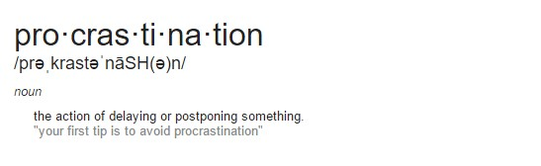

Ahem. ***How does it actually feel?***

It is unquestionably the most happening thing of all time in the whole world. The harder you control the urge, the harder it is felt. The farther you push, the closer it gets. You kick it out of the front door, it creeps in through your back door. The deeper you dig, the deeper you get. The mind plays a deceptive game where the victim ends up using his/her precious time for irrelevant activities while remaining confident of finishing the actual job before deadline which never happens in true sense.

***How does it begin?***

It begins like always in front of a book, maybe near the index page or at the introduction of your essay. The victim will be doing a task which is very important and less tempting when suddenly something less important and more tempting takes its place. Confused? , Let’s take an example.

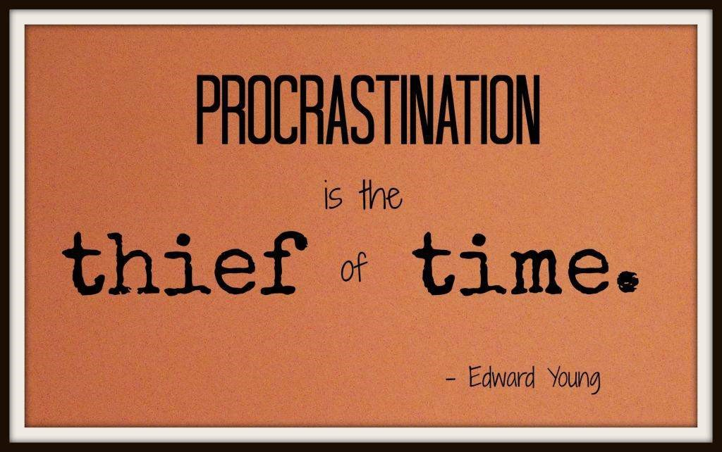

Example: Exam preparation (and/or) writing an article (and/or) assignment completion etc – all tasks that have something called a deadline, are replaced by more pleasurable tasks like: watching a movie (and/or) texting friends (and/or) surfing the web (and/or) listening to music etc. Basically, all tasks which need minimum effort and lingers within the radius of the victim’s comfort zone.

***Effect of Procrastination:***

Whether one chooses to acknowledge it or not, results of procrastination are filled with small and temporary satisfactions which are later overshadowed by a dreadful demon called ***deadline***. Once the victim realizes his incapability to complete his task before the deadline, one ceases to believe in its purpose or degrades oneself for his incapability. Either way, he is demoralized.

***How to tackle it?***

1. Be Inspired by the task at hand.

You’re doing it because you find the task unpleasant : Many procrastinators overestimate the unpleasantness of a task. So give it a try! You may find that it’s not as bad as you thought! Hold the unpleasant consequences of not doing the work at the front of your mind. This way it’s easier to get rid of few easier and silly temptations. Always remember the results of those temptations are only temporary as against the main task. DO NOT POSTPONE. DO IT NOW!

1. Watch yourself periodically until your work is done.

Keeping a close watch over your actions without letting temptations win is discipline. Ask yourself, “Is this what I REALLY want?”

1. Plan out your work & work out a plan.

But make sure the plan is realistic and doable.

1. Reward yourself

As you are prone to so many deviations, gift yourself something once you’ve completed your work. But do not gift yourself a solid 3 hour movie before an exam. Be responsible about the rewards you give yourself.

1. Keep a limit over how often you take out your phone to check for notifications or how often you get up from your desk while working. These are the moments where you get lost. Do not give away any attention unless relevant. Undivided attention is a must!



1. If avoiding entertainment is impossible, make a guaranteed plan for fun-time every day, so that the obsession dissolves in your routine and you can peacefully focus on the task.
2. Read articles on procrastination like this one and share them with your friends and have a giggle about it. Nothing helps like a giggle with friends.



### Interstellar

**— Saylee Bhide**



**NOTE:** *This is a candid review with contributions from Shri Ram, who has a penchant for sci-fi movies.*

Okay, call it my impertinence or my brutal honesty, Christopher Nolan’s

“Interstellar” literally forced me to say “Whaaaaaaaaaa, what the hell?” at least 20 times in a span of 169 minutes. Interstellar talks about serious stuff – quantum mechanics coupled with theory of general relativity to find a feasible solution for gravitational equation and many such things which you do not comprehend.

Here’s my take on this movie in few points. Here we go –

1. Christopher Nolan, what were you thinking? Why can’t you limit yourself to our solar system and experiment with it? Why are you going to some other galaxysomething that seems so “far-fetched”?
2. Did I just come out of a movie which recited and presented a research paper of a Harvard astro-physics graduate- with extra emphasis on amazing visual effects and haunting music? Did we literally combine a “Research paper+VFX+Hans Zimmer”?
3. And seriously- why is the past, present and future all messed up in the beginning? My brain does not have the capability to map all these three phases of a timeline in fraction of a second.
4. We had a “Black hole” and now we have a “Worm hole”. What next? Polo?
5. In context to the “hibernation” concept- How can you just undermine the teachings of biology to strategically place Dr Mann on Mann’s planet? Did we just mix zoology with anatomy?
6. They say, if you cannot convince then confuse. Was that the purpose behind the dimensional circus that you tried to convince us with? A two dimension in five dimension Tesseract? Heyyy! I need an eight dimensional cerebrum in a ten dimension skull to understand that logic of yours.
7. Memories of the past and superhuman of the future are helping the present become the future. Like, why is this movie not stable? It’s like an infinite loop-what if we fail in between?
8. This movie runs neither in one timeline nor on one planet. Forget planet- we keep switching in between two galaxies!

Apologies if my hatred has hurt your feelings. Though I found the foundation of this movie lackluster, I do have a few words of praise for it.

1. Nolan succeeds in breaking all the forbidden barriers of our imagination and transcends us through a dimension of space-time-gravity and yet keeps us rooted by the emotional gravity of the relationship between a father and daughter. Time varies, planets vary, people vary, galaxies vary- yet the unshakable love between a father and his daughter remains constant, surpassing the expanse of the universe.
2. Who can forget the VFX? A special mention to the company *Double Negative which* is behind the awesome VFX of this movie. I mean, I cannot even fathom the amount of hard work that has gone into the VFX part in order to make the visual experience a treat to the viewers. A credible effort nicely furnished by perfection and care. Every scientific detail is well-handled and projected beautifully – for instance just look at that worm hole!
3. Did anyone observe the peculiar design of the robots-“TARS” and “CASE”?

Our brain is channelized to see a robot that looks like “Wall-E” but in this movie, “TARS” has a quadrilateral shape! The robot’s movement is fluid and wellcoordinated with its shape.

1. Interstellar shows us that progress in science is a yardstick for mankind. We are breaking out of the clutches of this rudimentary comprehension and stepping into a higher cosmic awareness. This is a pursuit of self-awareness. If self-awareness is what counts, leaving earth is probably worth it.
2. Last but not the least, actual science is rooted in the fabric of the movie. Every scientific calculation is real and factual. Nolan’s strategy for the course of the movie may be a fickle affair, but the scientific calculation is no work of fiction. Such equations actually exist, and yes, such people actually exist- hope I never get to meet one.

Overall, this movie is a colossal loss with any stretch of my logic, yet it manages to garner visual and auditory appeal. The music composed by Hans Zimmer is just so well fitting, that it lingers in your mind throughout the movie.

Maybe next time, Nolan should restrict his imagination and try not to play with a genre which is too complex to understand. As they say, too many cooks spoil the broth. Too many complexities, spoil the fun!

## The Restaurant At The End Of The UniverseDouglas Adams

**— Praharshita Krishna**



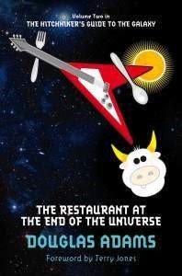

Ever thought about your food preferences and your reasoning behind it? Sound or otherwise?

Whether you are one of the noble green eaters or the proud meat eaters, you will definitely have a different take on food after you read this book, for a talking cow will startle you with some really depressing yet futile (in the case of Arthur) arguments on why it should be eaten or more pathetically, which part of it would give its patrons most gastronomic pleasure.

***The Restaurant At The End Of The Universe*** peaks exactly at the title, i.e. when you reach Milliways.

The amount of thought gone into time travel to make this trip possible is amusingly insightful, more so when he describes the grammar issues that would arise as a result of time travel.

The major problem is simply one of grammar, and the main work to consult in this matter is Dr. Dan Streetmentioner’s *Time Traveler’s Handbook of 1001 Tense Formations*. It will tell you, for instance, how to describe something that was about to happen to you in the past before you avoided it by time-jumping forward two days in order to avoid it. The event will be described differently according to whether you are talking about it from the standpoint of your own natural time, from a time in the further future, or a time in the further past and is further complicated by the possibility of conducting conversations while you are actually traveling from one time to another with the intention of becoming your own mother or father.

Most readers get as far as the Future Semiconditionally Modified Subinverted Plagal Past Subjunctive Intentional before giving up; and in fact in later editions of the book all pages beyond this point have been left blank to save on printing costs. -An Excerpt from “The Restaurant at the end of the Universe”

The thought is simple yet isn’t something people bother themselves with and he takes us down a new path of thinking maybe, shakes you out of your old thinking habits.

Then we have the ideal description for the ruler of the universe, which makes sense after a while because only a truly objective person can make cold and calculative decisions unaffected by any undercurrents emotional or otherwise, without ever having to face the consequences of his decision or even be aware of it.

There is a very clear explanation as to how our (or any)society behaves like a wellevolved ecosystem; more importantly how every profession has evolved and stood the test of time to be almost as important as a species and with all the implications that come along with this train of thought.

His witty and biting comments on society, religion and human behavior will leave you laughing for a while till you realize how deep it goes! The icing on the cake is Marvin, who has to deal with an army bot, armed with the latest of battle armor, only to defeat him with reasoning and emotionally unsettling the other robot, given that these robots have genuine *people personalities.*

Also, there is the total perspective vortex that again brings to light how very insignificant we are in the universe. While reading this book, wherever we may be *definitely* puts our self-obsession into light. For if we weren’t obsessed with either ourselves or something or someone else, we would listlessly roam the universe for the rest of our biological life spans in soul crushing depression.

Douglas Adams in the course of 170 odd pages takes the reader to a different place in our own psyche and shakes us out of our established thinking patterns. Perhaps, as a result, our imagination works better with every word till we are completely sold on the idea.



### Home-made Lipbalm

**— Medha Ch**



There are so many kinds of lip balm out there, but it can be hard to find just the right one. What’s the solution? Make your own, of course! It’s surprisingly simple to whip up a batch of lip balm that’s perfectly customized to your taste. Here are simple, actually the easiest, steps that can be followed to make chap-sticks in less than 10 minutes.

All you need is-

1. Petroleum Jelly
2. Olive oil
3. Wax crayon (any colour of your choice) or bee wax(if you want it to be colourless)
4. Essence(I used vanilla)
5. Empty lip-balm containers
6. A small spoon to stir and a big spoon(used as a cup to heat)



All that you need.

Now you are all set to make your own lip-balm in less than 10 minutes!

1.Add the petroleum jelly, Olive oil, crayon or bee wax, and vanilla essence in the big spoon or a small cup and heat it.

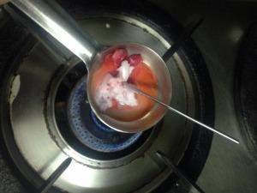

1. Keep stirring with the small spoon till the essence is dissolved in the mixture and the wax crayon is fully melted.

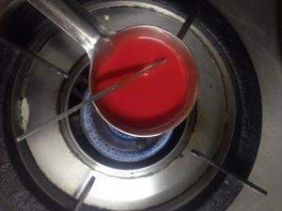

1. Once the mixture is becomes a fine liquid, pour it into the empty lib-balm containers and refrigerate the container for about 5 minutes.



1. Your self-made lip balm is ready! Happy lips! 😀



#### *Image Courtesy- Niharika Emmadi*



### Big Hero 6

**— Praharshita Krishna**



Who would have thought that Walt Disney’s fear of mice and his amicable portrayal of the tiny rodent would eventually lead to a multi-million dollar company, which now has the power to influence many generations!

Every movie has a message and a moral; there also are movies that have set ideals for every relation in a child’s life, from father-son, siblings to many others. Big Hero Six is another such movie about two orphaned brothers raised by their aunt, who are interested in robotics and live in San-Fransokyo – which quite obviously combines San Francisco and Tokyo – because Japan is on the cutting edge of robotics.

The entire story revolves around how the younger brother (Hiro) tries to avenge his elder brother, Tadashi’s death which seems like an accident. More evidence comes to light which makes him think otherwise. We also have the adorable, cuddly, nurse bot Baymax that diagnoses a health problem and comes up with a medical solution.

Medical technology is quite under developed in many aspects, the humble syringe for one, is more than 150 years old ([1844)](http://en.wikipedia.org/wiki/Francis_Rynd). While medical robots are inevitable in the future to bridge gap between increasing population and lack of medical resources, Baymax seems to be an interesting and user friendly healthcare alternative. Hiro tries to convert this huggable, friendly and adorable robot into a killing machine and along the way makes some very intelligent and unusual bunch of friends who each have their own inventions. Each invention is incorporated into their suits so that they can fight the villain who is operating on stolen technology that Hiro had made( microbots ).

Although I am a huge fan of all-things-robotics and/or animated I must admit that this is more of an original story. If you must watch only one movie this week, give it a miss and opt for *Interstellar* which is getting an amazing response at the box office.

#### Watch a clip here: <https://www.youtube.com/watch?v=nC49uRsKmR8>



### Cloud Computing – The Pros and The Cons

**— Akshay Chandra L**



Cloud Computing – it’s here, it’s there, it’s everywhere. Some believe it’s the future. They say if you aren’t taking advantage, you could probably be left behind.

So,what is it? Well, Cloud computing is a reference to computing resources, (like software or hardware) that exist on computers that are at a distance from the user, and are delivered and employed by end users as a service over a network( like the internet ). Chances are likely that you are already using cloud-based computing without even realizing it. For instance, web-based email services are “in the cloud.” **Pros:**

* *Cost Effective*

Cloud computing is the most cost efficient method to work, maintain, upgrade and progress. Traditional desktop software costs companies a lot in terms of finance. To top it off, licensing fee for multi-user based infrastructures is a nightmare for financiers. On the other hand, cloud is available at much cheaper rates which significantly lowers the company’s expenses. Working or operating on the cloud can be inexpensive and maintenance free for IT companies.

* *Scalable*

Cloud is a leveraged infrastructure as a service. So, quick development of apps and tools that support your infrastructure is possible. And if the load on an application grows, one can scale horizontally by provisioning new servers.

* *Unlimited Storage*

Storing information in the cloud gives us almost unlimited storage capacity. One no more needs to worry about running out of storage space or increasing your current storage space availability.

* *Backup and Recovery*

All the data present is stored in the cloud, so backing it up and restoring the same is relatively easy when compared to getting it all from a physical device.

Furthermore, most cloud service providers are usually competent enough to handle recovery of information. This makes the entire process of backup and recovery much simpler than other traditional methods of data storage.

* *Easy Accessing*

If one is registered on the cloud, then one can access all the information stored from anywhere in the world. Working internet connection is all that is required. The cloud makes it so simple to work on one’s data, irrespective of different time zone and geographical location issues!

**Cons:**

* *Technical Issues*

Although the data and info on the cloud can be accessed anytime from anywhere, there are times when this system can have some serious dysfunction. This technology is always prone to outages and other technical issues, in spite of companies keeping up high standards of maintenance. Besides, one will need a very good Internet connection to be logged onto the server at all times.

Connectivity problems can cause immense loss of data and info.

* *Surrendering the data*

Security issue is one of the major issues of Cloud Computing. Once one adopts this technology, it means that one will be surrendering one’s company’s sensitive information to a third-party cloud service provider, putting the company at great risk. Hence, you need to make absolutely sure that you choose the most reliable service provider, who will keep your information totally secure.

* *Prone to Attack*

Storing information in the cloud makes you vulnerable to external hack attacks and threats. The cloud is prone to attack, it isn’t completely secure and there is always the possibility of stealth of sensitive data.

**Conclusion:**

Like every other techie thing, cloud computing has its pros and cons. It can be a great asset and a shot in the arm to the companies having good understanding and usage vision. And yeah, with the vulnerability of data at stake, it can bring one down too.

#### BTW Baba

**— BTW Baba**



1. Do you think our college should have an open gate system and leave the fate of the students to themselves ? – By Anonymous

A: In my view, prisons are the only places that should have gates. Colleges are just supposed to be a medium that provide opportunities for students to learn on their own. However, taking security issues into consideration, I think it’s right on our college’s part to prefer a closed gate system.

1. Baba , can you please explain the procedure for challenge valuation in JNTUH ? -By Anonymous

A: Procedure to apply for Challenge Valuation (Official Notification Included).

Detailed Notification :

The students who intend to apply for Challenge Valuation should submit their applications (Through the principal) within 15 days from the date of declaration of Recounting/Revaluation results by paying Rs.10,000 (Rupees Ten Thousand only) per subject, in the form of Demand Draft, Drawn in Favor of The Registrar, JNTUH.

1) On receipt of the DD, the photocopy of the answer booklet shall be given to the student.

2)Date will be notified to the student for CV.Then, the students need to go to JNTUH and attend the CV, where the paper will be evaluated in the student’s presence.

1. The paper will be evaluated in the presence of the students by the senior faculty appointed by the examination branch of the University.
2. If there is any change in marks (Equal or above 15% of the maximum marks), the new marks will be awarded to the student. Otherwise, there will be no change in old marks.
3. If the change in marks (Equal or above 15% of the maximum marks) occurs, an amount of Rs.9,000/- will be refunded to the student. Otherwise, the student will forfeit the total amount which he/she paid.

6)No Challenge Valuation for Lab Marks.

**Note:**

1. Example : For B.Tech Student :: 15% of maximum of marks (75 Marks for External Exam) means , there should be an increase of 11.25 = 11 marks after CV, only then JNTUH will add marks & will refund the amount of Rs.9,000/-

If a B.Tech student secures 22 marks in external exam & if he applies for CV after RC/RV results are released then after CRV he/she should secure 33 Marks (22+11) so that student can get back the amount of Rs.9,000/- & new marks will be updated.

1. Notification will be sent to colleges soon.
2. Students can apply for CV only within 15 days from the date of declaration of Recounting/revaluation results.

Official Notification (This is an official Notification from JNTUH)

**Code**: [**http://jwfiles.net/my07rbzhbdx9/JNTUH_CRV_2013.pdf.html**](http://jwfiles.net/my07rbzhbdx9/JNTUH_CRV_2013.pdf.html)





Houston, we have a problem. It’s 2015!

**— Aditi Ghotikar**



Whoosh. That’s the sound 2014 made when it passed by.

Amidst two semesters, placements and the watchmen’s whistles, 2015 is already staring at us. We stumbled, dragged and sleepwalked our way through the semester exams. Like, yours truly. Then there were some who *flew* through them, never mind. For the final years, it’s only one more to go. Phew! *does a pirouette* for the first years, the wondrous college life has just taken off.

2014 has been a bumpy ride for us as a nation too. We broke new frontiers across fields. It has been a year of incredible technological advancement for India in space. This has, among other things, brought the ingenuity of India’s best minds to the forefront. If the year *belonged* to anybody, it had to be the Indian voter. We were simply tired of the scams the frontpage carried each day, weren’t we? General elections came up with a resounding mandate, giving our nation a new government and a new Prime Minister.

Our New Year Edition is all about winter and good cheer. Have a look!

Here’s hoping 2015 keeps us all grinning from ear to ear in rain and in shine.

A very Happy New Year from the k-MITRA team!

And, yes, do drop in a word at kmitemagazine@gmail.com



##### Confidence and Clothes

**— Neeharika Palepu**



Style is a way to say who you are without having to speak. Now, how do style and confidence interweave? Well, clothes reflect how you feel. Pure, intense emotions. It’s not about the design, it’s about the feelings. We are in a world where everybody is trying stand out. Confidence is what makes you tick, what makes people believe that you are distinct. Putting on a superhero shirt makes you feel strong and brave. And when you are wearing a collared shirt or formals it makes you feel important. So, clothes *do* reflect our state of mind.

Taking from the clichéd *lady in red*– nobody stands in a crowd like a woman wearing blazing red. The mood-enhancing quality of clothing is what makes the fashion world turn, and when one is in need of a confidence hit, it can be just *the* answer. Confidence-inspiring clothing works wonders on the potential pitfalls of the everyday, be it heading a meeting, going to an interview, or just tackling a Monday morning. The best thing about confidence is if you can’t feel it, you can fake it. Anything said with the right amount of conviction makes people want to believe in you. And the right clothes definitely take us a bit closer to achieving that. When we see a woman in a pantsuit, our mind immediately forms an image of a strong lady who is ready to conquer the world. The message of a leopard-print jumpsuit is clear: She is a huntress who gets what she sets her eye on and is not afraid to fight for what she believes in.



This phenomenon is called Enclothed Cognition – meaning our brain links a woman wearing clothes such as blazers or pantsuits with powerful intelligent women.



It is always necessary to dress right to bring your A-game to work.Keep in a few things in mind:

1. Dress to the occasion.
2. Know your audience.
3. Know your personal style.
4. Know the effects of colors. The **most** important point is to be *comfortable* in what you wear.

You can have anything you want if you dress for it.

–Edith Head

Style is a simple way of saying complicated things. Dressing right also has a great impact on cheering you up. After a long and a tiring day, all you want to do is go to a restaurant, eat good food and look at people who look well. You don’t want to see a slob with open shirt and messed up hair – at least I don’t! Dressing with confidence is a lot more than just wearing something that was featured in the New York Fashion Week, it’s about feeling good about yourself, poised and self-assured and ready to tackle any situation. As mentioned above, dressing according to the occasion is *really* important. Here are a few suggestions that might help you.

1. If you are attending a formal meeting or an interview opt for pantsuits and structured blazers and pair it up with kitten heels. Accessorize minimally.
2. An evening party? You can never go wrong with classic black skater dress, red cocktail dress, and a white ensemble and team it up with pumps, peep-toes and wedges and statement accessories would be pearls, or a simple pendant with an amazing necklace. Today, heavy detail necklaces like the spiked necklace or the coin necklace are back in demand. Now, *that* would be another option to jazz up your attire.



1. And Indian Parties..boy do we wish we could wear **Manish Malhotra designs** all the time and since that’s not going to happen, here are a few looks that would make quite some heads turn- Ghagra, Saree or a simple Anarkali – keep the color theme to blacks, navy blues, light pinks and reds.

If we change the way we dress, the way we feel will change. When we are dressed well and look good we automatically feel better. When we feel good we are more likely to feel good inside, have more energy and treat others better. Your closet isn’t frivolous, it is a myriad of channels, a sense of eclecticism, a selection of gateways to pickup the best version of yourself. As **Jonathan Lethem** said in his novel *You Don’t Love Me Yet:*

You can’t be deep without a surface.

So girls, let your hair loose, put on a jacket, smack on a red lip, get yourself a right pair of shoes and you are ready to conquer the world!



##### Nobel was never quite so Noble

**— Praharshita Krishna**



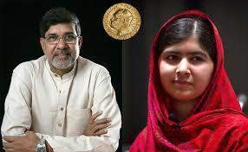

In the past few years, the Nobel Peace Prize was always a matter of debate.

It is pretty clear that this award is quite subjective because, how can one act of kindness be valued over another,or more importantly who decides that a person/organisation has changed more lives for the better over any other? A lot of criticism was heaped, when President Obama was awarded a Nobel Peace Prize questioning what he had done that was deemed worthy of this well coveted award, within a year of being sworn in.

Many speculated that this award was more to ensure that global peace remained and further war was avoided by the superpower, perhaps a plea for him not to follow in his predecessors’ footsteps.

Then when the European Union was awarded the Nobel Peace Prize further speculation rose into the role of the prize as a tool in global politics rather than a momentous occasion honouring the best of humanity. But this year , there is no doubt in anybody’s mind when it comes to whether the joint winners Malala and Satyarthi can be deemed worthy of this global prestige.

Gul Makai has won hearts world over with her expanse of courage and depth of character. I cannot help but draw parallels between her with Joan of Arc who at a very young age mobilised the troops and helped France win the war with a single minded focus. It takes guts to stand up against a bully which very few have,and it is amazing how the loudest voices emanate from the smallest of bodies.

Quite David and Goliath …

Or Katniss and the Capitol…

But, stating it so simply only undermines her journey so far which I am quite sure leads her to being a world leader some day, if not the PM of Pakistan. While many speculate that the heinous attacks on Peshawar has a strong relation to her winning, perhaps the terrorist factions have understood that when one person rises against them it is enough to give an entire nation hope,and hope is quite literally everything in the war against blind hatred, that they would rather have blurring the senses of their nation because that is what gives them power. She could not have put it more aptly when she said,

[The wise saying, “The pen is mightier than sword” was true. The extremists are afraid of books and pens. The power of education frightens them. They are afraid of women. The power of the voice of women frightens them.](https://secure.aworldatschool.org/page/content/the-text-of-malala-yousafzais-speech-at-the-united-nations/)

It couldn’t have been more appropriate for two nobel laureates to share an award, one being the upholder of child rights while the other for education.

Kailash Satyarthi is the pride of the nation for he has been saving innocent souls since the 1990’s . To put it in plain figures his organization, Bachpan Bachao Andolan, has freed over 84,000 children from various forms of servitude and helped in successful reintegration, rehabilitation and education. That is, 84,000 lives that have a second chance in a world,that isn’t quite fair to all.

It makes us proud to call ourselves citizens of the same country as him but that alone does not entitle us to a feeling of goodwill because unless we are pulling our own weights and trying to make the world a better place the bad might dwarf the good in volume.

P.S.-The physics and economics prizes were also given for amazing contributions.

To read about it,follow the links given below. http://www.nobelprize.org/nobel_prizes/physics/laureates/2014/advancedphysicsprize2014_2.pdf http://www.nobelprize.org/nobel_prizes/economicsciences/laureates/2014/popular-economicsciences2014.pdf



##### Net Neutrality

**— Shriram Pydimarri**



Internet is a global system of interconnected networks that connects billions of devices, both wired and wireless, enabling billions of people across the world. The internet is so huge and so powerful that it its utility is unique to each of its user.The world today without Internet is nothing less than an apocalypse.Yet, It is as helpful as it could be vicious. Regardless of the multifaceted nature in defining the ethics of its utility, it is one of the greatest inventions of mankind as yet.

*“***The Internet is becoming the town square for the global village of tomorrow.**

**“ ~ Bill Gates**

The internet was originally created using end-to-end network principle. To a lay man, understanding End-to-end principle and its implementation in the internet is almost brain damaging. But to keep it in simple words, it is this principle which makes internet neutral or a “dumb pipe”. The word “dumb” ,when used here only means that it doesn’t have influence on the data when transferred through its intermediate nodes and that it merely passes on the data from one end to another untouched and unhindered. Internet was originally designed to be a dumb network which provides for the purpose of communication between various end-to-end sources and without these sources, the platform called internet would have no meaning.

According to wikipedia,

“**Net neutrality** (also **network neutrality**, **Internet neutrality** or **net equality**) is the principle that Internet Service Providers and governments should treat all data on the Internet equally, not discriminating or charging differentially by user, content, site, platform, application, type of attached equipment, or mode of communication. The term was coined by Columbia University media law professor Tim Wu in 2003 as an extension of the longstanding concept of a common carrrier.”

Internet Service Provider is the one who brings internet to your doorstep.

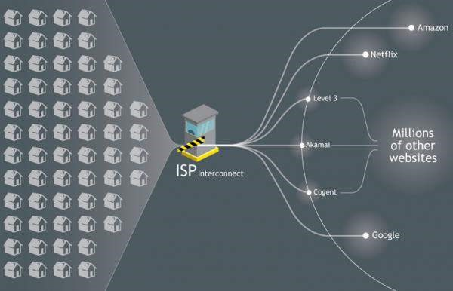

To begin with comprehending this definition, “Net-Neutrality” should be constantly enforced upon all service providers by the regulating or governmental bodies. As of now, there is NO law by constitution which ensures the enforcement of Net-Neutrality in India. The **Telecom Regulatory Authority of India** (**TRAI**) is the independent “regulator” of the telecommunications business in India. There seems to be no hurry of any kind to institutionalize net-neutrality and there have been severe violations by many service providers in the past. Recently, Bharti Airtel changed its service terms for 2G and 3G data packs so that VoIP data was excluded from the set amount of free data. A standard data charge of [₹0](http://en.wikipedia.org/wiki/Indian_rupee).04 per 10 KB for 3G service and [₹0](http://en.wikipedia.org/wiki/Indian_rupee).10 per 10 KB (more than[₹1](http://en.wikipedia.org/wiki/Indian_rupee)0,000.00 for 1GB) for 2G service was levied on VoIP data. This means Skype, Viber and other VoIP (Voice over Internet Protocol) based apps will not run on your mobile data packs.

But to have a holistic picture of what’s going on, one should look at each perspective and discuss the pros and cons on each side. Many internet service provider companies suggested internet companies, like Facebook and Google, to share revenues with them as these internet companies reap huge profits from small investments whereas the internet service provider companies invest a lot in building huge networks involving tedious hardware and cable operation. In a way, certain big internet companies do attribute their profits to these big-scale network providers. But this is, after all, an internet service provider profit-making standpoint. Clearly, Telecommunication Companies are annoyed because of the fact that internet applications like Skype, WhatsApp and other chat based and VoIP(Voice over internet protocol) based companies reap huge profits by providing free calls and other cheaper communication options than most of these telecommunication companies. Suddenly the service providers get a pitiable advantage since chat and voice transfer is the basis of their business and it is being offered for relatively lower rates or for free of cost by the internet companies.

Internet companies on the other hand argue that they face equal competition from other internet companies and if there is high traffic on their web-portals it is only due to the quality of service they provide to their users. In addition to this, they are not at all answerable to any network operating company because the ISP companies do not compete on the same level as these internet based companies do. The business constraints are different and they often come under different regulating bodies. Thus, there exists a fair point on the internet-based companies standpoint as well.

USA has “net-neutrality” guidelines which are enforced reasonably through the famous FCC – **Federal Communication Commission**. Yet, the nature of law is such that constitutional amendments are needed to be made regularly as ingenious business models of MNC’ are based on the loopholes of these regulations. However, there is a huge expectation from the USA’s FCC as it’s law amendment, which is to come by early 2015, will be reflected in many countries.

By compromising net-neutrality, the rules of the basic game play will change and there is a lot of negative consequences at stake. Restriction to access information was always a classical explanation of creating an oblivion. Once an oblivion is made, internet cannot be called a transparent place. Privacy issues arise once Internet Service Providers start controlling what you do over the internet. Service Providing Companies will know more than they have to know. This will give them(companies) a lot of power and scope for more money but this is a threat to the Internet morality and dignity. This is how future of internet might look like :



Once fast lanes are created over the internet and when discrimination takes place in full pace, there will be ground-braking shifts in global market dynamics and all those companies which are immediately benefited from this market scenario will in most probability rule the world, both literally and figuratively. Imagine billions of people being shepherded by Multinational Companies. It is not as if world has not foreseen this dilemma, and free citizens can never be wrong in assuming the worst. All MNCs, politicians, regulators, law makers and law breakers were waiting for this moment to make the most of it.



Thus to solve this paradoxical puzzle over what neutrality means to the free world, we need a judge of highest caliber and credential, the judge is the “user”.

Since the internet is meaningless without the end-user, the user’s stand point should be held in high regard while framing the law. Internet is supposed to be a source of free information and also as a mode of communication. It was the basic underlying principle with which internet was introduced to the world. All these companies don’t really seem to understand the way a healthy system works, or maybe they did not attend their market ethics class 101 .But to provide high quality products for the cheapest possible prices is the unarguable fate of all companies. There should never arise a situation where the user should face any problem due to the internet or be a victim of digital abuse. The vulnerability of a user is manifold if internet does not abide by general equality standards. Users cannot and should not compromise on net-neutrality because the consequences it brings upon them as a whole is too overwhelming to assess. Also, the internet cannot be anything less than transparent to all because not all companies work in the best interests of users, their interests lies in profits and more profits and many companies have controversial boundaries. By obstructing information, companies can create a high potential business model which may not be the way they project it but it is kind of understood that this a golden opportunity to become invincibly powerful. With great power comes great responsibility and often humans tend to forget the responsibility part of power. Users should be aware that false scarcity is being created and that users are deceived into artificial supply- demand infinite circle.

Net Neutrality is being called the First Amendment of the Internet and it is time to ask ourselves some questions:

* Do Multinational Corporations really have a say in what we can access over the internet?
* Wasn’t this whole platform originally made for everybody to share and innovate and promote the ideology of globalization in the first place?
* Does the Internet favor the wealthy?
* Is it not the common-man who should decide the future of internet?
* Is it too much to ask for a democracy in the world’s biggest platform?

In the name of Net-Neutrality, watch this 2-minute song : <https://www.youtube.com/watch?v=UNM8Z1lm9bM>

Step into 2k15 in style!

**— Vineetha Rachamallu**



Now that we have come to the end of an amazing year, it’s time we celebrate the finale and kick off the new year in aplomb and style! So why not begin with a ravishing fresh look this year. The trends this season may slightly vary. The bright hues from the last season seem to have given space to the more pastel and softer shades. The fabrics that are in this season are Chiffon, Crepe and Georgette just like the last one. But surprisingly besides these soft fabrics, Silk seems to be in the limelight. This traditional fabric is going to rule the fabric charts in 2015. The basic trends that are likely to stand out in this spell are:



**Colors**:

The shades that might be marked are pastel shades like beige, coral pink and peach. A few shades of blue like indigo, mauve and plum are also strike a chord. These soft hues are sure to leave a classy yet stylish look on you. But, the color of the year is purple and the hot pink of the last season still seems to be in trend.

**Floral Prints:**



Floral never goes out of fashion! Blooming prints, fine and delicate motifs, floral appliqué work and flower inspired designs never fail to impress. They always leave an elegant and cute impact.

**Digital Prints:**

The geometric patterns, tribal prints and illusory prints are back with a bang.

They are high on drama with a mix of prints and colors and are a visual treat.

**Accessories:**

While last year, the nose ring ruled the jewelry trend, this year it makes way for stunning waist belts, and quirky head gears. The chic bow head gears and ribbon belts elevate the styling factor. You can also complete the summer look with sporty shoes.



The oversized bags and leather bags still remain the top pick this year, but the sling bags are also back in fashion.



Here are a few helpers that will get you through:

1. For the fall, textured knitwear and chunkywoolens are in vogue. Bold colored knits are completely in, be it the classic burgundy or charcoal grey.
2. Leggings are the other hot picks this season. You can wear any bright colored legging under any boring dress to add a dramatic twist to it.



Hope this helps. Have a splendid year and stay á la mode!!

A CHANGED WORLD!!

**— Vaishali G**



What has happened to today’s mankind, where have the colours of LOVE faded???

What wretched time is this!!! There is a battle between brothers,somewhere there is blood and somewhere there is blaze. Who knows what is about to happen!! Everyone’s head is bowed today. The Independence procession has stopped,all around is just treachery, only treachery….

On every dagger there is blood. Today all are sad. Hundreds and thousands of men and women are crying, the courtyards and alleys are crying, all neighborhoods are crying, Salma is crying, Seeta is crying, Quraan and Geeta are crying. Today the Himalaya’s are shouting : where is that old connection and relationship gone? The whole country has been bitten by poisonous snakes, the home’s are set on fire by the lamps owned by them.

Our country was that country, where in difficult times men sacrificed their lives but, saved the honour of their sisters. But now!! Where have that affection vanished??? Now all that is left are the wounds. The wind is blowing backwards,women are shivering with fear, today each veil is in danger,sisters’ honour is in danger, the bangles of the bride are in danger, the ankle bracelet is scared in case it gets wounded today.

Today no home is safe any more,everyone is afraid of being looted. We have seen our country,we have seen the downfall of men. Today even sisters are attacked.!! In some far corner the religion cries…….. Upon whose head can the blame be laid? To whom can we appeal? Those who are fighting ,all of them are our own brothers, all of them here are the accused. Alas, all have forgotten love. Today, it is the blood that is flowing.

Look at this HUMAN, look at the son of the earth, look how mean spirited he is.

He has stolen the happiness of millions,the devastation he has created today,this country will give evidence of that. The result is the enmity with each other . The world is laughing at us and the reputation of our country is hurt. This is the warning of what type of danger????

Today there is poison even in the wind,where ever you look this is what that is happening. This is horrifying. The shadow of death is in each house. The windows are closed, the doors are closed. Everyone are scared. What will happen to these poor souls? What will happen to these helpless people? They can lose every thing,they can be attacked. No saviour is in sight, the Giver is lost in the sky. What is this condition of our world, today we can see the funeral procession of

Love……!!

FOR THE CHANGE, BE THE CHANGE!!

##### Little did I know

**— Mohammed Salahuddin**



With mind full of chaos, entering the gates of the college came the sight of the green plants signaling the goodness of the campus and indeed my future. As I was rode towards the pavilion with my friend, I didn’t know about KMIT as this was a random visit before picking the choice of our college based on priorities.

As I slowly proceeded ahead, I saw a structure to the right, which I now call Audi*.* I was clueless that I would spend an hour and a half after my college hours here in *Audi* just to make sure that my placement doesn’t need to wait and I can give my recruiters a better choice, moving forward I see a hut type construction with the banner as “canteen under renovation” little did I know that it will be my second class room where I’ll handle my assignment on the last day of submission and having finest delicacy let it be *Manchuria* or the *schezwan noodles* which has its own taste with the soft drink and various types of juices and not to forget the *pani puri* with the *alu toast.*

Then my eyes caught the block in white stating “first year block” or the place where I’ll start my future’s base. Little did I know that I would spend a year here with moments that cannot be defined from bunking of classes or standing out of the entrance for being late to college, giving mock interviews for ELCS lab that taught us so much.

Then comes the exciting beats in my heart pronouncing KMIT Radio 90.4 as I always was enthusiastic for extracurricular activities little did I know that it’s actually a heritage site and you can visit that block ‘E’ for whenever you need a yellow slip.

On the direct left the big choice of sports some of them playing as team of six and team of eleven and at one sport where people were random numbers and two floors of classes and the second glance of excitement came as I read KMIT TV Studio that made me get down from my bike making my chaotic mind to clear its way to see a new vibrant choice with spectrum of opportunity.

Well then to ruin my confidence something happened. There I saw a boy(Senior) I hardly remember who he was but his words remained in my brain as a threat. It was a reply which makes me hesitate to put KMIT on top of my wishlist of colleges for Engineering. My conversion was short with him:

Me: Hi! I just want to inquire about the college like how is faculty, management, studies and all?

Boy: Yeah! College is good and faculties, management all are good.

Me: Does anyone rag juniors..?

Boy: Are you going to take admission..?

Me: Mostly….

Boy: Sometimes we rag, don’t worry I’ll only rag you……

That reply left me motionless and confused on how to react, with all efforts I gave him fake smile and rapidly left on my bike. Little did I know that he spoke the truth and I would be ragged by defining myself in three different languages and what made me regret is singing my favorite song.

Whatever happened in my first visit to college convinced me to take a chance and that is what I never regret. Little I knew about KMIT but that was enough to make me feel that this is right for me and my future.

##### HOW TO BUILD EFFECTIVE VOCABULARY

**— Abhishek Bele**



Here’s a joke that was doing rounds on the internet sometime back:

Two trucks loaded with thousands of copies of High School Grammar & Composition by Wren and Martin collided as they left a publishing house last Thursday.

Witnesses were aghast, amazed, astonished, astounded, benumbed, bewildered, confounded, confused, dazed, dazzled, dumbstruck, electrified, flabbergasted, overwhelmed, paralyzed, startled, stupefied, surprised, perplexed, taken aback, traumatized….

While the humor is subtle, it is quite an appropriate example that involves a wide range of words that are closest in meaning. For those who may ask why vocabulary building places such stress on this area- good vocabulary helps, not only in improved performance in the Verbal Ability sections of exams, but in greater enjoyment of the language and in effective communication as well.

At least 15 minutes a day of concentrated study on a regular basis can bring about a rapid improvement in your vocabulary skills. Consider this ,though- if you learned only one new word a day for the next three years, you would have about a thousand new words in your vocabulary, whereas, if you learn ten new words a day, in one year you would have added over three thousand words to what you already know, and you would also have gained a lasting habit of learning and self- improvement.

**A few effective steps you can take:**

***Read, and be aware of words:***

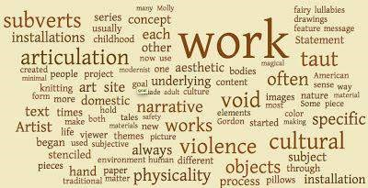

People with low vocabulary levels do not enjoy reading. It’s probably more of a task than a pleasure because they don’t understand many of the words. It’s

important to find things that you would enjoy reading, and to read as often as much as possible, with the idea of learning new words in mind.

***Use a dictionary:***



The dictionary you use should be large enough to contain much more than just spellings! It should contain extensive definitions, word origins, notes on usage and examples.

Get into the habit of reading the entire entry for the word you look up. Remember, words can have more than one meaning, and the meaning you need for the word you are looking up may not be the first one given in your dictionary. Even if it is, the other meanings of the word will help you understand the different ways the word is use.

***Use the internet:***



There are thousands of sites on the web that help the enthusiast, including many sites that mail you a word a day, a vocabulary tip a day, and so on.

Another efficient method is the “Roots- Prefixes- Suffixes” method. You will find this approach useful; because it helps you understand how several words are formed. At least half of the words in the English language are derived from Greek and Latin roots, and this can often be of help in figuring out a word’s meaning from its context.

In a nutshell, the most important factor in successful vocabulary building, however, is self-motivation. A larger vocabulary will help you in academics and at work. Stay keen and look at adding to your word bank constantly. Your effort could not be better spent.

10 Things Every KMITian can Expect from

2015

**— Nithya Gubbala**



###### 1. JNTU will start giving sensible question papers and results

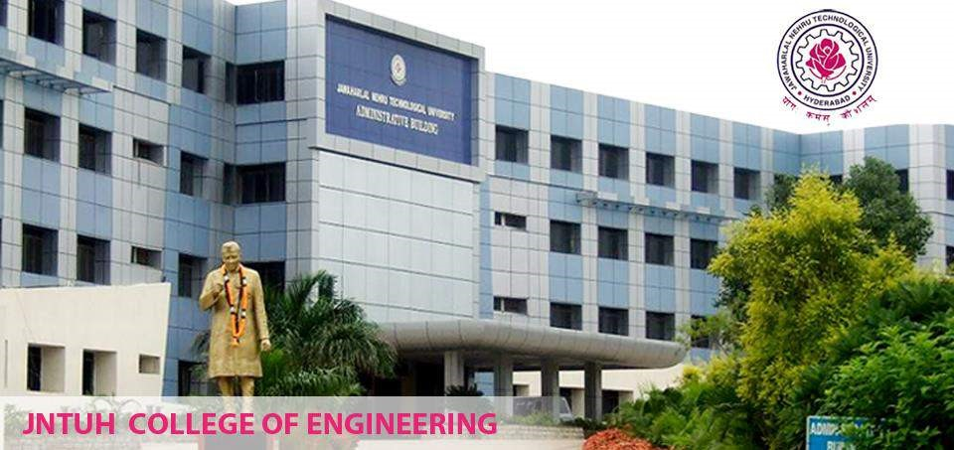

I’d rather let’s pray, that JNTU will give us those Marks we deserve at least from following semester onwards.

###### 2. Microsoft will come to campus for recruitment



Who doesn’t fancy an offer letter from MICROSOFT? Let’s expect that 2015, will bring back Microsoft recruitment to KMIT. And after Srinivas Pushkar one of us will bask in that glory!

###### 3. Our Library will start issuing NOVELS



How many of you have wished to take home novels from our Granthalaya? Count me in! May 2015 grant us this wish.

###### 4. We get to take a selfie with Narendra Modi

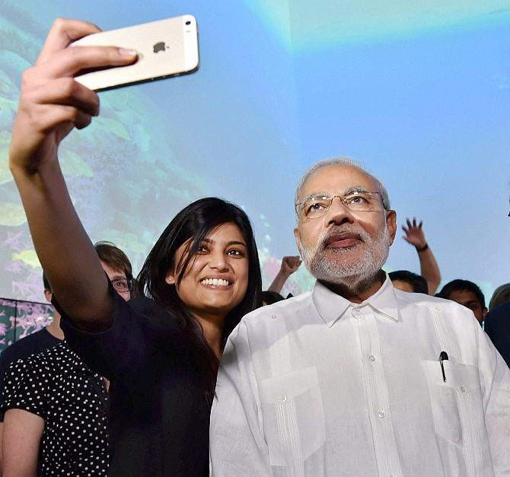

Prime Minister Narendra Modi is coming to KMIT in August yet again, well I hope he will click a Selfie with us and we can all flaunt it!

###### 5. 2015, give us less monstrous VIVA externals

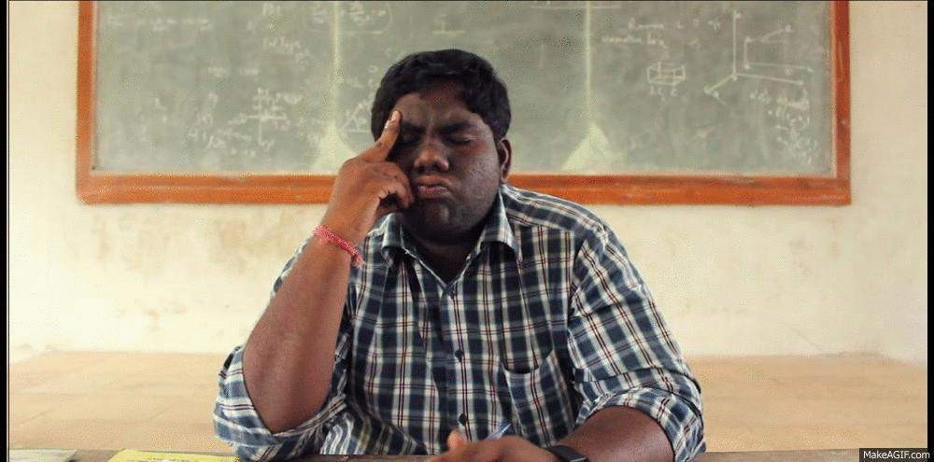

You know what I mean, if only that encounter we face once in a semester can get a little better in 2015

**6. National and Public Holidays don’t fall on SUNDAYS**



This is one thing that will never go off the list, be it any year. Imagine the pain of losing out one potential holiday!

###### 7. Our watchmen will STOP whistling

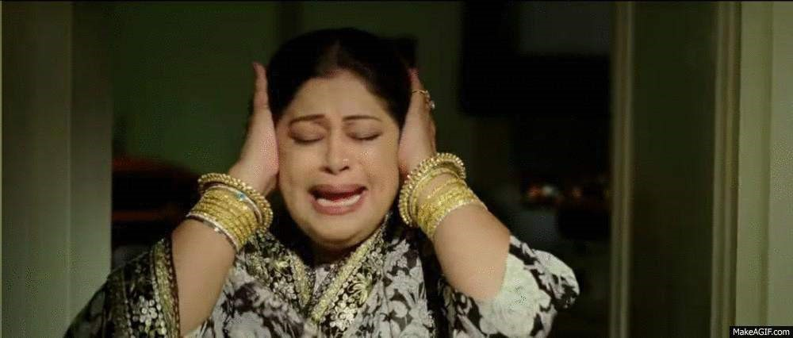

I know this is wishful thinking, but they will stop at nothing until we actually start following rules.

###### 8. Let’s hope KMIT Radio will restart with a bang in 2015

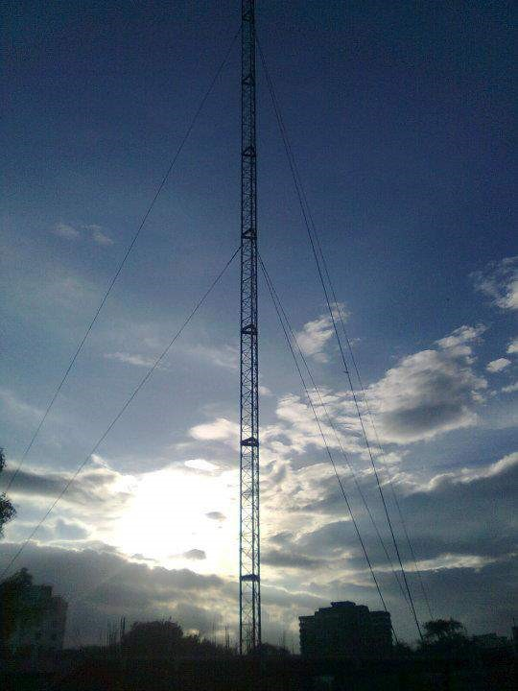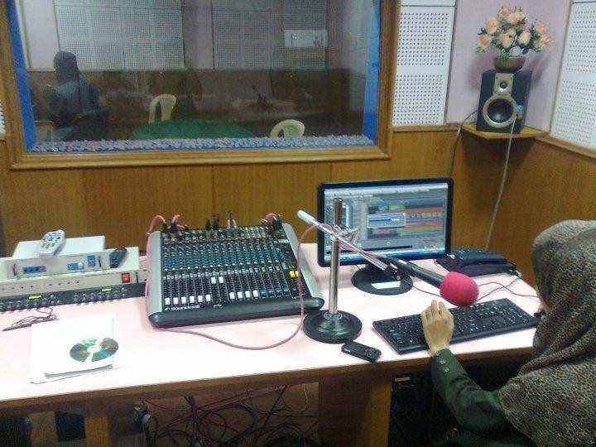

I’m giving away a surprise, you will actually get to listen to your favorite tracks on campus. 90.4 FM KMIT Tarang all the way!

###### 9. 2015 will start with our very own Saanjh-e-KMIT



Saanjh-e-KMIT or KMIT Evening or Annual Day call it with any name it promises to bring loads of entertainment and fun. Wish along with me, that this New Year celebrations will continue with preparations for KMIT Evening

###### 10. We start studying from the very first day of the Semester



Yes yes yes,but what’s the harm in dreaming you know? 😉

Special Mention

###### 11. FREE WIFI in college



If only, we could get access to college WiFi, well, all we can do is Wish and Wait for it to come true!

##### Winter-inspired body lotion

**— Medha Ch**



The ultimate cold weather condition this year has obviously put our skin in terrible condition. There are people on hunt for the best creams to maintain their skin smooth this season. Here is the best way to give yourself a spa treatment at home! This DIY shows you the easiest way to make your own body lotion at home to protect your skin from the cold wave.

**You will need:**

1. 1 tbsp Johnson’s baby lotion (or another mild cream)
2. Half tbsp petroleum jelly (I have used Vaseline)
3. 1/4 tbsp almond oil or olive oil
4. 1 tsp glycerine



Method of preparation–

Add all the above mentioned materials into a small cup. Take a spoon and start stirring continuously.



Continue stirring the mixture until you get an even creamy feel. (It took me about 7 minutes).



Once the paste is smooth and evenly mixed, shift the cream into any likely empty container and you’re done!



Isn’t it the easiest way to protect your skin? Go ahead and try it out for yourself!

Happy Winter!

**Picture Courtesy**– *Niharika Emmadi, 2nd year CSE*.



##### BTW Baba

**— BTW Baba**



***Q)***  Already, 1st mid exams are over and my performance is below expectation. Keeping in view 2nd & 3rd mids and final exams, any extra classes are there for revision of the syllabus? Any concentration on the students getting low scores?

Please advice.

A: As you are still in the first year – the answer might sound a little off but trust me – nobody will be satisfied in their first mids; that’s the reason we have two more. Since the final result will be an average of the three mids, I think you will have to start preparing for the next mid-exam. No matter how many extra classes you attend or how many tuitions you take, in the end, self- study gives better results. So, stop worrying and start exploring the textbooks. Plus, don’t rely on all-in- ones! 😀 They might seem easy but in reality, they are lot more tough than textbooks!

BTW I think I haven’t answered your question properly. You’ve asked whether we have extra classes, I don’t know for sure but I think we haven’t got such programs in college. I advise you to come out of the phase of Narayana and Chaitanya – the spoon-feeding mentality. Don’t rely on someone to take care of you, I hope you have outgrown that.



P.K – All or None?

**— Saylee Bhide**

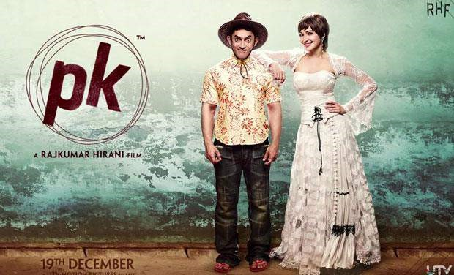

PK (not an acronym!) is an alien who is robbed of his remote controller and so he sets out on a journey to retrieve his lost possession. The way he evolves throughout the journey forms the story-line of PK.

PK’s poster came as a bolt from the blue for many people out there and even managed to irk some moral police. Well, the movie is as bold and symbolic as the poster and may now irk the religious fanatics as well! Just as a new born child, our PK is nude, curious and innocent– a “man-child”! PK moves around with a radio and I did not really understand the symbolism of that in the movie apart from the fact that it saved the movie from being certified “A” rated.

Everything about PK is unique and “literary” – right from the movie title to the songs! “PK” is actually “Peekay” and you must have, by now, figured that out. Songs like “*Chaar Kadam*“, “*Nanga Punga dost”, “Bhagwan hai kahare tu*” and “*Tharki Chokro*” are all interjected to fill in for the dialogues of scenes which needed to be forwarded briskly.

I don’t think Rajkumar Hirani was unaware of the fact that the message he wanted to convey in PK was already highlighted by Umesh Shukla in “Oh My God” which is a satirical comedy-drama. What discerns Rajkumar Hirani’s PK is, one, Amir Khan’s acting and two, variety of religious symbolism. Aamir Khan, with his gollum eyes and elf ears, captivates us with his innocence and charm offsetting the flaws in the movie. Aamir Khan’s *par-fe-sun-ism* is evident in his top notch dialogue delivery. When Parineeti Chopra tried to copy “Hyderabadi” in “Daawate-ishq”, it sounded harsh to my ears. Aamir Khan’s bhojpuri dialogues are beautifully delivered, the nuances of the language so well preserved. Aamir contributes a 3 to my PK’s overall rating of 4/5!

Anushka Sharma friend zones Aamir for Sushant Singh Rajput and hence she is not worth my appreciation. Jokes apart, her acting is quite natural, nothing different from what we saw in her previous movies. I feel she should start opting for atypical roles rather than opting for unusual lip styles. She seems to have outgrown her girl-next-door image. Sushant is the like the title and credits of a movie- meaning literally and technically.

The problem with PK is that you don’t know if you loved the movie or you disliked the movie but certainly not hated the movie. The jokes are raw, naïve and absolutely hilarious!! Most of the public awakening plot is a re-run of *Oh My God!* where news reporters are involved, fake godmen are involved, mass awakening is publicized, social experiments are done yada yada yada. Rest is just *Oh My God!* The way we arrive at a conclusion that PK was right is also very bizarre. You start getting the feeling of ‘so much khichidi for nothing’! There are certain scenes where situations are inserted just for the sake of a single dialogue – nothing short of a bomb-blast! There is a lot of stress on religion-related dictums that, along with the others, forms a basis of the humor track! While you enjoy the humor, you start getting bored of the monotony.

Remember the twins of Dhoom 3? I don’t think the slightly off-head twin died! He came back as PK on our lullified-gola!

This is PK.

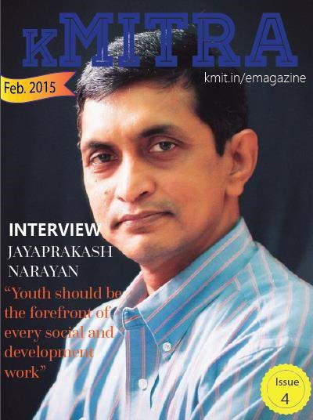

Quizzically Fit!

**— Praharshita Krishna**



“The important thing is not to stop questioning. Curiosity has its own reason for existing” -Albert Einstein

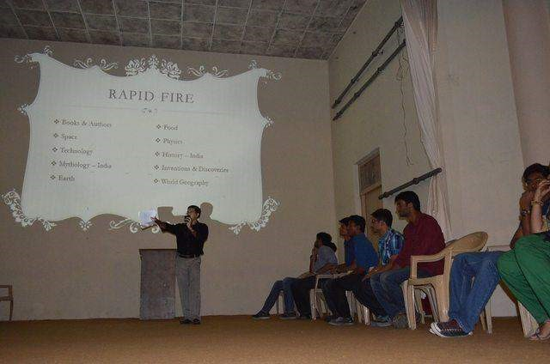

Our thirst for knowledge wills us to rise above all other creatures of nature.

We question and analyze things till they make some sense to us.

We try to look at things from all possible perspectives and then search for the practical applications of the knowledge we have acquired, trying to make our existence on earth a little more meaningful and a little less inconsequential.

We look for acknowledgement of efforts.

Hence the need for quizzes.

A test of our mortal intellect perhaps?

KMIT held its annual quiz in two rounds.

The written prelims on 22nd January, after which only 15 teams were cleared to go on to the final round on 24th January.

It was held in the Sardar Vallabhai Patel Auditorium, hosted by Dr. Siddharth

Ghosh (H.O.D. of the C.S.E department) and Shweta Ma’am (BEC & SS Trainer)

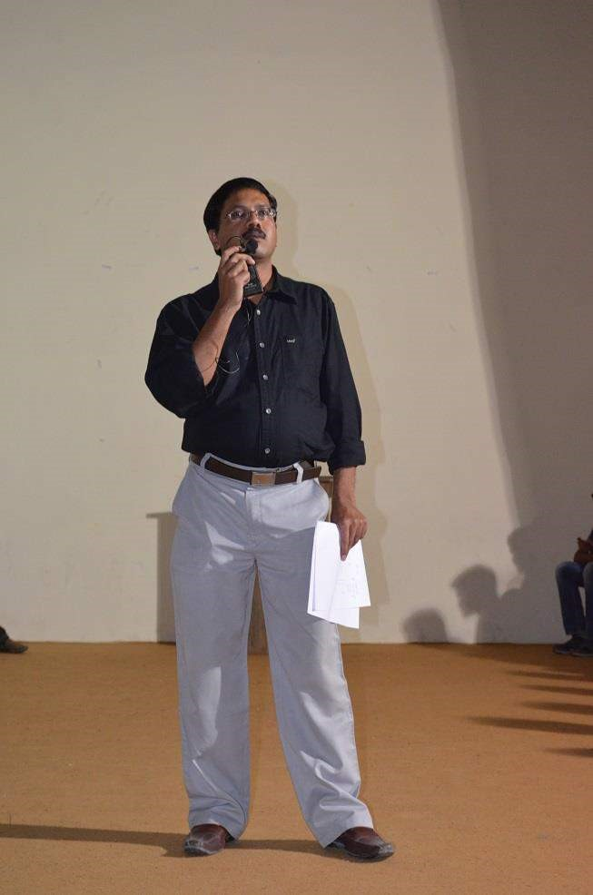

We got to see a lot of audience participation with the questions not answered by the teams.

After the first round of Mains only 9 teams went forward to the Second round, which was a rapid fire round.

The teams with higher scores got priority on the choice of topics.

The third round was multimedia based.

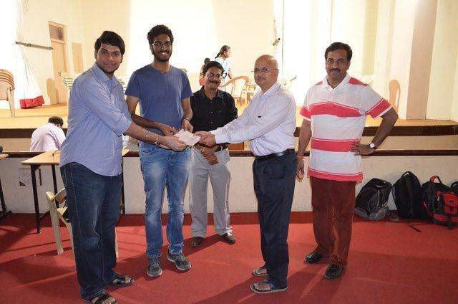

Way Ch and Karthik Raju, fourth year students from CSE Branch, were victorious and walked away with a cool thousand rupees.

The first runner ups were Sumith and Aashish.

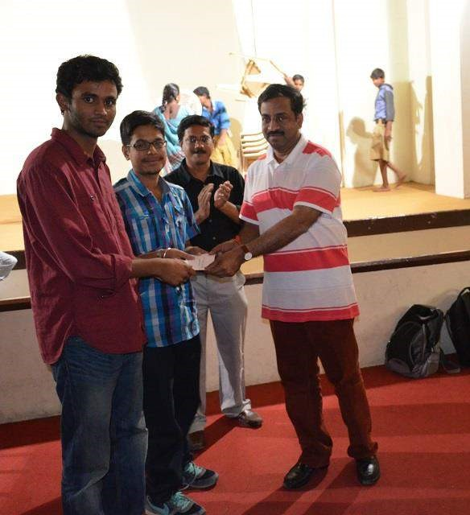

And the second runner ups were Anirudh and Aashish

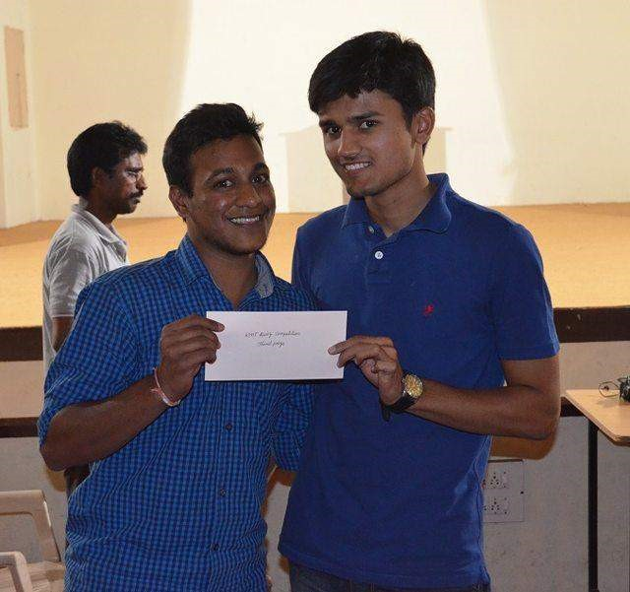

With each round , the crowds excitement rose and the questions were interesting.

People are definitely waiting for the next event on the agenda,which is a Short Film Festival – coming soon….!

Can’t wait to see the KMIT’s Movie enthusiasts bust out their movie reels and show their talent.



##### 10 things that we do in the First Month of College

**— Akanksha Bodhankar**



###### 1. Forget the Past

What would be your reaction if someone asks about the past year? I would say “I don’t even remember about it and *All Clear* is my favorite phrase” Let’s just hope that there are no backlogs 😉



**2. Where have you been?**

College would be boring without our *besties* wouldn’t it? Spending half of the day with friends is just so different from meeting at MCD and IMAX. Eating together, studying together and bunking together, only your gang knows the crazy you. We surely share a special bond with them.



###### 3. It’s so boring

The classes have just started and the lectures are already working as a lullaby for you. In the holidays we say “I’m bored of holidays, when will the college reopen” and now we are already waiting for the next vacation.



**4. How do I impress?**

It’s the beginning of the semester and the time to impress the lecturers. So, we won’t have the attendance problem later. Flaunting your skills before the lecturers is not new.



###### 5. I got you

Haven’t you ever counted the number of time a lecturer says “Okay?” We have always been great mimics when it comes to our lecturers.

Rather than concentrating on the lecture we end up observing how our lecturer behaves. We have a special talent of mimicking their slang.



###### 6. Yummy Tummy

Homemade food is always tasty, but don’t you miss the delicious canteen food? After all, our college canteen is famous in and around campus. So, we rush to the canteen every other day to gulp our favorite dish. And that promise of “I won’t spend much in canteen” is meant to be broken.



**7. Let’s Bunk!!! But how??**

“I don’t have the mood to attend classes” “C’mon let’s bunk” said one; and that was enough for your gang to escape the college. But wait guys, do you think it’s that easy to bunk?? LOL at least not in KMIT (If you know what I mean)



###### 8. Procrastination is my birthright

All of us decide to study from the first day of college. We just hope that it doesn’t end up to be last minute work again. But, aren’t we experts of last minute preparation? We are engineers, after all



###### 9. Textbook search begins

It’s been nearly a month, yet you don’t have the textbooks. The assignments need to be submitted, that’s when you remember about them. And now you are searching for books in library. But, you are late and you always get to hear “Those books are already borrowed”.



###### 10. Let’s get started

The last semester was the past and so was the sem break. But, you are still in the mood of “Exams done!only fun now”. The mids are nearing and at last the dusty books will be opened. And don’t forget about the heaps of incomplete assignments. So, buckle up guys 😉





##### Crane vs. AK-49

**— Praharshita Krishna**



If you haven’t been paying attention to the news lately,something quite interesting has been happening in Delhi.Mrs. Kiran Bedi has been drafted by the big guys to play for them against AAP .

Considering the fact that if Arvind Kejriwal hadn’t tried to rebel against himself with “anarchy” ruling the day,this just might not have happened.

It is unfortunate that Kiran Bedi entered so late into the game (i.e. Indian Politics) because frankly, we could have avoided a lot of high octane shouting on national television with Mrs.Bedi waving the Oxford English Dictionary at people. Her support for BJP had started pretty early on,so this seemed inevitable in hindsight.

While many may call this “Horse Trading”, having been shoulder to shoulder with AK-49 in the times of the Jan -Lokpal bill (which for some reason has conveniently been forgotten),or perhaps she wishes to enforce the agenda while in the government. After it has won clear majority, while she was tweeting against them countless times before election results.

And while the country is still waiting on the black money to return to homeland, which if it does will single- handedly tackle any and all funding issues we might have for a very long time, we get to see Kiran Bedi who was anti-corruption join

BJP who she has accused of said corruption. 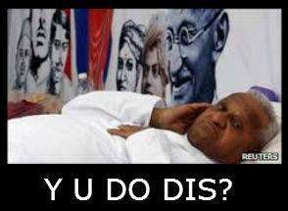

But curiously, the Jan-Lokpal bill will not be on her agenda(Ann-Shun forgotten), for she states her first priority now is women safety which I completely support because no-one can understand the gravity of the situation more than a woman(which is saying very little for the previous Delhi C.M.-immortalized by Katrina Kaif- her name is Sheila), more-so for a woman who has braved a highly male-dominated field and faced gender discrimination first hand.

She has been through the fire and I am sure we trust her to tackle the rising hate crimes with the sole determination with which she turned around the prisoners of Tihar Jail.

Her agenda consists of 6 P’s

‘The first P is people and that is parents, principals and the community leaders (the preachers). People is a very vital component.

The second P is the politician as the politician gives you the rules, it gives you resources, it gives you regulations, it gives you law. If you notice, the law came so late after the Nirbhaya’s case and even the law against sexual violence came by an ordinance. So, a politician has a very important role in strengthening laws. The third P is the police and it is for reaction as well as response. We then have the community policing, which is for prevention and investigation.

The fourth P is prosecution as to how fast is the trial, while the fifth 5 is prison. This is very crucial as in the past many rapists were those who were released from prisons such as the Shakti Mill and Uber case.

The last P is the press – how they deliver and communicate. These are the six P’s and this is the crux. They need to meet regularly with a strategy.’

While I am cautiously optimistic about women safety, it seems futile to keep high expectations of any party really handling this problem because this is a problem that has deep roots in who we are as a patriarchal society, so would she be able to change an entire culture, more-so the identity that lies in it?

But that’s just my jaded opinion, and anything is better than the rioting bluefaced,anarchist she might contest against.

But you never know, maybe the reservoir of Mobil oil he should have collected by now just might fuel him to the finish line.

Aaah ,probably not, so don’t let the broom hit you on the way out!

##### Interview: Vikram Aditya and his ShadeS

**— Akshay Chandra L**



Music! Music is the key to creativity. Its the universal language. It makes people from different parts of the world come together. It makes education enjoyable. Maybe that’s why we remember the poems and rhymes more than those tiring multiplication tables. Music has no barriers, no age, no constraint. The modern world now has a whole new definition for music. We have Electro, Dubstep , Folkstep, Slouch Rock, EDM, CDM and so many we don’t even know that exist.

Rapping has always been the ‘thang’ for most youth. The artists out there make it look so easy. It isn’t. Here is a candid interview of a rapper who raps for his own band, **Vikram Aditya a.k.a Vik** from ECE Second Year of KMIT.

***What’s your band ? Tell us about it !***

“Our band is SHADES. It’s a rap/hip-hop band of two, my friend from School Mahadeva and myself. We got signed in 2013 but right now we are going independent.” Why ? “Trying to find the independence in making music maybe.”

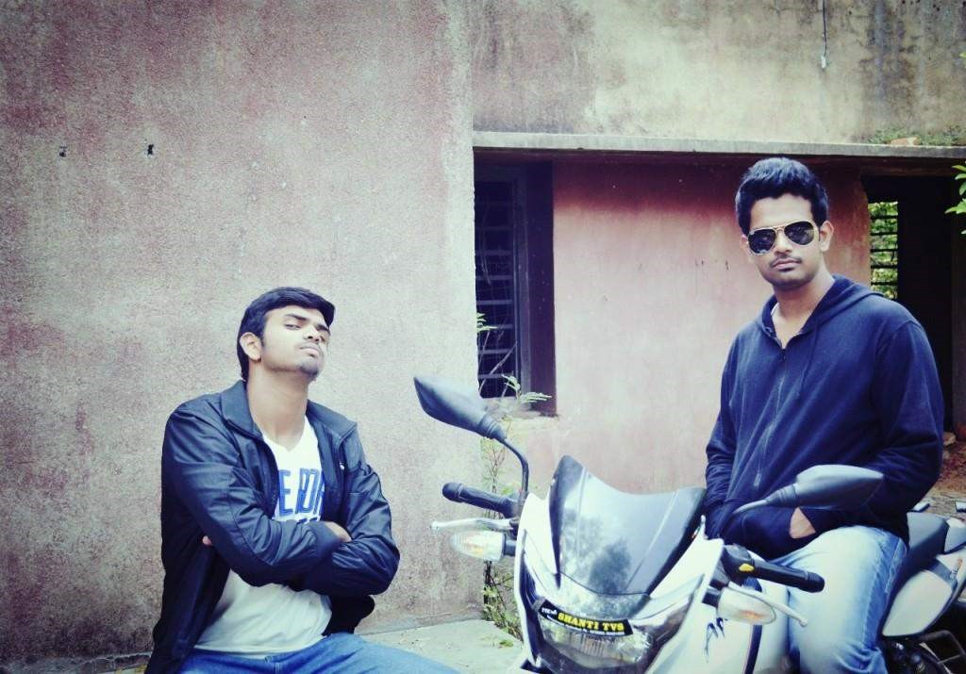

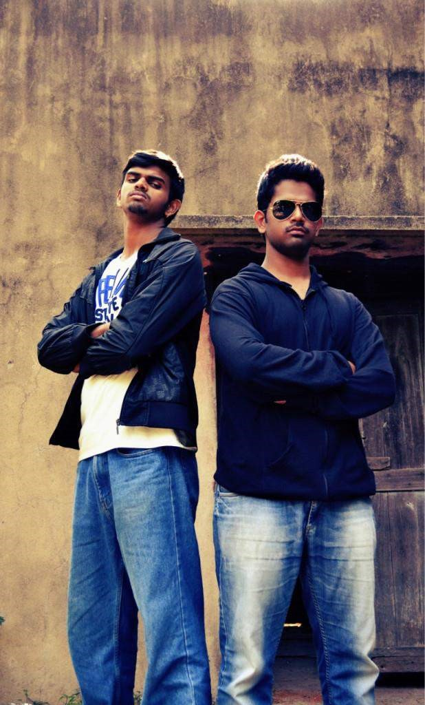

Vik(on the right) on his band’s posters.

***Who was your inspiration? Who do you look up to right now?***

Tech Nine, Eminem, 50 Cent and Nas have been my inspiration. Right now, I look up to my fellow rapper Mahadeva a.k.a Maahaa.

***When did you first start rapping?***

I got interested in it when I was 16, I mean I used to listen to raps on my iPod.

Then I started writing lines for myself when I was 17.

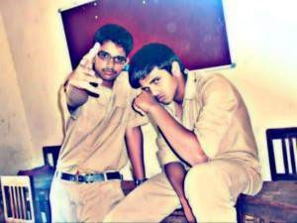

16 year old Vik (left) with his fellow rapper Maahaa.

***How supportive were your family and friends with this?***

Honestly, in the beginning, they did not know what I was up to. They always wanted me to give my first priority to academics. But after releasing a few singles, they started being very supportive. And friends, I always had their backs.

***How your family react to your first single and what did was going through your head?***

My parents were really happy with me, they were always so appreciative. Our first single was ‘The Indian Emcees’. It’s about our country. I was nervous of course, but we were expecting a good response as it is about India and how we perceived things being an Indian. And we were appreciated by many.

***Engineering itself is a big task. How are you managing both rapping and studies? They say it’s not easy.***

It’s not easy, definitely not. But somehow we make time for music no matter what.

We’re doing what we really love, so finding time for making music isn’t really a big deal you know. And studies, I’m not really a super studious guy, but I manage to keep up with the academics.

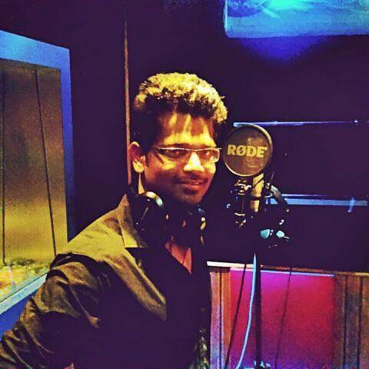

Vik at the studio recording for ‘IRKED’

***Do you perform anywhere? Like in clubs etc.?***

I don’t do it on a regular basis. But Yeah, I performed at a few places.

***What do you hope to do with your music?***

I just hope my interest in music takes me to a level where my family will always be proud of me. I believe I can make something in this someday. I am fortunate to have so much support from my family and friends and now from you guys as well.

Thank you so much for the interview. It means a lot to me.

“*We are slowly but surely making it bigger*!”

Let’s just hope Vikram a.k.a Vik makes it big (really big) someday and inspire many more to not give up on something that they really love to do. kMITRA wishes Vikram all the luck and success.

Check out his recent single on Youtube, here’s the link: <https://www.youtube.com/watch?v=O5nKXR-aNRQ>

Check out his band’s Facebook page here:

[www.facebook.com/ShadeSquad](http://www.facebook.com/ShadeSquad)



##### BTW Baba

**— BTW Baba**



**I’m a person who can work only under stress. Before exams I procrastinate, one day before the exam I panic and don’t study. I look back and regret. How do I stayed focused? How do I motivate myself, constantly?**

###### –anonymous

**Answer:** I’m glad someone has asked that question, I share similar habits. It’s the same with a lot of us but instead of procrastinate people panic, before the exams and they mug up or read whatever they can and write some rubbish on papers. But, let me tell you there’s no easy way to stay focused

Even if I try to answer this question just by giving some easy Steps I would be lying. Usually hunger drives people to do great things and helps stay focused on what they want to do.

It can be hunger for knowledge, hunger to become popular or hunger to do great things.

There’s no easy means of finding constant motivation unless you have a big dream which doesn’t let you sleep until you achieve it. So, instead of trying to stay focused or get motivated try to search for what’s your real goal that **doesn’t let you sleep**.

###### Basketball Tournament 2k15

**— Akshay Chandra L**



Sports are very important in our lives. They say it can make life happy and relaxing. How is something physically tiring and mentally challenging called relaxing? Well, a lot of factors add up in a life of a sports person. A person learns more than dunking the ball or shooting a goal, he learns time management, responsibility and brotherhood. The list goes on. Our college luckily provides all sections of sports. But it would not be an exaggeration to say that irrespective of the unexpected holidays and college events, you will always find at least 4 students playing in our Basketball court. Of course football and volleyball and others have got great craze in KMIT but the thing about basketball is just different.

To encourage the spirit we students and coaches have towards basketball, KMIT recently hosted an “Inter Engineering Colleges Basketball Tournament” on the occasion of Platinum Jubilee of the Keshav Memorial Educational Society, which reached out to the colleges all over the district. Sri T. Padma Rao Goud, Minister for Excise and Prohibition & Sports and Youth Affairs was the Chief Guest of the event alongside with Sri C. Ram Chandra Reddy, M.L.A. of Khairatabad. It was delightful to see Sri C. Ram Chandra show us some basketball skills of his own.



The College officials opened the tournament with a gesture of flying Tri-Colour balloons into the sky.



Title Trophy of the tournament

Although the preparations for the tournament started a week earlier, KMIT had given us a brand new basketball court.

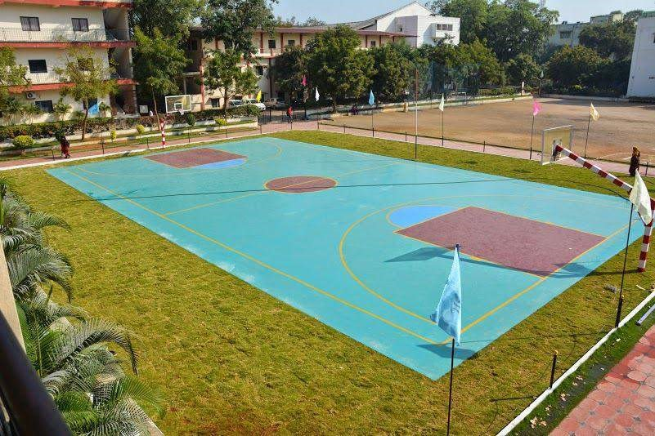

Basketball Court

The tournament was hosted very effectively giving the visitors and the spectators a quality experience of all sorts. It started with an eye catching dance mob from the students of KMIT, cheering the players and the hosts up right from the beginning. Twenty teams took part in the competition. There were games which had a point difference of 21 and games that went on for beyond the extra time. It was a treat to all the basketball lovers.

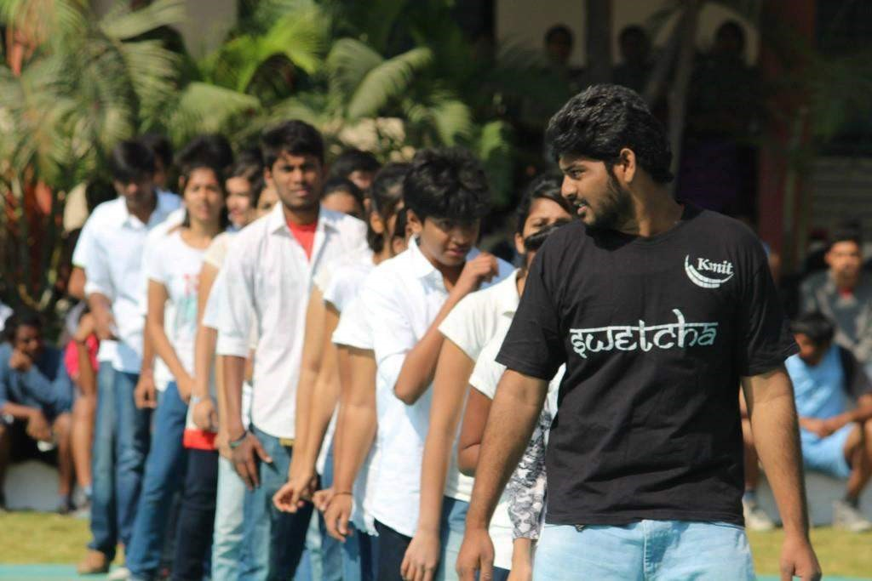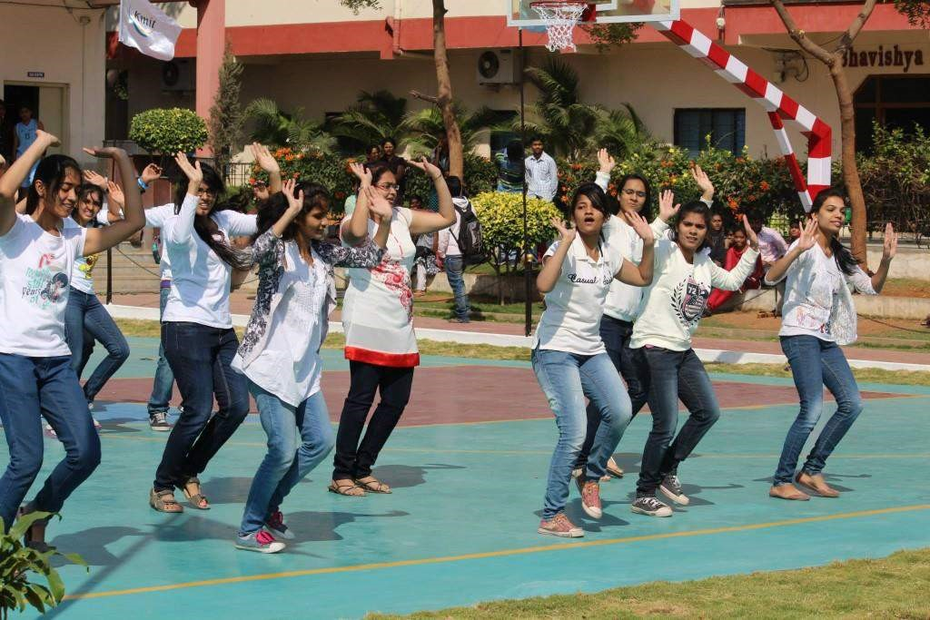

KMIT Students during the flash mob.

It was a delight for everyone to see some crazy dunks, clean tackles and so many 3-pointers. There were more than 4 teams that played like they deserved the title but at the end of the day, there is only one winner. St. Martin’s Engineering College was the team to win the title in the end showing their authority right from their first game. They were at their best right from the beginning of the tournament. MVSR College was the runner up in the tournament, showing everyone some decent basketball play as well.

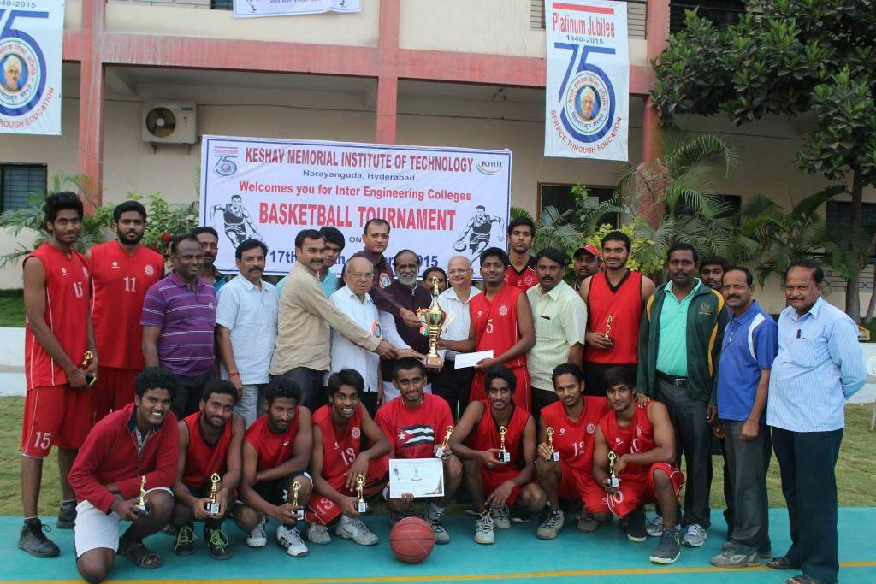

*Title Winners: St. Martin’s Engineering College*

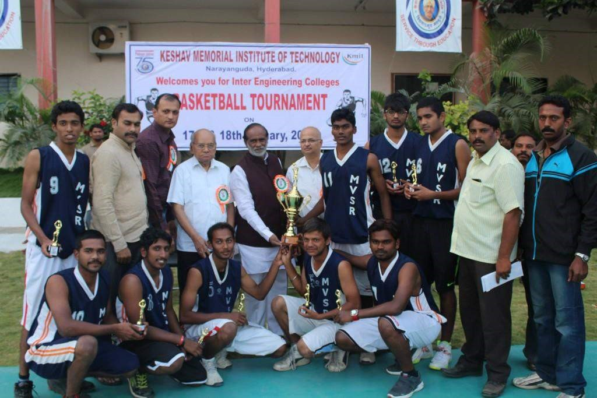

*Runner ups: MVSR Engineering College*

KMIT and Muffakham Jah were beaten in the semi-finals by St. Martin’s and MVSR respectively. KMIT was unfortunate to lose in a nail biting semi-final with a point difference of 2(29-31). We were just 1 basket away from the win. Irrespective of the disappointing end to the cracker, KMIT players have shown us their own class of play.

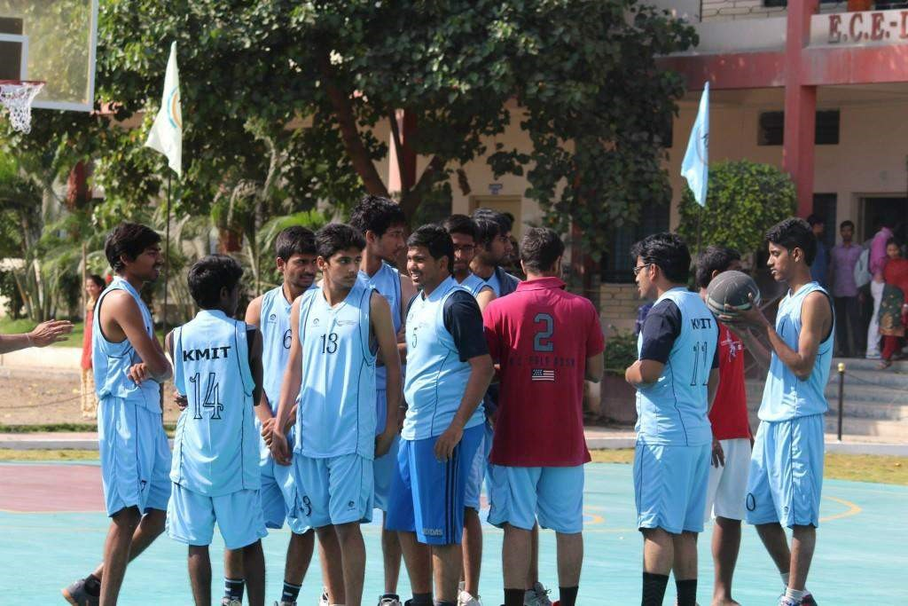

*KMIT Players before the semi finals*

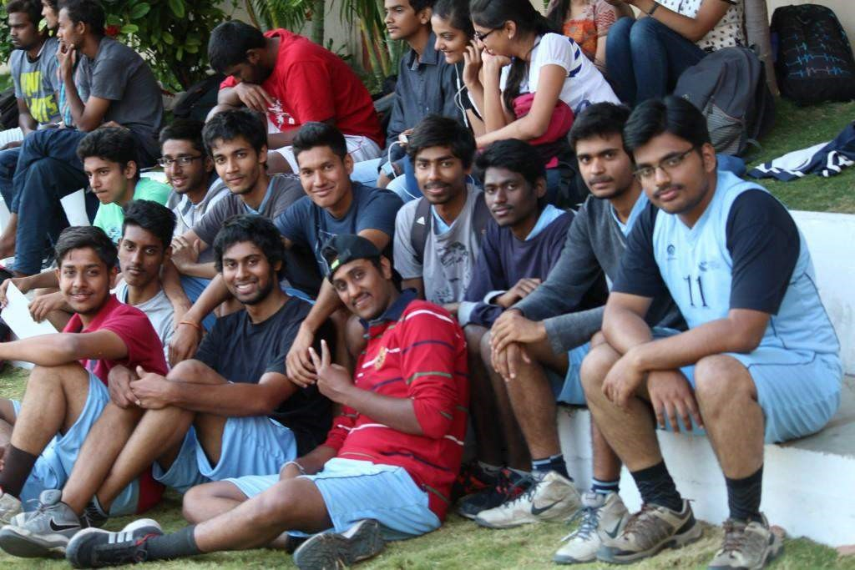

*KMIT Players on the sidelines*

When asked about the tournament, a KMIT player from third year said,” Not only did this tournament bring out the potential in us, but it showed us that we are the perfect basket of combination players. Little did we practice as a team, but on the day we somehow stood against the seasoned players of the city. Starting on the right note, we played St. Peters and beat them hollow. The win got us the right confidence we needed to take on other rivals. As the tournament progressed, our opponents started getting tougher but our determination and home court advantage took us to the semi finals.”

He then added, “The semis were tough because we knew our opponents well but unfortunately the aggression, sun, not to mention, the adrenaline rush pumped us up followed by a feud and things started getting messy. At the end, one small mistake cost us a basket and we lost. But, we are happy that we didn’t give up and fought till the very end. We will remember this event not only from learning point of view but also for the fun we had with each other. One of our best players will leave college this year, and we hope that the juniors will fill up the gap. Giving the credit to our sports in-charge Mr. Laxmi Narayan, we hope that more such tournaments will be organized in the campus to encourage our team, new players and finally help us fulfill our dream of becoming the best in the city.”

In a way, KMIT has set a bench mark among the colleges in the city. All in all it was a wonderful experience for both the host and the visitors, giving us some good memories and motivation for the players to work harder. Let’s hope that we’ll host many more tournaments in the future and encourage the sportive spirit of the ‘engineers in making’.

##### Top Fads Among Youth These Days

**— Way Ch**



###### 1. Using the word ‘*chutzpah*’ like it’s legit

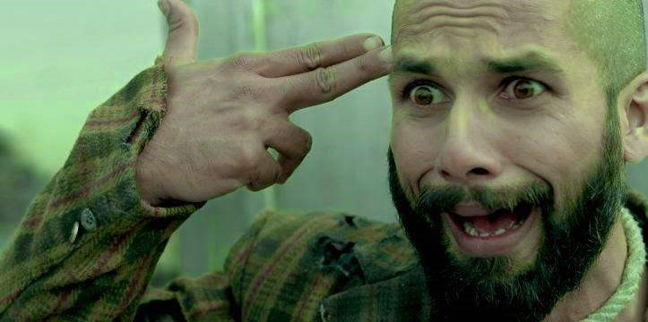

1. Claiming themselves to be avid book readers, even though they have only read books by authors such as **Chetan Bhagat** and **Amish Tripathi**.

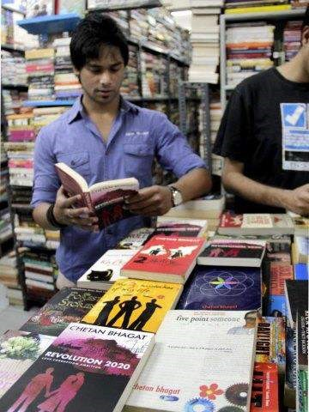

1. **Hookah or any smoke** for that matter even cannabis. Using the term YOLO

(You Live Only Once) as a justification for for smoking, boozing, partying, etc.



1. Using the term “***bucks***” instead of “Rupees” when dealing money

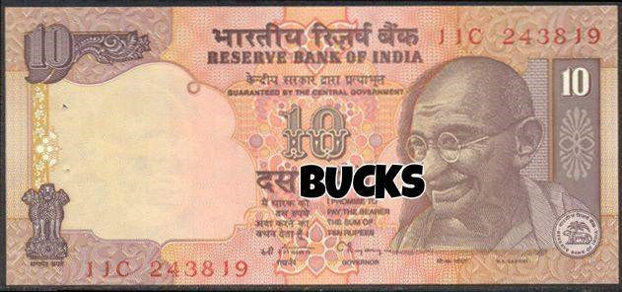

1. Quotations as Picture Captions which need not be related to each other whatsoever. It can be a *selfie* in a washroom with a quotation from Einstein I mean whaaaaat?!!



1. Facebook Check-ins for every place they go!

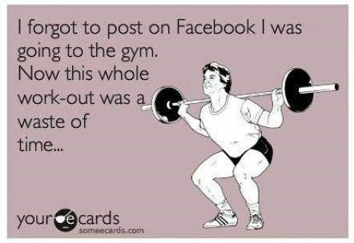

1. Watching TV shows dominantly american (Game of Thrones, Breaking Bad, Big Bang Theory -this stuff is like centuries old but people still watch it) and terrible Indian ones like Splitsvilla and Bigboss. That’s the reason**aliens** don’t visit our planet. Thank God Roadies is out of the league!



1. Modi wave (I bet half of those who support Modi can’t name his constituency, leave that they don’t even know the full form of NDA)

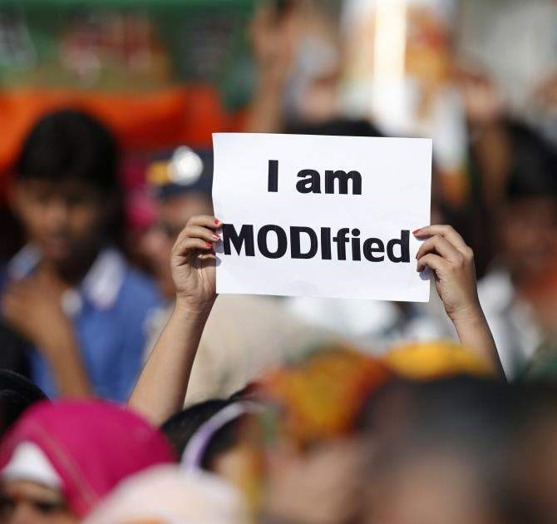

1. *typ lyk dis* as if it’s cool (*by the way* it’s definitely not)

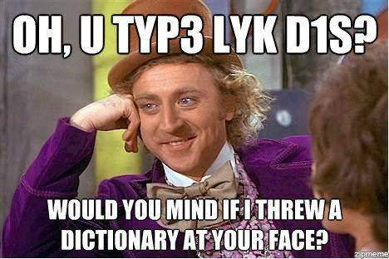

1. Hating Justin Bieber for the reason they even don’t know.

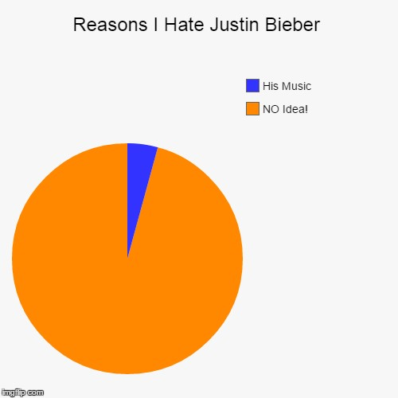

1. Photography Pages on Facebook owned by every person who owns a DSLR.



1. Nolan fever (yeah the same Christopher Nolan from Batman series, Inception and Interstellar) – behaving as if they know everything about Nolan and his movies and if someone doesn’t like his movies; Nolanites start abusing them because Nolan is God.

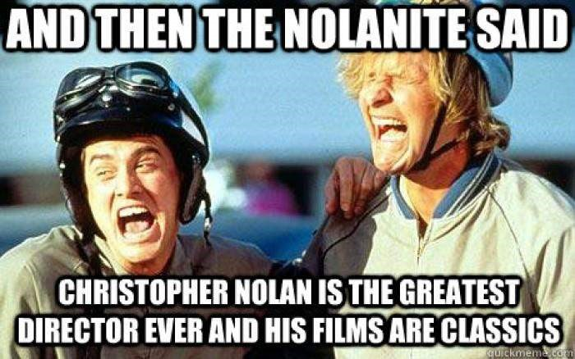

1. Wearing a Che Guevara T-Shirt without having any idea of who he is and no idea that he was from Cuba

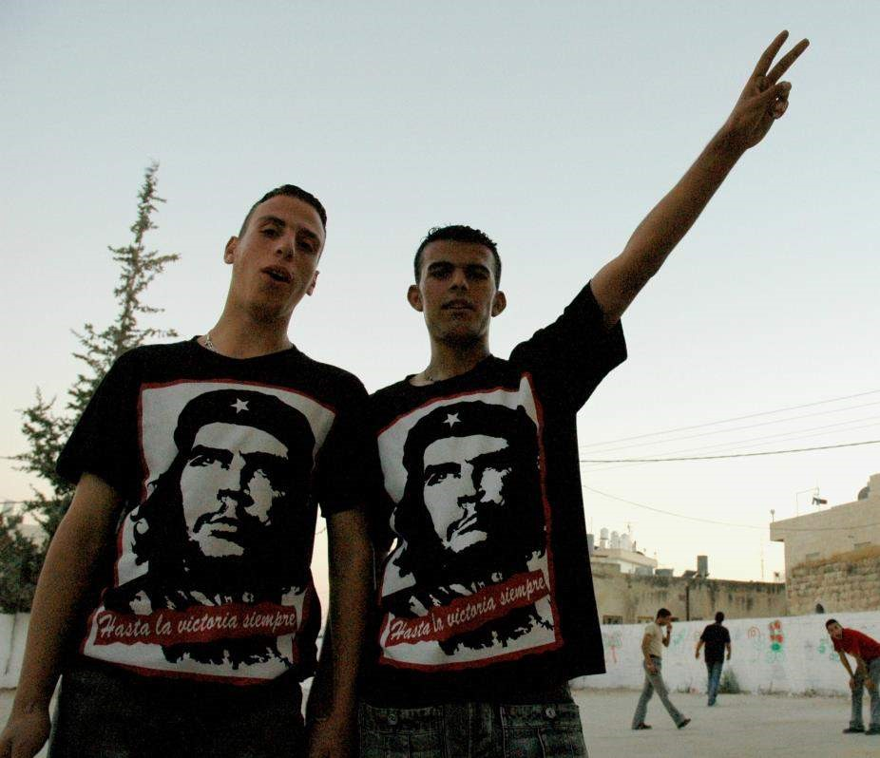

1. Listening to **Yo Yo Honey Singh** songs; these are the same people who think **Pitbull** is cool



*Source :* [*Quora*](http://www.quora.com/India)

###### Dosa Addas

**— Medha Ch**



Food and students, they just team up so well! Who can say NO to have a Paneer dosa or Butter Dosa before coming to the college? Butter Cheese Dosa, 70mm Dosa, Paneer Dosa, Masala cheese Dosa, Malai Dosa, Butter Masala Dosa, whatever we want, with a guaranteed yummy taste.

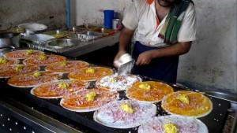

Well, it’s not just *Pragathi Dosa* or *Ram ki bandi* anymore, there are few ‘Dosa Addas’ around Narayanguda and Himayatnagar selling really tasty, mouthwatering Dosas!

Here are two ‘Dosa Addas’ nearby our college, selling the city’s favorite Indian tiffin.

1. Mahalakshmi tiffin centre

Just inside the lane adjacent to KFC, Himayatnagar is this tiffin center selling different Indian tiffins, including a variety of Dosas. The surroundings around are neat and clean, the atmosphere is also healthy, making it a great choice to go to, whenever you’re in a mood for Dosa. The price of the Dosas here is little higher than other addas but it’s definitely worth the cost. Green cheese Dosa is famous here. For the tasty tiffins that they make, there is always moving crowd here. For those people in love with Dosas but have neatness-issues, Mahalakshmi tiffin center is the *best* choice.

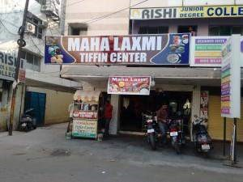

**2. Rahul Tiffins and Fast food centre.**

Near Vijaya Diagnostic Centre, Himayatnagar, Rahul tiffins sells the tastiest tiffins in the area. Though the surroundings are not too clean, the food is fresh and fine. The best Dosa available here is the Butter Dosa. Apart from dosas, the idlis are also famous here. This place is also busy with people coming for tiffins in the morning. Rahul tiffins also has a branch in Narayanguda but it is not at par with the first one. Rahul tiffins’ Dosa can always be given a try.

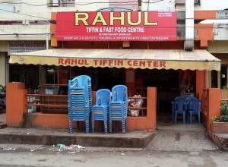

All in all, these two places can always be looked up to when we’re running late to college and have to grab a quick, yum bite!

More food points to be coming up. Watch this space for more! P.S: Don’t forget to tip the waiters!

##### Saanjh-e-KMIT 2015

**— Praharshita Krishna**



The sudden increase in number of college activities has Kmitians positively brimming with excitement…

With three events in a span of a week you could feel the college alive with people bustling out of classes to get where they want to, while the non-participants took the liberty to bunk with the rest of their friends to show class solidarity… *Saanjh-e-kmit* was one of the biggest events in the history of KMIT marking the platinum jubilee of Keshav Memorial Educational Society (KMES) What was amazing is the huge amount of talent that was sparkling on stage. It was unprecedented to see so many people come together to organize many skits and performances that even the local newspaper-Eenadu covered it!

Some skits were amazing in terms of content and acting…

A few that stood out for me were the one about suicide and the sci-fi time machine/robot that had everyone in stitches.

A message was clearly sent to the students about the futility of taking one’s own life but not in the preachy and boring way that you would expect. The dialogues were crisp and the delivery was above par…

The sci-fi robot-time-machine was amazing in concept…

We can understand how hard it would be to explain something like that on stage and make it funny rather than a lecture on science, but they managed to impress us all with their trick ending with the message that even the good times pass away regardless of whether we want it to…

What surprised us more was the beautifully graceful dance number performed by our lovely but usually stern lecturers…

It definitely set the whole crowd hooting in delight, to see them let their hair loose…

And then just three days later we had the traditional *Patang Utsav* where people had a jolly good time flying kites and visiting stalls put up by our creative kmitians.

The treasure hunt was no less with students puzzling over the riddles and searching for more clues…

“To stimulate creativity one must develop childlike inclination for play and the childlike desire for recognition.” – Albert Einstein

I couldn’t agree more because I am sure that people are invigorated and refreshed after the JNTU exams, and are willing to face another semester and show their colours (the flying ones).

“All work and no play”?

That no longer applies to KMIT-We do it all! 😀

Check After movie of KMIT Evening by kMITRA here <https://www.youtube.com/watch?v=HWJZ2wHLXE0><https://www.youtube.com/watch?v=Ns1nKPijy4s>

##### A.T’s Future

**— Aashish Sharma**



There was a guy called A.T, he was a regular guy. He was born, earned his food and shelter, reproduced and died. No one had any complaints on him. But people like A.T are more of a liability than an asset for today’s youth. We are burdened with an additional responsibility of creating a sustainable future. There is an exponential growth in the global population with India leading its way to be the most populated country on earth. With such an increase in the population, the opportunities in country are increasing, and productivity of the whole country is shooting up. By the next census, the average age of an Indian will at least be 29 if not less, it means that the country is getting younger and for the first time in the history India will be run by the rule breakers of the society. We must start being reasonable with our actions and with resources like Internet available in everyone’s pockets, it is not difficult to filter out the bullshit that we are fed every day. We are living in a glorious period of time where even miracles can be reasoned and the smartest thing to do right now is take ourselves a little more seriously and start rationalizing our actions.

###### The Perks of Being a Wallflower

**— Akanksha Bodhankar**



The perks of being a wallflower is a deep novel written by American author Stephen Chobsky,which is all about the teenage roller coaster ride. Fifteen year old Charlie is the main character of the story who is sensitive and shy, basically a wallflower. This story is beautifully written in the form of letters addressed to an anonymous person by Charlie also includes a poignant poem which is supposed to be a suicide note.



As the story begins Charlie loses his friend Michael, who commits suicide. This makes Charlie emotionally unstable. At the same time death of his beloved Aunt always haunts him as he misses her. Meanwhile, his Middle school begins and he comes across many new friends who are mostly his seniors. He hangs out at parties with them and eventually his friendship with Sam and Patrick brings a twist in his life. He falls in love with Sam, who is a confident and bold girl, and cares for Charlie as a good friend. Patrick is Sam’s step brother and a social guy who turns out to be gay. Charlie enjoys the pleasures of life like never before and lives the infinite moments with them. The catching quotes like “I swear we felt infinite” brings a sense of happiness for the readers. But, unknowingly his life tangles with the dark side of teenage life and he finds himself dealing with relationships, drugs, alcoholic problems. The memories of Aunt Helen and the serious issues with his family and friends turn the story into a painful one. The rest of the story illustrates how he gets over it. At the end, however, unbearable pain leaves Charlie hospitalized. He then, peacefully thinks about his future and flushes away past and prepares himself for many more chapters of his life to unfold before him.

*This is the brief summary of the story. As you know what really happens at the end now discover yet another ending for the story here:*

**EPILOGUE**

August 23, 1992

From the day Sam left, I am daily visiting my Aunt Helen’s grave. I stay there for long hours, sometimes even the entire night and my parents drive me back home. Everything would be the same until that dream. It changed my perception towards life.

I was on a sea shore and started walking towards the land. Somewhere far behind the mist, I saw Aunt Helen’s grave. As I moved closer, I was surprised. It was me, grown up, no more a teenager. I was offering flowers to my Aunt Helen. I was more surprised when I observed that a hand was holding mine and it was Sam’s. She was as beautiful as she is now. I saw myself happy and out of all the pains, my heart was at last in safe hands. I moved towards them but, in seconds the illusion was gone.

I was lost in thoughts, but they were interrupted by someone’s weep. I followed that sound and I found myself in an illusion again. Many people had gathered for someone’s funeral. I stepped closer and there were my friends and my family. My mom was crying continuously, my dad mourning and my sister weeping and my bother consoling. Near the grave, I saw a beautiful girl silently shedding tears. I heard her whisper “Why did you do this”? It was Sam’s voice. I was traumatized when I saw my name on the grave. I was taken aback and again in seconds the illusion was gone.

*“You have to choose Charlie, You have to choose”* many voices whispered.

I was restless and no sooner the dream broke. Many thoughts arose in my mind “What a frightful dream was that?” “Why did I do what Michael did?” but then, I am glad that it was a dream and I was glad that I still had time to choose, to choose how my future would be. I remembered what Sam told me “Be honest and be what you really are. We can’t choose where we come from but we can choose where to go.”

Now, it was the time to decide and my heart said that, I would never want to be another Michael. I want to be with Sam, how it was in that dream. So, I decided to wipe off all the haunting memories. I knew it would be very difficult for me, but, I had to do it for a better future. Then, that poem struck my mind, which was supposed to be some suicide note. I immediately started searching for that poem. I strike out some lines. And I rewrote those lines.

~~“That’s why on the back of a brown paper bag~~

~~He tried another poem~~

~~And he called it “Absolutely Nothing”~~

~~Because that’s what it was really all about~~

~~And he gave himself an A~~

~~And a slash on each damned wrist~~

~~And he hung it on the bathroom door~~

~~Because this time he didn't think~~

~~He could reach the kitchen.~~

He decided to stand up for everything

And that was bold indeed

That’s why on the back of a brown paper bag

He tried another poem

And he called it “Absolutely everything”

Because that’s what it was really all about.

And he hung it on the kitchen door

Because this time he didn’t think

He could hide it anymore.

I was very happy that I would never let the past reflect on my future. I started thinking about that dream again, but, I was interrupted by the phone.

“Hello, Charlie, we are coming to pick you up in 10 minutes” said Sam. It was so nice to hear her voice and nicer that she was back from Penn states for the summer.

Later, Sam and Patrick came by in Sam’s pickup truck. We went to Big Boy and remembered those sweet memories and later we drove into that tunnel. Patrick played our favorite songs and I told them about my dream and about my decision. Sam was delighted and hugged me tight. Patrick was happy too. I stood up in the tunnel and felt the wind kiss my skin. I was lost in the songs, in the mesmerizing weather and this time with Sam. And at that point we were again infinite.

Tomorrow, I start my sophomore year. And I am confident that this year I wouldn’t be afraid anymore. I will feel bad that my old friends wouldn’t be with me and also that, Bill wouldn’t give me more books to read. But, they will always be special to me and I will frequently meet them. Also, this year I will try to participate more and try to make new friends. I am not sure whether I will have time to write any letter to you. So, this might be my last letter. And believe that things will be good in my life. And I will believe the same about you.

Love always,

Charlie

###### OBAMA’S VISIT TO INDIA

**— Abhishek Bele**



Following President Obama’s visit to India, it is time to understand what this historic visit means, for India, for the U.S., and more importantly for the people of both countries.

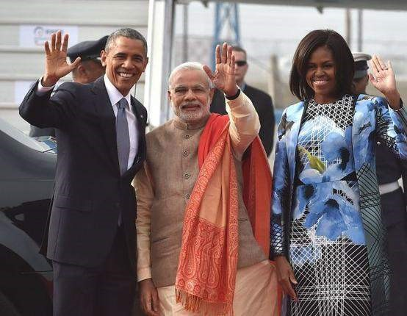

As a departure from protocol, PM Modi went to the airport himself to receive and welcome the U.S. President. Mr. Obama was given a 21-gun salute and a ceremonial welcome at the forecourt of Rashtrapati Bhavan. America and India are true global partners in the work of strengthening economies and strong democracies. That is why the President is the first to have visited India twice while in office. As Prime Minister Modi said, “This is a natural global partnership. It has become even more relevant in the digital age. It is needed even more in our world for far-reaching changes and widespread turmoil. The success of this partnership is important for our progress and for advancing peace, stability and prosperity around the world.”

In his remarks at a reception with President Mukherjee, the President quoted a hymn that was dear to Mahatma Gandhi’s heart:

*Abide with me; fast falls the eventide;*

*The darkness deepens; Lord with me abide. When other helpers fail and comforts flee, Help of the helpless, O abide with me.*

“Here in the eventide, Indians and Americans, let us know, in the darkness or day, in good times or bad, whenever one of us looks to the other, we will surely say, abide with me,” said the American President.

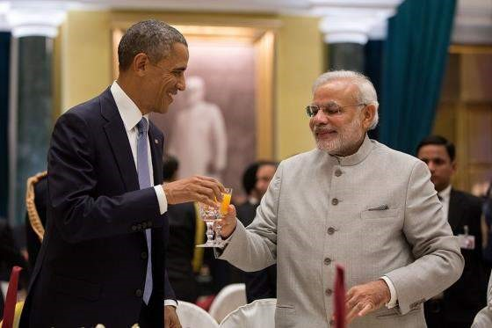

In his talks with Prime Minister Narendra Modi on Sunday, both the leaders managed to remove the hurdles to operationalize the civil nuclear deal besides deciding to jointly produce military hardware and stepping up economic engagement. In what Obama called a “breakthrough”, the two sides resolved key hurdles pertaining to the liability of suppliers of nuclear reactors in the event of an accident and the tracking of fuel supplied by the US. The United States said a decade ago it was making a “long-term strategic bet” on India and the visit showed that India was also ready to reciprocate. The visit was heavy both on symbolism and substance. Barack Obama became the first US president ever to be the chief guest at India’s Republic Day and the first to visit India twice during his presidency. The President and the Prime Minister of India welcomed President Obama as the chief guest at India’s 66th Republic Day celebrations — a day that honors when India’s constitution officially went into effect.

On the substantive front, the most important takeaway from the Modi-Obama summit is the coming together of India and the US on “grand strategy” in Asia.

The signing of the “Joint Strategic Vision for the Asia-Pacific and Indian Ocean Region” may sound mild but it is packed with signals – to China. This is the first time India and the US have come together openly to say that they do not want Asia to be dominated by one power.

But is also important to remember that this is not an “alliance” against China since both India and the US are economically engaged with Beijing. It is a sort of building of fences to ensure China follows international rules.

The other important takeaway was the renewing of the 10-year India-US defense framework agreement, which envisages more military co-operation between the two countries. The two also decided on four defense projects for co-development and co-production.

US President Barack Obama, who addressed a town hall-style meeting in Delhi on the last day of his tour to India, went the Bollywood way to connect with the university students and activists. In the first two minutes of his speech, Obama quoted popular dialogue from ‘DDLJ’. “Senorita… *bade bade deshon mein*,…you know what I mean…”he said.

In an attempt to leave an impact on the audience, he delivered a well thought-out, strategic speech with allusions to eminent Indian personalities. Obama who started his speech in Hindi with ‘Namaste’ and ‘Dhanyawaad’, referred to star Shah Rukh Khan, and Sports Persons Milkha Singh and Mary Kom in his speech. “Every Indian should celebrate the success of Shah Rukh Khan, Mary Kom, Milkha Singh equally, not by the colour of skin, or worship,” he said.

Shah Rukh Khan said he was proud to get a mention in US President Barack Obama’s speech on gender and religious equality.

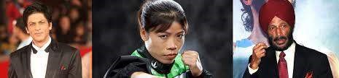

“Proud to be part of the gender and religion equality speech of President Obama. Sad he couldn’t do the Bhangra…next time Chaiyya Chaiyya for sure,” Shah Rukh tweeted.

MC Mary Kom too said it felt proud to be acknowledged by the US President. “I am thankful to him for mentioning my name. He acknowledged my performances over the years. It was surprising because he could have taken anybody’s name. I am feeling very proud,” said the five-time world champion. “Obama ji taking names of sports people is very encouraging for Indian sports people,” said Milkha Singh.

President Obama’s public address to Indians as his last event in Delhi was the icing on the cake – he celebrated India’s diversity and hoped that the country won’t splinter along religious lines or any other lines.

It was a gentle reminder from the visitor that it would take a strong India to face the multiple challenges in Asia. Differences will remain as between any two friends but the old-style suspicion of each other which manifested itself as kneejerk anti-Americanism in India and irritation with India in the US, will diminish. This in the end means a stronger relationship which gives India diplomatic and strategic space against difficult neighbors.

###### OF MICE AND MEN

**— Saylee Bhide**

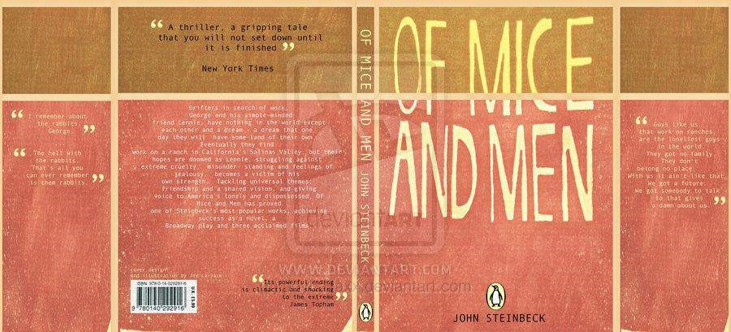

Ok, let me put it this way! I consider myself lucky to read this book – “Of Mice and Men” a notable work of John Steinbeck, a Noble Prize winner. Published in the year 1937, the book is one of the prized works of the author. Loved reading the book and here is my synopsis of the book.

“Of Mice and Men” talks about a very loving yet tragic friendship between two central characters George and Lennie, who are migrant ranch workers. “Friendship” is more of a family affair here, where the symbiotic relationship between George and Lennie is more like a father-son relationship. Lennie is so painfully cute that your heart aches to see a child caught in a man’s body while George is a sensible and hardworking man who adores Lennie to the world’s end and has a dream that one day he will have his own land (allowing Lennie to tend the soft rabbits on his land). Lennie has a bizarre fixation for stroking soft objects/animals which seems innocuous until he kills that animal. This fixation and resulting outcome turns out to be disastrous shattering their shared dream and threatening a painful death for Lennie.

The character description of Lennie and George and their relationship is so precise and so well etched out that you can actually picture them having a dialogue, the characters so graphic and living in front of you!

Personally I felt that the language of this book is slightly profane, but then I realized that you cannot have a posh dialect in a ranch-labour setting! That would be hilarious, isn’t it? After all, it’s not in the “Victorian” setting that was supposed to be highly moralistic with straitlaced language and so on!! So this profanity-laced language is apt and in complete sync with the setting of the book.

One negative that I would like to emphasize on, is the very obvious racial slur that is highlighted in one of the chapters- calling a Black man a “coloured” man. This book was published around the time that the United States of America was surging with racial mutiny and so I wonder if this book was not perceived as one adding fuel to the fire!! It must surely have been the favourite of all the critics out there who must have banned this book for promoting racism. Also, relating to my earlier point on the language of this book, I am sure the critics must have freaked out on the vulgarity and offensive language dimension!

Also you might wonder why is the title of the book “Of Mice and Men” so unrelatable to the story? Yes, the book is about many “men” but the “mice” do not have any significance in the book. It could have been “Of Men and Rabbits” because Rabbits is all you hear in the book. Well, the title of this book is inspired by one of Robert Burn’s poems “To a Mouse, On Turning Her Up in Her Nest with a Plow” which refers to the dream George and Lenny share, of having a big ranch and rabbits that Lenny can tend to but ultimately fate had other things in store for them.

Though the book is just a 100-page one, it manages to resonate at a high emotional frequency, allowing you to immerse yourself in it and feel what the author wants you to feel- Lennie’s unadulterated love for George and George’s pure adoration for Lennie who he tries to protect from being exploited and eventually “painfully” killed.

To achieve this feat of making the reader get the “feels”, it’s common to see authors tending to stretch a novel and it then can round up to massive page-count! They say the “longer the better”- but Steinbeck clearly refuses to adopt this clichéd dictum, thus making it a “short and sweet” read – and an impactful one!





BACK TO COLLEGE OOTD!

**— Neeharika Palepu**



“What should I wear?”

I am sure most of us are haunted by this question. When we are in college we are really start to develop a fresh wardrobe that will get us through four years. And since we finally got rid of those boring uniforms it’s time to flaunt our fashionable

side! College Fashion

is considered as the perfect time to explore your style and experiment with your look.

Our personal style is always a work in progress and during college we tend to gravitate towards minimal aesthetic and comfortable fabric. As we are always carrying our books and laptops, bags are an integral part of our day. Backpacks epitomize student life, leather backpacks or funky looking laptop sleeves are something to look into.



Here are a few must haves in your wardrobe

1. Jeans

Who would have ever thought that a miners uniform will become a fashion trend? Jeans first appeared in in the mid 1950’s and took the fashion industry by storm and ever since they have been reinvented to fit our personal style,right from bell bottoms to torn -jeans.Denims have proved their worth and are here to stay. **2. Formals**

Take it from me, guys look their best in formals. We don’t want to see someone with the bird-nests(Mohawks) and baggy shirts.

3. Kurtis

Embrace the decadent magnificence of Indian culture and include it in your college wardrobe.Kurtis and Chudidhaars bring in the ethnic side of your fashion.

Plain white shirts are an absolute classic and always have a moment. It’s quietly charming and beautiful and could be aptly paired with a sweater to create a relaxed work outfit. Adding a little sparkle to your regular work wear is a quick and easy way to spice things up.



And the colors?

Adding a bit of my opinion – MONOCHROME!

Monochrome madness is not over yet!Turns out, I’m not the only one! *sings like Sam Smith* This classic combination is finding its way everywhere – from runways to the streets. And since you are in this outfit for the most part of the day, keep the accessories to a minimum.

-Fawn Necklaces are just too cute to let go.

-Mini Rings

-Watch

-Bracelets

The summer floral bag is perfect for a long day out and breaks the monotony of the outfit.

The Sun is out and its time to say goodbye to the winter blues and embrace Monday mornings with a bang!

# New pizza boy’s in the town

— Satwik Reddy



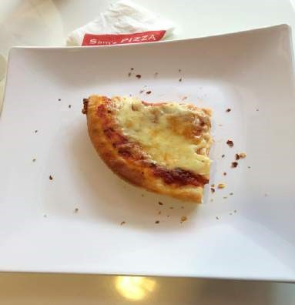

For all those people who are bored of the same old Dominos, Pizza hut or Pizza Corner, located opposite Telugu Academy, Himyath Nagar, Sam’s Pizza will refresh your taste buds.

The way they welcome their customers is different from other pizza shops.

Sam’s Pizza attracts their customers with a board variety of Pizzas, a number of salads, unlimited garlic bread and finally a scoop of ice-cream with a brownie.





The Garlic bread is a must try here. Though there is not much to explore in the menu, their star dish named ‘hot and spicy’ was delicious beyond words. Another steal deal here was a Jug of Coke for a reasonable price. The ambiance was good and brightly lit. The music was regular, – they could improve on it. Staff are warm and are quick with the orders. Overall it was a good experience. I definitely recommend this place to all the Pizza lovers out there! This is can be your new hangout place as it is a lot more affordable, than any place near our college.

Cost for 5 people – 1400 INR

Ambiance – 4/5

Service – 3.5/5

Food – 4/5

Value for money – 4/5

Overall – 4/5

Where and How did I learn Python and Django?

**— Ray**

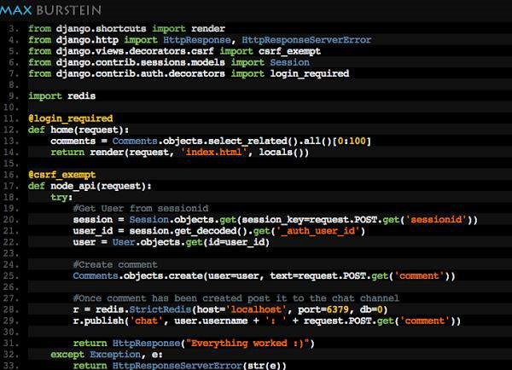

**tl;dr**: It’s about the complete story of my life at KMIT and Django. Where did I use it, How did I learn? Go to the last heading to get the resources.

My Guru – Jayant Kirtane

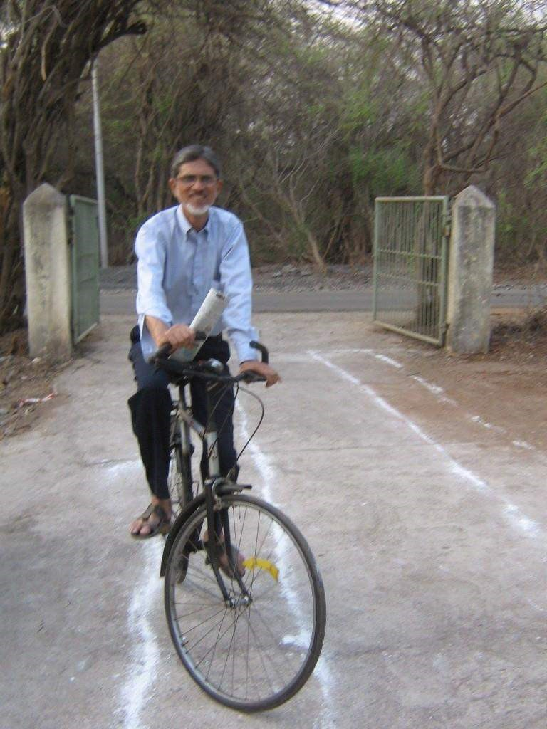

Recently, My Python Guru(Jayant Kirtane) has called me. During the conversation we were discussing about how did I learn Django, I didn’t have a straight forward answer for that. Because after I learn something, I just forget how I’ve learnt it.

Having good lecturer is not common in india, I had the best.

**Jayant Kirtane** – He take’s suggestions from his students on what to teach and ranks himself than ranking students, that makes him one of the best teachers.

Where did I use django, when I was in college?

I have used Django in my college project/my personal project, It’s called Rat

Notes. It’s completely [open source.](https://github.com/iraycd/rat-notes) My external examiner appreciated me for that

Note: Rat Notes is the first collaboration notes which enables you to write the notes and share with your friends and teachers. In simple, Rat notes is GitHub for Note making.

How I impressed the external?

1. [Presentation](https://rawgit.com/iraycd/rat-notes-slides/master/index.html) – For what he opened his mouth wide open.
2. Way I wrote application. Structure, Comments, The Beauty of the code.

Using python[styling a](http://docs.python-guide.org/en/latest/writing/style/)s much as possible.

How did I learn python and django?

* Jayant Kirtane. Is my guru in computer science.
* He told me the word “Python”, He thought me that for few days. • Best resource to learn python: [Python – Learn python the hard way](http://learnpythonthehardway.org/book)
* Jayant gave me a hard copy of the book. Which I didn’t return but shared with a junior who wanted to learn it.
* I didn’t read it. I just skimmed through the pages.
* I knew how to code in C, C++ and PHP when I was learning Python.So, It was easy for me to learn python.
* I worked on 2 or 3 PHP frameworks. So, wanted to see what was it like to work with similar framework in python.
* There are many such frameworks. But Django is the best of all, because developer community was already using it and they are always ready to help.

Other resources.

At the time I was learning there were no proper video tutorials. But, my journey actually started by attending PyCon 2012 and Seeing the intern requirements of Helpshift(Infinitely beta back then).

Internship Requirements Were:

* Google App Engine.
* Django.
* One NoSQL Database.
* Understanding of Git and GitHub.

What experiences have taught me:

When I knew the basics of Django I dived into it, at first I was horrible in coding.

Everything comes from experience and hardwork.

I have realised quite early that writing code by following good patterns is the only way I can write better code.

Every developer must follow [The Zen of Python](https://www.python.org/dev/peps/pep-0020/) either when you are writing in python or any other language. This will help you a lot.

Starting Point

* Best tutorial to learn Django is always from the [Django Demo Tutorial](https://docs.djangoproject.com/en/1.7/intro/tutorial01/) • Python has a huge developer community.
* Use GitHub/Bitbucket there are many open source projects using Django.

Where can you learn python/django?

* [Python – Learn python the hard way](http://learnpythonthehardway.org/)
* [Python Fundamental Training](http://www.youtube.com/playlist?list=PL26BA8B9FC33789FF) – Youtube playlist
* [Manipulating CSV](http://www.youtube.com/watch?v=mlt7MrwU4hY) using python. Teach you basic things.
* [Installing easy_install, virtualenv & django](http://www.youtube.com/watch?v=oT1A1KKf0SI)
* Old Django o [Django Basics 1.5](https://docs.djangoproject.com/en/1.%E2%80%8B5%E2%80%8B/) o [Video Basic Tutorial](http://www.youtube.com/watch?v=zTNA0MtZwso) o [Best Practice](http://www.youtube.com/watch?v=EcY1HBK9hf4)
* New and Best o [Django 1.7](https://docs.djangoproject.com/en/1.7/) o [Best Practices](https://lincolnloop.com/django-best-practices/)

## The Red Traffic Signal

**— Manasi Ramani**



With five minutes till the main gates close

The red signal stupefied my vehicle. I froze

On the spot. That’s it. I’m late. Oh, the woes Of being tardy. Ah, these phases of morose.

I look around and notice nice, long rows

Of hanging Indian flags and Nehru’s photos.

It was Children’s Day, November 14th.

The day for people just like me.

A day for all who feel childish glee

At the sight of sweet sugared candy. I was certain that tonight on TV,

I’d find the likes of Arnab Goswami

Riddling about what they think the country is to be So that our freedom fighters can rest in peace. As I was looking about and looking around A little girl walked up to those around. Her height was short and her face was round

But her winsome charm seemed profound.

For a girl with such inner beauty, her deed left me dumbfounded.

With a smile on her face, ear-to-ear

She approached each driver, there and here.

She wiped the dust off their vehicles with a mere

Little kerchief she had; she dusted both front and rear.

She was stopped by most as she did so; The drivers told her to stop and just go.

She held up to them a meagrely filled bowl

Of coins. They gestured and nodded- they said no. Not even for one person did she expose The tiniest tad of pitiable sorrow.

She just went on to the next in the row

Of vehicles, to be treated to the same negligent show.

Then she came to me; it was my turn

To choose to be open and kind of taciturn.

She began dusting but I stopped her with a churn

Of feelings. I couldn’t see someone like her yearn

For a life that she fully deserves.

I had to do something to preserve

That lovely smile she boasts in the sun.

I wanted to be at least one

Of many who would soon help her overcome

The struggles she’s facing. I wanted them done.

She held up to me the same meagre bowl

And smiled to me- “Didi, kuch toh bhi dedo.”

I felt a crush within and tears almost flowed

From my eyes but her eyes still glowed

With beaming hope that I would differ from those Who dismissed her with an insolent ‘no’.

I gathered myself and flashed a smile back.

I asked her to wait and she took a step back

As I reached into my bag and pulled out a stack

Of a couple extra sandwiches my mom had packed.

She laid her amber eyes on the sweet sight

Of those sandwiches packed one on another, nice and tight.

Seeing her joy, I held back tears with all my might

And handed the sandwiches to the girl with a smile so bright

That the sun, for a moment, lacked the light

To outshine the girl’s pure and innocent delight.

She almost jumped a bit before saying ‘Thank you, didi!’

She extended her hand which beckoned to me

To extend mine too. But for what? I didn’t see

Any reason for it. And then she wished me.

‘Heppy Childrin Day, Didi!’

And that was that. I wished her back.

She skipped along to the sidewalk’s path.

She sat down, tucked in and took a bite of the snack

That gave her the one thing she lacked-

Satisfaction.

The ultimate goal from a journey’s inception.

It isn’t an uncommon misconception

That it is enough to have a predilection In order to succeed in one’s life.

Success is something that many strive

To achieve. They certainly have the drive But they lack the means to contrive A change in their own lives.

On Children’s Day, we should aim

To provide means to children so that they remain

With equal chance to ensure they gain

Every advantage to achieve their own aim.

The day we do this we will be so pleased

With the results that this transformation will yield.

And the day children’s suffering will cease

Is the day that Pandit Nehru will truly rest in peace.



### Moonlight

**— Saylee Bhide**





## “My life is an open book”- An Interview with JP

**— Swapnil Kova**



Nagabhairava Jaya Prakash Narayana , (born 14 January 1956), also known as J.P, is an Indian politician. A former Physician, J.P. is a political reformer and columnist. He is the founder and the President of Lok Satta Party, and was a Member of Legislative Assembly from Kukatpally constituency (2009-2014).

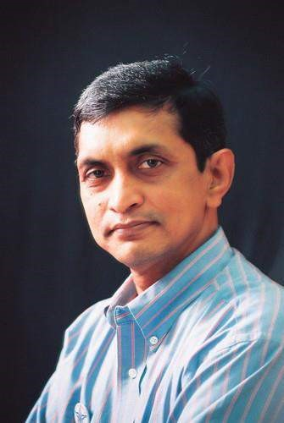

***1.What was your student life like?***

My journey of sculpting for new things began during my childhood. Those were the times which taught me to crave for knowledge. For me, my life as a student was exciting. Though during the initial days of my schooling I was physically inactive later on during the college level I took on to some physical action. I would play Tennikoit quite often. On an overview I wasn’t a sporty guy but my interests were inclined towards other co curricular activities. I hadn’t left even a single tool in making my presence felt in Debates, Quiz and Elocution. I could rather say I was “culturally an active partner”. Though I took part in many activities, my quest for reading books never subsided.

***2.Would you give importance to feelings or***

***thoughts?***

“I am a man of thoughts”. In the history of Indian politics it has been the ‘feelings’ which has predominated over ‘thoughts’. People have been emotionally driven by feelings for short term gains by leaders which was inappropriate. I would again repeat by saying “I am always inclined to thoughts”.

***3.Your life as an IAS***

***officer?***

Getting into the shoes of a public administrator was never an easy task but was always challenging. “IAS has given every bit for me to understand the country’s issues. I’ve shouldered many responsibilities. I made sure that I didn’t make my presence felt in anything which caused disharmony”. The major reform which has brought me recognition was the Development of the Infocity HITEC city (Hyderabad Information Technology Engineering Consultancy City) in Hyderabad to facilitate the growth of the software industry. On an overview I would say that “Wherever I was I delivered something”.

***4.What is your view regarding the present education***

***system?***

I would like to say three points regarding the present education system:

1. On a positive side we see that the kids are hardworking but the bad news is that “the supply is horrible”. We need to reshape the evaluation system completely. We all want success but we are unaware of the definition of success.
2. In most of the Universities and colleges the staff(teachers) selection is disgraceful. Teaching must be made glamorous, respectful and proficient. The quality of teaching is vital, which is lagging in the present scenario. For instance “A Harvard University student does not become a Harvard University Teacher”. iii) We see that knowledge is taking a back-step when compared to degrees. Students are craving for degrees and drifting away from gaining knowledge. If we can efficiently manage this change, in the coming days we are not far from seeing a vibrant India.
3. ***Should younger generation enter politics?***

“Politics is about citizenship and public interference”. We all need to build a community of infrastructure. If we want to avail the basic amenities like health, sanitation, water, food, power, education public interference plays a major and a vital role. So government is necessary and so as Politics. I would say that “Youth should be the forefront of every social and development work.”

1. ***Transition from IAS to a Politician?***

My experience in the government convinced me that the faulty governance process is the biggest hurdle in India’s path of progress. From then on my path has been rerouted and I’ve started working on the grassroots to deliver good governance but I don’t feel any sort of change or what so ever. During IAS it was work for me and so as now.

1. ***How would you be liked to be remembered as in the public?***

Right since I have entered into public life my only desire was that the lives of the people should be improved, I think that’s the greatest tribute for me.

1. ***What’s your take on Dynasty politics?***

We have seen in the recent general election 2014 that the word ‘dynasty’ has been scrapped from the field of politics. “Dynasticism is not acceptable” in the field of politics.

1. ***What’s your view regarding the Aam Aadmi Party?***

I would undoubtedly say that there are too many flaws in the Aam Aadmi Party.

With Arvind Kejriwal’s headstrong attitude his peers in his party started deserting him. The allegations made by him against other parties were proved wrong in most cases, his style of politics was inappropriate by showcasing himself as the only option to the people.

1. ***What’s your view regarding our Prime Minister Narendra Modi?***

Modi was always consistent and personally less corrupt. He boldly took a chance and has delivered to the people of Gujarat during his tenure as a Chief Minister. People have seen a beacon light of hope in him and that is why he is respected among all.

1. ***Your role models and inspirational leaders?***

Verghese Kurien(Social entrepreneur) is one of my role model. He believed in hard work and reckoned that anything could be possible with integrity and utmost determination. I have also been inspired by Sharad Joshi, his ideas and work for the country.

When it comes to leaders no one can forget the services of Mahatma Gandhi but I have been inspired a lot by Dadabhai Naoroji, Gopal krishna Gokhale and of course Sardar Vallabhbhai Patel -The Iron Man of India, who have played a major role in the freedom struggle of India.

1. ***What message would you like to convey to the younger generation?*** You are a privileged generation. No other generation had such opportunities. You have the opportunity to succeed. In our days if we had to gain knowledge we would look towards the Library (books) but now you are just a few clicks away to know something. Technology has made things easier for you. So, here is the opportunity, “here is the narrow window”, don’t stoop down until you reach the goal.

Check the full interview here:

<https://www.youtube.com/watch?v=bcKZ69BZqXA>

Interview Credits: Questions – Way Ch and Ray Ch; Videography- Ponnam Rahul

 Room Temperature using LM 35 sensor &

Arduino

**— Shriram Pydimarri**



What is home automation? What is the internet of things?

Basically, if any electrical appliance at your place starts working on its own whenever required, without any physical human prompt, then that is called home automation. Imagine a situation where the temperature of your living room goes high and you feel the need to turn on the fan. You need to stop whatever you are doing and get to the switchboard on the wall and switch on your fan. What if a device does this job for you? Now that’s really cool isn’t it?! The way I see it, it is medieval to have to get up from your couches just to turn on fans!

This edition’s DIY is about calculating room temperature using LM 35 TEMP sensor and Arduino. And also to make an LED glow whenever the temperature rises above a certain value.

Let’s get started!

Things you need:

1. Arduino Uno
2. Arduino Uno Connector
3. Bread Board
4. LM 35 TEMP Sensor
5. LED pin
6. Jumper Wires
7. PC with Ardunio IDE

How to connect :



1. Hook the 5 V power supply pin on Arduino to Breadboard
2. Hook the ground pin on Arduino to Breadboard
3. Take the LM 35 Temp Sensor , which comes in a 3 pin TO- series package ,fix it up onto the breadboard
4. Connect the LM 35’s Power and Ground terminal pins to the 5V and ground pins on the breadboard, which was branched out from the Arduino Uno in Steps 1&2.
5. Connect the middle pin of the LM 35 sensor to one of the Analog Input ports on Arduino, say A0 pin.
6. Connect the LED pin’s positive terminal to Digital PIN 13 and the negative terminal of LED to the Ground terminal above PIN 13.
7. Make sure the connections are accurate and aren’t loosely made.
8. Connect the Arduino board to your PC from where you will be coding.

**How to code:**

You’ll need to Download Arduino Open Source Developer IDE Software for this! You’ll find the download and setup procedure in the link below:

<http://arduino.cc/en/Main/Software>

Make sure you download the compatible setup file for your OS and System Properties. After the Arduino IDE setup is done, open the Arduino IDE shortcut on your Desktop. You’ll see a screen like this.

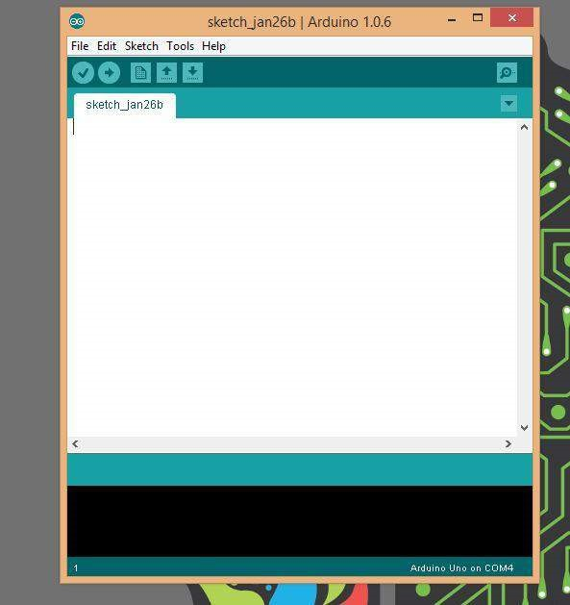

After coding on this file, all you have to do is verify and upload and you’re good to go!

**Writing your Code:**

Aim of the code is to define input & output variables and calculate the analog input which is coming from the analog input pin and convert it into degree Celsius format and display the temperature. Also if the temperature calculated rises over a given threshold value the LED should glow! The temperature value should be measured every 3 or 5 seconds, as per convenience.

This is the code you will be typing out on the IDE.

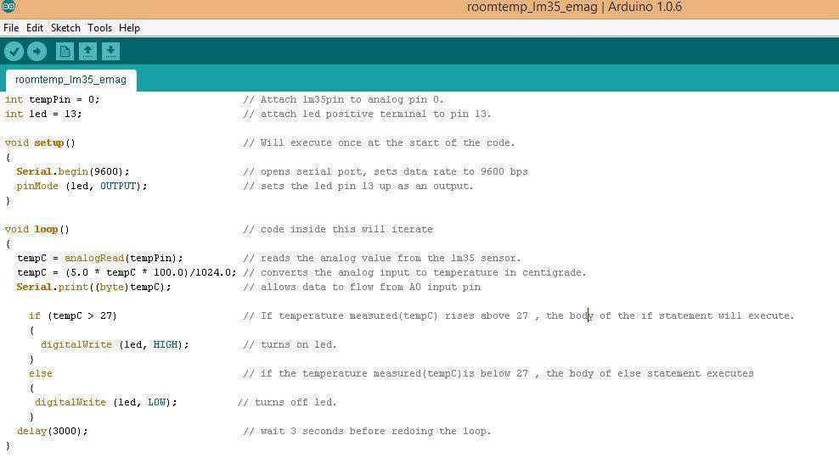

After uploading , you can view the working on the serial monitor.

To open serial monitor, go to Tools->Click on Serial

Monitor (or) simply press Cltr+Shift+M on your keyboard.

To raise the temperature of the sensor, simply place your finger over the sensor for the temperature to gradually rise up.

Once the temperature reaches critical value (in this case, 27 degrees Celsius), you can notice that the LED glows.

<https://www.youtube.com/watch?v=m5zmqQe-Tqo>

This is how a simple temperature monitor can be made using a sensor and an Arduino board! Have Fun!

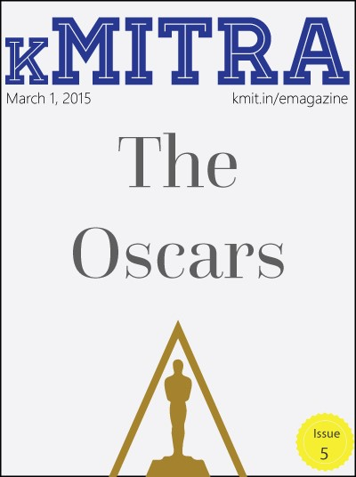

### Glitter, Glory & Gucci

**— Neeharika Palepu**



For all the movie lovers out there, it was the best night (technically early morning for us) of the year.

Why?

because,

It was Oscars!

Awards come and awards go, but nothing can ever beat the Oscars! The *87th Academy Awards hosted in the Dolby theater in Hollywood was the usual star studded extravaganza* and we were left speechless on seeing the celebrities.

Full-length gowns, daring necklines, dramatic trains – the Oscars red carpet had it all.

Stars in a rainbow of colours and a myriad of styles posed for the world’s press before making their way into the Dolby Theatre.

From bold lips, to strong brows, the stars brought their A-game to the red carpet.

We saw a whole lot of head-turning outfits on the Oscars red carpet this year. From Dakota Johnson in Saint Laurent to Lady Gaga in Azzedine Alaia, celebrities clearly made an effort and some of their looks really won the show.

We present to you the **BEST DRESSED** of the Oscars.

#### 1. EMMA STONE



Emma Stone was stunning in her Elie Saab Haute Couture dress and Tiffany Blue Book Collection jewelry. Although the long sleek gown looked conservative there was a leg slit and an open back to edge it up. Her signature red locks were swept to one side in Hollywood waves and she donned an orange lipstick that popped out the colour of the dress. With the perfect combo of ‘Sexy and Classy’, the *Birdman* star never fails to impress us.

#### 2. ROSAMUND PIKE



Rosamund Pike chose a strapless, embroidered red Givenchy Haute Couture gown for her red carpet look. The strapless neckline and the lace overlay flows with her curves. Plus,the high slit and the satin detailing at the midsection accentuates her waist. And, the blonde locks were styled to perfection in a ballerina bun!

#### 3. Margot Robbie



Margot Robbie wore a Saint Laurent black, long sleeve gown with a plunging neck top and Van cleef & Arpels necklace. With the deep V neck, the sheer hands and $1.5 million statement necklace, Margot, looked absolutely stunning. The slightly mussed hair and the bold lip gave the look an extra boost to set the red carpet on fire. Turn.It.Up.That dress, that lip, and that necklace!

#### 4. Jennifer Lopez

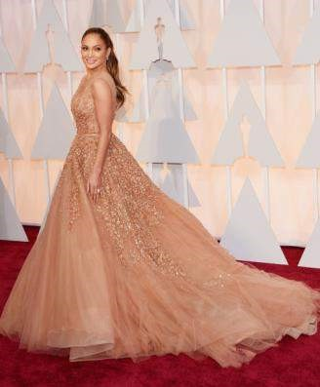

JLo wore a flowing Elie Saab champagne coloured gown, *Salvatore*

*Ferragamo* clutch, *Neil Lane* jewels, and *Giuseppe Zanotti* shoes and looked dropdead gorgeous. The gown was absolutely exquisite with layers upon layers of champagne coloured embellishments that billowed into a gorgeous train. She sported her classic deep V neck and finished of her look with a high ponytail and a pop of pink on her lips.

#### 5. Anna Kendrick

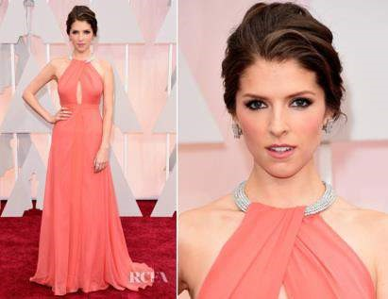

Image courtesy-RCFV

Anna chose a coral-peach Tycoon gown with a cut out in the front and back,there was a fun weaving at the neckline and it looked as if the dress was made especially for her body. Her choice of the earrings matched with the neckline of the gown and complimented the look perfectly. Her makeup was kept simple with a nude lip and smokey eye,and her up-swept hair was tousled and youthful and brought out her beautiful face. She not only killed it on the red carpet but also stole the show with her opening monologue with Neil Patrick Harris and Jack Black.

#### 6. Dakota Johnson



Dakota was an absolute stunner with her asymmetrical Saint Laurent dress. The colour perfectly complimented her skin tone and shoulder detailing was totally unique,it looked like a rope of bling hanging off her shoulder and the sweet-heart cut with the side slit was undoubtedly perfect for her. The red lip and simply styled hair kept her look very modern.(50 shades of Hot?!)

Coming to the Gentlemen, from the classic Tux to the experimental accessory we’ve got it all.

#### 1. Eddie Redmayne

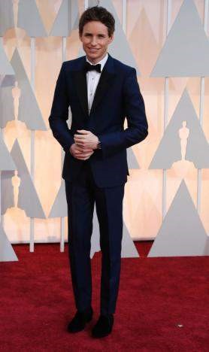

Eddie looked striking in the Tuxedo by Alexander Mcqueen. The actor wore a navy blue tuxedo and a black bow-tie to the event. With that dimpled grin, steady eyes and a great deal of talent, I think it’s safe to say he totally deserved that Oscar!

#### 2. Ansel Elgort



Ansel chose a navy blue and black tuxedo by Prada for this red carpet look. *‘The fault in our stars’* star sure did not make any flaw this time.

#### 3. Tim Mcgraw

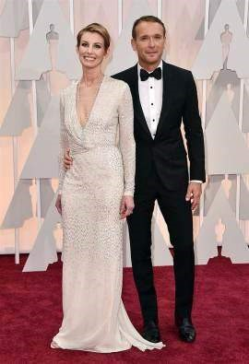

Mcgraw looked almost unrecognizable without his cowboy hat,but the country singer sure made it to our best dressed list in his Lavin Tuxedo. He also performed

“I’m not going to miss you” (That voice though.)

#### 4. Benedict Cumberbatch



And, we saved the best for the last, Benedict wowed us in a white ensemble and a black bow-tie at the red carpet. With a jaw line that could cut glass and an extremely photogenic face, the actor took over the red carpet. Well, he might play *Sherlock* on screen but he did look *James Bond* on the red carpet.

#### The Grand Budapest Hotel Review

**— Saylee Bhide**



The Grand Budapest Hotel is indeed, a generous masterpiece delivered by Wes Anderson, and rendered by the brilliant Ralph Fiennes and Tony Revolori. The script of this movie carefully plays with the passive and impassive tones, adding the narration and its concomitant dialogues to chug the movie forward!

A book written and narrated by the author (now deceased) introduces us to the story of the “Grand Budapest hotel” which tantamounts to the story of the Richierich Mr Zero Moustafa. If you are aware of the concept of “nested loops” in computer science, then in the literary sense, here, we have “nested narration” running throughout the movie.

As narrated by Mr Moustafa, in a fictional state of Republic of Zubrowk of Central Europe rests a fallen “institution”- “The Grand Budapest Hotel”. Back in its glory days, it was known for its aristocratic guests and the influential women clientele, who flocked the hotel for all wrong reasons. The movie is about Gustave H (Ralph Finnes) a concierge of the Grand Budapest, notably the “infamous chic (ken) magnet” and his accomplice, Zero Moustafa (Tony Revolori) a lobby boy in the Grand Budapest Hotel.

When one of the hotel’s regular customer and a “special” guest of Gustave passes away, the family or rather a “Goth band” family of the lady, frames Gustave for the murder on learning that she had bequeathed a priceless painting of the “Boy and the Apple” to Gustave in her final will.

The story line encompasses a substantial amount of melodrama with Gustave in trial for murder, a “Frankenstein” like detective with a very preposterous working style, for instance, ripping off people’s head, clipping fingers, throwing a Persian cat out of the window and what not, a mountain chase in the Swiss alps, a “line to line” rescue mission of Gustave by the “cross key society” and ultimately the vindication of Gustave from the murder charges.

This movie scales up the rating bar for mainly two reasons- though there is a heavy element of drama, one cannot deny the equanimity with which every scene has been dealt with. It seemed that every scene had been meticulously tamed to meet a delicate balance of both melodrama and comedy. Secondly, the movie emphasizes on the friendship and loyalty between Gustave and his lobby boy, Zero which eventually becomes the running theme of this movie.

Quirky, comical yet poignant, this movie is certainly a must watch!

FYI, yet another reason to underscore “must watch” is that The Grand Budapest Hotel won the Oscars for “Best achievement in costume design”, “Best achievement in music and hair-styling”, “Best achievement in music written for motion pictures” and “Best achievement in production design”! Not to forget, it was also nominated in the best film category of the Oscars.

#### Interview with Aneesh Jajodia

**— Akshay Chandra L**



Although the meaning of ‘being awesome’ is different for different people, everyone wants to be the awesome guy. Everyone wants to do something more than the routine, something beyond convention, something ‘awesome’. But only a few, dedicated and hardworking get there. And once they get there, they won’t stop, they go for more. Here’s a guy who surely is more than the routine, beyond normal, who is ‘awesome’.

Aneesh Jajodia is a web designer, a web developer, a hacker, a businessman, a photographer, an innovator, an inventor and yes, KMITian, Information Technology, third year. Well we believe he is not just a person, he’s an idea.

***So Aneesh, tell us about your education before KMIT happened to you. What kind of a student were you ?***

“Well, I’ve done by schooling from St. Pauls, and intermediate from Little Flower Jr. College. Honestly, I was never a person to be a star in studies. I’ve always managed to keep my grades over distinction. But never was too bright or bookworm kind of a person.”

***When and how did it all start? The web designing, developing, the interest, the everything! I mean, the turning point.***

“Well, it all started when my father bought a computer 16 years ago. So the very interest in computers/technology got into me through my dad. I started to play around with computers ever since. The little tinker in me always went behind the operating system files and other sensitive things I wasn’t allowed to play with. And during this process, I came across a lot of new things I did not know about, so whenever I got a chance, I used to explore the internet so as to find the scope behind them.”

“Eventually, I started building applications for some small groups on a Social Networking Website, using the Visual Basic, Visual C++ by using Google as my arsenal. These applications were quite useless and inappropriate, as those were for making fake IDs in websites like Orkut, Google, Yahoo etc. And I never got paid for doing any of them, but then I was learning new things and I liked that.” *Heard you were a hacker as well, what about that?*

“Yes, I was one. As I was entering my teens, I got into hacking phenomenon. I slowly started hacking small websites as I learnt it all myself. In this process of exploring and learning new things, I came across web development. Once the webdevelopment interested me, I started researching more and that’s when it led to making of my full-fledge self-owned website in my 7th standard, and I barely knew algebra then (laughs)”

***What was your source of learning? Any tips for your fellow juniors? Any specific tools you used while learning?***

“According to me, the only thing that can make you pull up your socks to learn anything is the passion. I’ve never been to any course to learn any kind of computer-knowledge I have right now. The only source for finding the source of learning was/is the mighty search engine, Goddess Google.”

“I experimented with a lot of tools available in the market to work with. Initially, when I started with the web-development I used ‘Dreamweaver’, but then because of it’s additional features which didn’t help me in any way (at least at that point). That’s when I shifted to ‘Notepad’, because that was just the perfect thing for coding/programming web.”

***Was /Is there a mentor for what you have been doing? Or is it just you fighting the world?***

“Mentor, none as such. Just the interest kept me going. Back when I was into hacking, Ankit Fadia, a prominent ethical hacker, was the man I dreamt of being.” ***How did your parents feel about you making websites at the age of 12? It doesn’t happen so often you know.***

“My parents were very proud of me with the fact that I was making websites at that age. And like everyone else, they kept boasting about my work to friends and family. But I did not let that get to my head, because I knew a few people who build far better, functional and heavy websites than I did. So I always tried to be down to earth and kept learning as much as I can and my parents never stopped me from doing that.”

***What about the ‘recharge.im’ you started?***

“My friend (from Ludhiana) and I started ‘Recharge.IM’, in early 2011, which was built for recharging a mobile phone or DTH connection etc. through online banking. But gradually due to the management problems and low-margins, we had to sell it.” Is it still out there? “No, I think it’s dead now (laughs)”

***‘Creative Cases’ is the startup everyone around us knows, specially the iPhone users. Tell us about it.***

“Creative Cases is a start-up initiated by my brother and me. It took us quite a while to put up things upright. Basically we build cases of high quality (which actually protects your phone), designed by creative young designers across India. As the desired quality couldn’t be achieved in India, we make them built in a factory abroad and procure them to our warehouse, which later gets packaged and marketed.”

“Currently we are dealing with designer phone cases for iPhones only, but gradually we’d enter the markets of other phones as we are in talks and process of setting up a manufacturing unit here.”

“Throughout the process, my parents have always believed in us and supported us.”

***You were always on the rise, didn’t people pull you back? Does it affect you anyway?***

“Well, people obviously try to pull you back with negative feedback. Maybe out of jealously or anything else, but then when things are properly planned, and you want to keep improving, you become quite confident in what you do and what you can do, and you tend not to deviate from your thing. And it isn’t like I don’t lack confidence, sometimes I do. But it’s fine, you know.”

***There is a huge collection of pictures taken by you. We believe they are very professional. Do you have any plans in that field?***

“Photography has always been a passion for me since a long time. I’ve clicked a lot of pictures, and have done professional shoots earlier. I used to run a website and a page of social media websites, promoting my photography. But on just any day, I deleted it off. Cause there was a lot of crowd which thought that owing a DSLR makes them a professional photographer. I did not want to be named as such, so I left it as my hobby. I still click pictures around at times for shoots, but it’s purely for myself, so no professional future at all.”

***Tell us about your recent work.***

“Well, recently I’ve been working out on my personal start-up, i.e.

www.creativecases.in. Otherwise I deal with projects of clients around my friendcircle/country.”

“ [www.marigoldweddings.co.in,](http://arjun.ninja/kMITRA-Web-App/www.marigoldweddings.co.in) [www.sandhyaconvention.com,](http://arjun.ninja/kMITRA-Web-App/www.sandhyaconvention.com) [www.fadjuice.in,](http://arjun.ninja/kMITRA-Web-App/www.fadjuice.in)

[www.kamalkiranphotography.com,](http://arjun.ninja/kMITRA-Web-App/www.kamalkiranphotography.com) [www.feplengineering.com,](http://arjun.ninja/kMITRA-Web-App/www.feplengineering.com) all these were just completed. I’ve got a few on my hand too right now, so I have been working on them. I try to take up as many different kind of projects as possible as I keep learning more through them.”

***With all this going on in life, how are you putting up with the college? JNTU is not so easy after all.***

“Like most of the JNTU guys, I listen to the classes and tend to study in the month of exams, because otherwise I’m just too occupied. I respect academics but with all this going on in my life, it’s so not easy to balance it all. But I’m trying everything I can.”

***So any future plans? Anything big coming up?***

“Nothing yet, just working on my start-up. Hopefully according to the vision, things can go big. Let’s hope for the best.”

“I never thought I was special but thank you kMITRA, for making me feel like one.”

Thank you Aneesh for sharing your work and ideas with us. kMITRA wishes you all the luck and success with your start up.

In some way or the other, Aneesh teaches us that through zeal and hard work, one can do wonderful things, even beyond one’s level. It won’t be an exaggeration to say that Aneesh gives us the real definition of ‘awesomeness’. He has set a bench mark to a class of upcoming computer geeks in the college. It is a privilege to have someone around us who can make a difference in lives of people around him as well. As they say,

*Choose a job you love, and you will never have to work a day in life.”*

Aneesh achieves it as he is passionate about his work, something he finds fun to do, isn’t it something we all look forward to?

*Check out his start up at:* [*www.creativecases.in*](http://www.creativecases.in/) *Check out Aneesh’s work at:* [www.aneesh.me](http://www.aneesh.me/) *Contact Aneesh at:* me@aneesh.me

#### Oscars 2015

**— Abhishek Bele**



##### **The 87th Academy Awards**

Each January, the entertainment community and film fans around the world turn their attention to the Academy Awards. Interest and anticipation builds to a fevered pitch leading up to the Oscar telecast in February, when hundreds of millions of movie lovers tune in to watch the glamorous ceremony and learn who will receive the highest honors in film making. The Oscars is also the oldest entertainment awards ceremony; its equivalents, the Emmy Awards for television, the Tony Awards for theater, and the Grammy Awards for music and recording, are modeled after the Academy Awards.



The 87th Academy Awards ceremony, presented by the Academy of Motion Picture Arts and Sciences (AMPAS), honored the best films of 2014 and took place on February 22, 2015, at the Dolby Theatre in Hollywood, Los Angeles. During the ceremony, the Academy of Motion Picture Arts and Sciences presented Academy Awards in 24 categories. Actor *Neil Patrick Harris* hosted the ceremony for the first time.

Birdman or The Unexpected Virtue of Ignorance and The Grand Budapest Hotel won the most awards, tying with four each. Birdman ’s awards included the Best Director, Best Picture and Best Original Screenplay for Alejandro González Iñárritu, while The Grand Budapest Hotel ’s awards included Best Original Score for Alexandre Desplat. Whiplash, the only other film to win multiple awards, won three including the Best Supporting Actor for J. K. Simmons. The other winners were The Theory of Everything, Still Alice, Boyhood, The Imitation Game, Big Hero 6, Ida, Citizenfour, Crisis Hotline: Veterans Press 1, The Phone Call, Feast, Selma, American Sniper, and Interstellar.

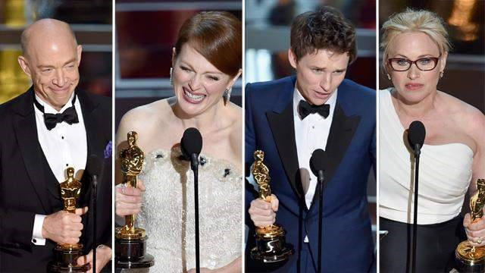

Patricia Arquette for *Boyhood* (Best Supporting Actress), Eddie Redmayne for *The Theory of Everything* (Best Actor), Julianne Moore for*Still Alice* (Best Actress) and J.K. Simmons for *Whiplash* (Best Supporting Actor)*.*

All of the films competing for Best Picture received at least one award in other categories, making it the first time this has occurred since the Academy expanded the category to more than five nominees in 2009. Alejandro González Iñárritu became the second consecutive Mexican winner for Best Director, with the statue having been awarded the previous year to Alfonso Cuarón for Gravity.

Iñárritu was the most awarded individual of the ceremony, winning each of his three nominations. Emmanuel Lubezki became the 4th consecutive recipient of Best Cinematography award after winning for Birdman as he also won for Gravity last year, and second Mexican winner of ceremony. Ida became the first Oscar winner for Poland in the Best Foreign Language Film category, with an overall ten nominations since 1963.

The Oscar statuette has stood on the mantels of the greatest filmmakers in history since 1929.

*The Oscar Statuettes*

There has been criticism of the predominantly white Oscar nominees & winners. For the third time since 1995, the 20 Academy Award acting nominations were only for white actors and actresses. Social media is already buzzed over all of the surprises – and snubs – of the 2015 Oscar nominations. In typical Twitter fashion, a special hash tag – #OscarsSoWhite – was trending.

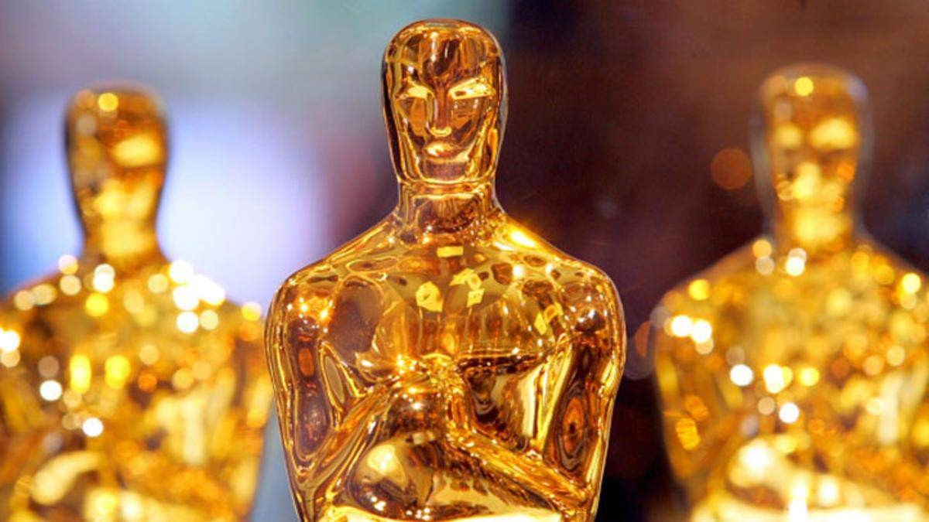

However, the telecast garnered nearly 37.2 million viewers in the United States. The show received a mixed reception from media publications. For the most part, the show’s main accomplishment was avoiding embarrassing low points. “Bottom line: It’s the work that counts with members of the Academy.”

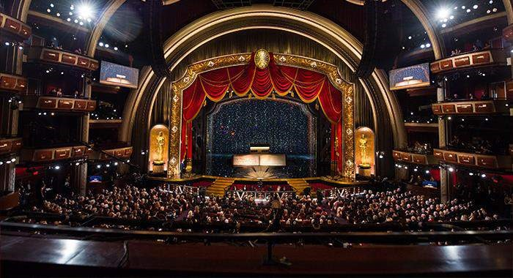

Movie editing made easy!

**— Medha Ch**



In the art of movie making, while half of the work is shooting the scenes, the other half is editing them. Editing brings in life to the pieces of videos, joined to perfection. Editing a movie is definitely not an easy job, adding scenes, setting up the audio, music, overlapping scenes and so much more! So when we understand that the movie- editing, though very tiring, is a must, it feels good to use software that make work easier.

Though there are a many Video Editing Softwares available for us to use, here are a few free ones which give almost a close experience of movie editing as the other paid software.



##### **VideoPad Editor**

The free version of VideoPad, though is feature-limited is easily one of the best software available for free. VideoPad has ample amount of effects that can be of great help. It also has a music library, which helps us to fit in the best music for the movie. VideoPad also comes with the ‘Narrate’ button which is a click away from us recording our voice as the video moves on. If you are looking for the best movie editing for free, VideoPad will not disappoint you.

Download Here:<http://www.nchsoftware.com/videopad/>



##### **VSDC Free Video Editor**

VSDC Free Video editor is not as user-friendly as other editors available, but once we get familiar with the software, we realize many powerful features available. A wide range of effects and filters are available in the editor, which makes it a preferable one. If one wants to go pro at movie editing at free of cost, VSDC Video Editor is the best choice.

Download Here:<http://www.videosoftdev.com/free-video-editor/download>

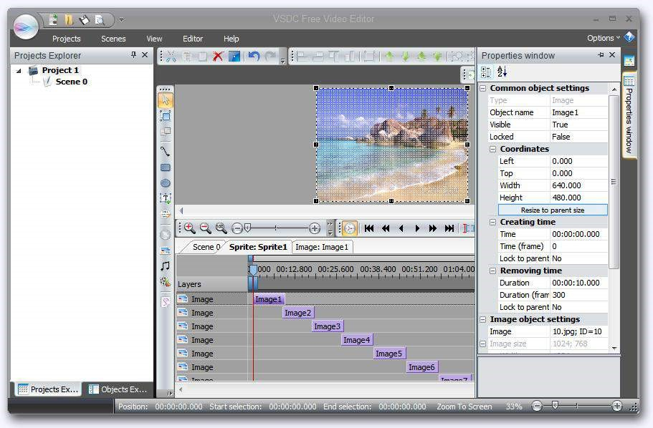

##### **Lightworks Movie Editing Software**

The Lightworks editing has been in the market for over 25 years now. This editor supports more video formats than any other video-editor available. The canvas is non-linear with floating windows that users can position anywhere or dismiss as per convenience. Lightworks also gives a world-class timeline setup which makes it easy for the user to trim or adjust the video clips.

Download Here:

[http://www.lwks.com/index.php?option=com_lwks&view=download&Itemid=20](http://www.lwks.com/index.php?option=com_lwks&view=download&Itemid=206)

[6](http://www.lwks.com/index.php?option=com_lwks&view=download&Itemid=206)

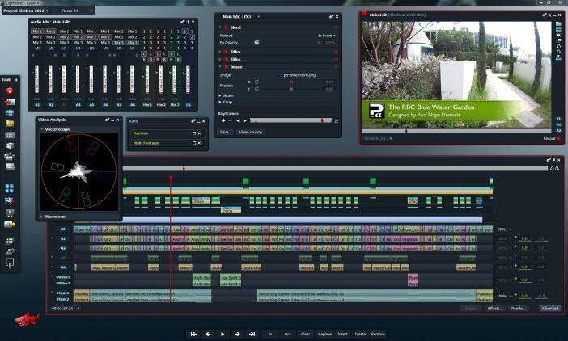

##### • **Avidemux**

The open source file editing software is reliable, simple and very comfortable. Video editing in Avidemux has been like that since years and the software has got enough fans by now. Converting video formats is also simple in this software. It may not be the application with best features but it definitely does your job right.

Download Here:<http://filehippo.com/download_avidemux>

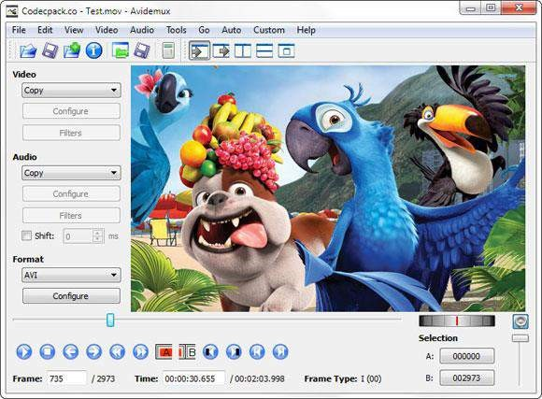

All in all, video editing needs so much creativity and there is a wide platform of software that can provide the user with anything he wants. I hope the above programs help.



#### COLLEGE FASHION

**— Shrutha Keerthi**

***Fashion is what you buy. Style is what you do with it***

Style is what we are, what we like and what we are comfortable in. We live in a world where having our own identity is important. Coco Chanel once said, “If a woman is badly dressed, it's the dress we'll notice; but if she is impeccably dressed, it's the woman herself we'll notice”.

Style talks, it is a reflection of our attitude and our personality, it makes people believe that each one of us is unique, that each of us is attractive in our own way. We feel confident when we know our look shows our most effervescent and spunky side.

Our college life should be fun, filled with friends and challenges and also good clothes to make hitting the classroom more appealing! Now-a-days, balancing studies, college work, sports, friends and family has become so stressful that many of us don’t have time for ourselves. But here at KMIT, we have so many versatile students who manage to do all these and still look so charming and stylish at the same time! Here we have, few of our students answering few questions for us and talk about their own style.

***1. What is that one piece of clothing you can not live without?***

* My jeans- Vineetha Rachamallu
* Shirts – Shri Ram
* Black dresses – Priyanka Engu
* Black shirts - Siddharth Nanduri



***2. Your favourite place to shop is?***

* I wear whatever fits me well and looks good on me, no particular brands – Vishnu Desai
* Madame, Allen Solly – Sindhu Valluri
* Its not always about the brand for me, its about the fabric and design, but if very specific, I like Tommy Hilfiger and Van Heusen – Adarsh Reddy

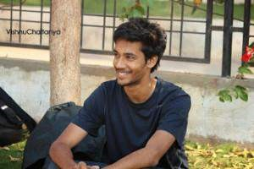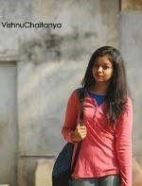

**3. *What kind of tops/shirts do you like?***

* Long tops,kurtis and crop T’s – Meghana Jalama
* Peplum and sleeveless tops – Chahat Jain
* Checks shirts and polo T shirts – Sourab Reddy
* Woollen tops are my favourite, also crop tops - Sindhu Valluri

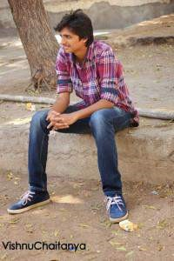

***4. What do you like wearing when it’s too cold outside?***

* I’d prefer wearing a full shirt with a sweater on it – Adarsh Reddy
* Hoodies or a jacket – Hanish Bhogadi



***5. What would you wear to a friend's birthday party?***

* A nice dress, along with good stilettos and I’d add in a few accessories - Sindhu Valluri
* Denim jeans and a dark coloured shirt – Shri Ram
* I'll wear a nice party top and trousers to go with, printed jeans or coloured jeans will also look good – Vineetha Rachamallu

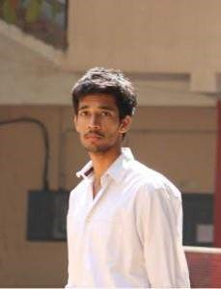

***6. What would you prefer wearing in summer?***

* T-shirt and shorts – Vishnu Desai
* Cotton kurtis or tunics – Priyanka Engu
* Kurtis! I think they're really pretty - Meghana Jalama

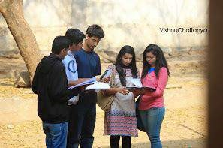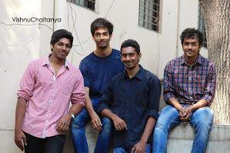

***7. What are your college wardrobe essentials?***

* Colourful leggings and kurtis are a must! – Chahat Jain
* T shirts and flipflops – Siddharth Nanduri
* Definitely Light coloured shirts – Sourab Reddy

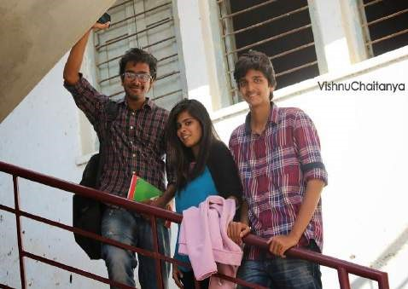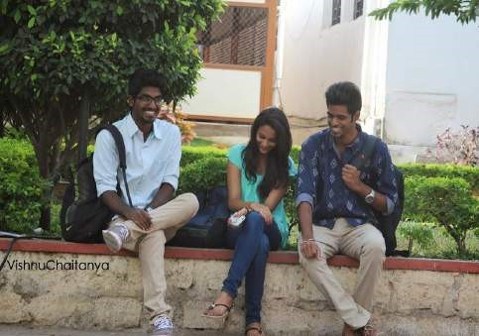

***8. Checks, stripes or plain?***

* Plain – Anirudh and Adarsh reddy
* Checks - Sourab Reddy and Shri Ram

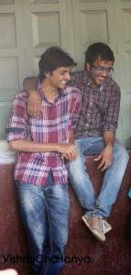

**9. What is your favourite hairstyle?**

* Fish braid and Side braids are also really cute! – Sindhu Valluri
* Its either loose or tied up into a pony, I like keeping it simple – Vineetha Rachamallu
* Open hair or loose curls – Chahat Jain



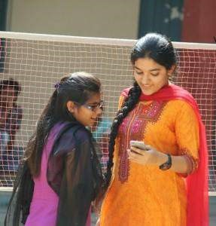

***10. What are your favourite accessories?***

* Lots of bracelets! And over sized watches are a must! – Meghana Jalama

* I always wear a watch. Also sling bags – Vineetha Rachamallu
* I think smile is best accessory - Chahat Jain



***11. Give us a fashion advice***

* A Black jacket goes with everything – Vishnu Desai
* Don’t pretend to look like someone else, be yourself – Vineetha Rachamallu
* Everyday isn’t a festival! Guys should never overdress, plain tshirts, chinos or jeans paired with flipflops should make your day – Adarsh Reddy
* The best way to experiment is to go through your moms stuff – Meghana Jalama

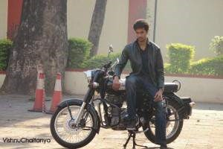

#### Short Film Festival

**— Saylee Bhide**



A short film festival in contrast to the regular film festivals, piles on the idea of the acronym “KISS” which stands for “keep it short and simple”. Myth has it that making a short film is easier than making a regular film, but in reality, one has to think out of the box while scripting it because the whole concept of the movie has to be elucidated in a time frame of minutes! The scriptwriter of a short film does not have the freedom of unbridled thought flow but is bounded by the shackles of time and the pressure of a perfect story line.

Complex much? Well, looks like even that degree of complexity failed to intimidate the KMITians who not only produced their own short films, but also belied the expectations of the faculty and the students sitting in the auditorium.

Held on the 7th of February this year, the short film festival received a good response with the auditorium stacked with eager faces, waiting to witness the “one of a kind” KMIT short film festival, featuring six short films in total.

The event kick-started with the kMITRA team’s advertisement of the college’s very own magazine “kMITRA” whose motto was expounded in the a five minute advertisement. To add a touch of vanity, the members of kMITRA were seen wearing their signature kMITRA t-shirts – a moment of pride indeed when they were formally introduced to the audience as the “kMITRA team”. Watch it here: <https://www.youtube.com/watch?v=j0523QwY5X0>

The second short film featured was “Blind story”, a national award winning film shot by Akash Dhote. This movie goes out to those, who will never have the opportunity to see the world with their eyes. It left me teary eyed by the end of four minutes and forty-four seconds, such was the poignancy of the movie. Watch it here: <https://www.youtube.com/watch?v=4RUIwiwZeEI>

The third short film featured was “Swatch Bharat” shot by Ponnam Rahul. It talked about the importance of “Swatch Bharat” which Gandhiji had staunchly believed in. With the message blatantly evident, this film, on the whole was a five minutes well spent.

Watch it here: <https://www.youtube.com/watch?v=9NbXLljTd2Y>

The next short film “Random Act of Kindness” by Nvas Shanmukha instilled in us the belief that there still exist some people in today’s society who invest in “random act of kindness” and believe that “no act of kindness, no matter how small, is ever wasted”. Kudos to Nvas Shanmukha for casting actors of this generation, because most of our generation has a notion that “random act of kindness” etc..is all “old-school” and too “main-stream”. Watch it here: <https://www.youtube.com/watch?v=6eXKgswl5ps>

To lighten the sentimental overdose, a light hearted Pixar movie “Partly Cloudy” was played. This five minute film is a delightful roller coaster of emotions! Watch it here: <https://www.youtube.com/watch?v=-a6Pe1ovKHg>

The last but not the least, was an animation film titled “Being grounded” produced by Praharshita Krishna. Though the animation seemed to be in its rudimentary stages, the efforts put into the making were sincerely appreciated because the concept and style together was unique and unprecedented. Going the Pixar way, I guess!

Watch it here: <https://www.youtube.com/watch?v=OhZPlxyn8DA>

Every short film in the festival was a unique affair without any repetitiveness or

“run of the mill” concepts. The event ended with a euphony of applause filling the

“crowded” auditorium and a cheerful chatter of the faculty and students marking the success of this event. Looking at the response and the talent aboard KMIT, we should definitely look forward to another short film festival in the coming times.



#### The American Sniper

**— Gaurav Patil**



The American action war film directed by Clint Eastwood “American Sniper”.

This is a movie based off a true story of a sniper named Chris Kyle. Bradley Cooper portrays Chris Kyle in this film. He does an incredible job. At about half way through the movie I was staring at the screen like, That’s Bradley Cooper Oh my God!. His performance in the movie is very subtle, you can see this rage and fear building up inside of him. There is never really a point when he explodes and that’s probably the most unsettling part about him.

He does an incredible job. Now the other actors in the film did a decent job I didn’t really notice any other stand out performances and there is one part where they show these guys with injuries who have healed up in the hospital and I was pretty sure they were real veterans. I just thought it was pretty cool that they put real guys from the real battle into the film. As far as the vets I am not 100% sure if that’s true but that’s what it seemed like when I was watching.

Was the movie itself any good?

Yes, it is a good movie. Clint Eastwood always directs action very well. So, this movie was serviceable for a normal action director. I thought during the action scenes there are few too many cuts, a few extra shots that didn’t really need to be there but overall it was pretty entertaining action.

There are some fairly intense parts in the movie. There is a character in the film named the Butcher that Chris Kyle is trying to track down and he kills people with a drill. Yeah! that is pretty intense. I thought there were definitely some parts of the film that stretched too long. The movie is 2 hours 12 minutes and it really could have been an hour and 45 minutes long.

Clint Eastwood makes long movies and I love long movies but only when it is necessary to make the movie that long to tell your story. And I don’t think this movie needed as many of a shootout as they put into it. I wished they would have focused a bit more on him as a person. From the trailer it seemed like it was going to be very much about his moral compass, how he thought about killing all these people that he killed. By the way If I didn’t mention it yet, he is the most lethal sniper ever in US history. So from watching the trailer it seemed like the main focus of the story was going to bethat and it kind-of is, kind-of! .The story isn’t really about that Bradley Cooper’s performances about that which i guess you could say is a good thing but I was really hoping the story was really gonna focus around him having to make those choices in people’s lives because it was real guy that really did a lot of things that they showed in the film.

Now the first time he killed someone in that movie really solid job, that was cool, like very intense and you could see that it really him.

I don’t really want to get into politics about what my views are about that war so I really just going to keep that out of this review. There are a few parts of the movie where I did check my phone just to see how long we have left not because I was bored just because it was long and I really did enjoy myself. I have seen several longer movies like Interstellar and I think that was a good 15-20 minutes longer but I never checked my phone, I was struck to the screen the entire time. I am not saying that Interstellar is a better film than this.Oh who am I kidding it is a better film. Okay!. It has spacing issues but it is a good film. I don’t think it should have been nominated for the best films of the year and I know there are many films that could easily take its place specifically Nightcrawler. So, I did enjoy this film it fairly dark on a couple of parts, it definitely keeps you entertained, not a sad as the trailer made it look like to be, wasn’t as emotionally hard-hitting as I want it to be but it is a good film.

I wouldn’t say rush out to your nearest theater and watch it but watch it once it’s on DVD or Blu-Ray.

एक दोस्त के लिये ।

**— Prashansa Ambarkar**

आपने हमे हसना ससखाया, फिसे । आपने हमे जीना ससखाया, फिस े ।

खद्ु से प्यार करना ससखाया, फिसे ।

खद्ु को खशु रखना ससखाया, फिसे । खसु शयााँ बाांटना ससखाया, फिस े ।

घम को भलु ाना ससखाया, फिस े कमजोर न रेह्ना ससखाया, फिस े । ताकत बढाना ससखाया, फिस े । चढने लगी यारी तम्ु हरी जान से । ननभा लगू ी मै उसे दिल से!!

### An interview of Krish

**— Swapnil Kova**

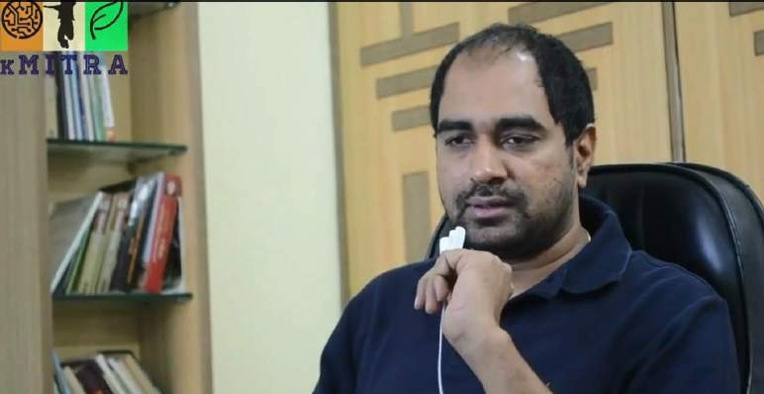

Radhakrishna Jagarlamudi, born on 10 November, 1978, also known as Krish is an

Indian film director, in the Telugu film industry. He made his directorial debut in

2008 with *Gamyam* starringSharwanand, Allari Naresh, followed by *Vedam* in 2010 starring Allu arjun and Manchu Manoj. Both films garnered a huge response at the box office, fetching him the Nandi Award and Filmfare Award for Best Director. He has also directed *Krishnam Vande Jagadgurum* starring Rana Daggubati and Nayantara which has also been a success at the box office. He makes films in such a way which leaves an underlying message and in turn has an impact on the society.

1. ***Tell us something about your experiences and your way of life as a child?***

The earliest days of my life were very exciting, I was very lucky to be a part of a family who have shown immense love towards me. I was very close to my brother, I would share each and everything with him, every evening we would bimble around the park and discuss so many things, he would narrate many short stories from books like “Chandamama” and other story books, most of the stories were related to Indian mythology which have inculcated lots of moral values and more over carved out a new angle in my creativity side and I have developed the art of

writing, reading and sketching. I was fond of reading books, novels, in fact I would read each and every book with lots of interest. I had wonderful friends, I’ve learned many things even from them. I’m thankful to god for giving me a wonderful family and friends. I cherish every moment spent with them.

1. ***What was your college life like?***

My life as a student was very thrilling and electrifying. We were three friends, Suresh, Srinivas and myself. We were very crazy about films. I remember, on the release date of some films, we would stand in long queues to watch our favourite films. Some of them were ‘Gitanjali’, ‘Sagara Sangamam’ and ‘Roja’. Once I reached Intermediate, I had wonderful friends like Satyanarayana(Satti) and Vinod.

Together we bunked classes, watched movies and participated in other activities. We were well known as the ‘3 Musketeers’. As a student, college life proved as a platform for me to explore my artistic skills. I was inclined towards Script writing which has eventually became an added bonus to my career.

1. ***Making of ‘Krish-The Director’***

I went on to do Masters in New Jersey. Here I took part in many activities, Indian Cultural activities being predominant. I had continued to write short stories and in the year 2002, I had started writing stories in a specific format. I used to share these stories among some of my friends and then one of my friends insisted me to take on writing as a profession.

Here, I was in a dilemma. I had to complete my Masters, I have questioned myself many times. I soon realized that there were too many hurdles in the process of film making, right from paper work to execution.

After completing my Masters, I returned to India. I then proposed the idea of film making to my parents. Initially they were a bit apprehensive about it, but they eventually agreed. I started working on my first script ‘Gamyam’. I knocked the doors of many notable producers, only to find myself in vain. Finally, I got support from my father (Jagarlamudi Saibaba), my brother-in-law (Bibo Srinivas) and my friend Rajeev Reddy. This was how I achieved my first success when “Gamyam” garnered huge response.

1. ***How was your experience as a debut director?***

In the making of my first film ‘Gamyam’, I faced almost all the difficulties one could possibly face while making a movie and at one point of time it was even difficult to go further ahead. However the script was the biggest saviour and provided us the strength to withstand all the hurdles.

1. ***Your take on life and society?***

So far I have three films to my credit ‘Gamyam’, ’Vedam’, ‘Krishnam Vande Jagadgurum’. All the three films had an underlying social message which I wanted to convey. “With the society” through Gamyam; “what is society” through Vedam and “there lies a society within each one of us” through Krishnam Vande Jagadgurum. In future also, I intend to make films which would have an impact on the society, without losing its commercial flavour.

1. ***Your views regarding Awards?***

I received Filmfare awards for Best Director for both ‘Gamyam’(2008) and ‘Vedam’(2010). However awards do not determine the success or failure of a person but they do act as pat on my back for the work I’ve done. I think drafting a good script, making a good film, garnering huge response from the audience is also important for gratifying a film maker.

1. ***Did you reckon any difference between Tollywood and Bollywood?***

To be honest I couldn’t find any sort of difference between the two industries. Apart from differences such as language and budget allocations,no major differences exists between the two industries.

1. ***What’s your message to the newcomers in the industry?***

On rare occasions I watch few short films, I can undoubtedly say that there is lots of talent hidden in them (i.e, filmmakers,actors). The only advice I can give is you have to develop the art of reading books. You need to become a book worm. Read novels, short stories, basically creativity starts from there . Develop passion for writing,reading, basically understand the story, thoughts will start flowing automatically . At the same time I wanted to remind you that this industry is all about knockout game, you need to have a good script if you want to make a good film but as of now i would say to “*concentrate on your education*” and then explore the talent. That’s all I have to say.

1. ***What was your best moment in the tollywood film industry till date?***

Seven years ago, on February 29th(2008),the leap year, was the release date for the movie ‘Gamyam’ and a day before the release date, it was the ‘premier show’, the movie was screening and almost everyone was present in the hall, like artists, technicians, crew, direction team, production team and other popular faces in the film industry. I was a little jittery on that day, goosebumps started appearing. Everyone was watching and I was very positive about the response of the film. After the climax, I could hear the sound of the first clap by a person from one corner and then all of sudden everyone started clapping together. Few were asking “*Where is the \Director?*” Few other “*Who is the Director?*”

I was sitting on the other corner in the last row of the hall. I was elated by their overwhelming response. I was eager to know their response. Everyone was congratulating me. I felt honored that day. I relish that moment it was one of the best days of my life. That was all on that day and later the movie has garnered a widespread response at the Box Office. The movie has won many awards and was critically acclaimed. That was a great kickstart to my career.

#### Apophenia

**— Praharshita Krishna**



Apophenia /æpɵˈfiːniə/ is the experience of perceiving patterns or connections in random or meaningless data.

The need to seek patterns is wonderful, as it is in essence responsible for us coming up with the laws of physics, mathematical theorems, understanding the patterns in biology-plant and animal behaviour.

But when it extends to seeing patterns in things not inter-connected, or more simply seeing patterns you cannot convince others to see, it becomes closer to the definition of schizophrenia. Hence, I am going to do my best to convince you that object oriented programming is similar to the capitalist strategy and structural programming is more of a socialist strategy to computing.

Because it would be terribly unfortunate to be diagnosed with a mental disorder (officially)

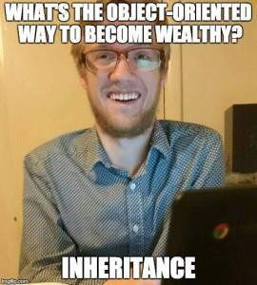

OOP is popular because its more applicable to real-world scenarios.

Objects that have Inheritance, Polymorphism abstraction and many other features quite similar to the real world.

Q.E.D. (Quod Erat Demonstrandum-“which had to be proven”)

Inheritance-Wealth, Property, Name & Fame

Polymorphism-Black, white and the whole spectrum of money (yes,the much sought out green paper takes many forms)

Abstraction-Our knowledge of the economy-we know that it makes the world go around-but not exactly how or why.

And since we are comparing it to such a monetary model,we might say that OOP is quite the capitalist notion going for it.

The objects are isolated, have attributes-social standing And functions-something to make money with-a business etc.

Each “class” is self-involved and sometimes self-sufficient.

It can survive and sometimes even thrive without the main. Rather the main takes a leaf out of the class’ repertoire and instantiates objects to get its work done. Division of labour while everyone is looking out for themselves and providing the very coveted illusion of “freedom”.

So,if you are sufficiently convinced that the OOP methodology, in some very slight sense resembles what in essence is capitalism.

Then perhaps you may even see the similarity between structural programming and socialism.

The fact that it is methodologically based,not intuitive or bringing in the money. So as to say -following the rules, step by step execution.

The overall good of the program, regardless of how slow the progress may be or the lack of certain very important features that will certainly cut down coding time and increase productivity.

Single entry and single exit,no access specifiers limiting the resources from the “main” i.e. govt.

Everything works for the main, and in it lies the overall execution of the program.

The overall good of the functions.

Just like a novice programmer is ecstatic when he finds that he can declare and initialize the variables anywhere in the program and not in the start of the main like C.

A person might feel the freedom of capitalism allows for entrepreneurs and small businesses and other enterprises to start whenever and wherever.

But, if the novice programmer were to come to the conclusion that Java was for all accounts better than C.

He would be highly mistaken for if it were so, then a majority of all the Operating Systems(Administrative Processes) wouldn’t be programmed in C.

While many might agree that OOP is definitely much better for programming like capitalism there are certain social trade-offs or rather design trade-off’s we are making in the process of getting things done (The greater good of the nation,and the people that comprise it being sidelined for higher GDP’s and Bragging rights). So, the optimal solution would be somewhere in between OOP and Structural programming, I assume based on this absurd bout of apophenia.

People came to the same conclusion when it comes to socialism and capitalism.

“Socialism is not only a way of life, but a certain scientific approach to social and economic problems.”

Jawaharlal Nehru VS.

“Despite a voluminous and often fervent literature on “income distribution,” the cold fact is that most income is not distributed: It is earned.” Thomas Sowell

With my limited understanding of economics,I have come to a weird conclusion that the Modi Govt. is taking us from a very stagnant pseudo-socialist nation,to somewhere along the lines of a capitalist country.

Starting with the “Make in India ” campaign.

#Facebook recruitments taking place through GATE examinations…

Gives us an overall understanding,that what has been so far hasn’t exactly drowned the country, yet it hasn’t quite taken us farther than where we started from.

“What business has science and capitalism got, bringing all these new inventions into the works, before society has produced a generation educated up to using them!”

Henrik Ibsen quotes

I quite agree this is what is happening or has happened with our generation.

We are not quite socialist nor quite capitalist.

And this is the basic paradigm shift of intellectual property.

What you have can be shared,only if it is your wish.

In the coding community we have the socialist coders-the developers of Open Source Softwares and freewares.

Then we have huge companies that have taken a capitalist route to their coding nuggets of wisdom and made a killing out of it.

Then we have the biggest philanthropist who will soon win a Nobel Prize for his efforts because he is quite literally converting his intellectual property into quantifiable assets that he is using to help the world.

-If you haven’t guessed already its Bill Gates.

So I guess, that the balance between socialism and capitalism might work for the country (dare I be optimistic) just like the combination of structural and OOP has given us Java-the ubiquitous language.

Or perhaps this question is moot with the information age,and new economic theories or models need to be developed to characterise what we are seeing worldwide.

Now for some more optimism-The polymorphic sweet-spot of being both socialist and capitalist…



#### The Theory of Everything: A brilliant Portrayal of Stephen Hawking

**— Abhishek Bele**

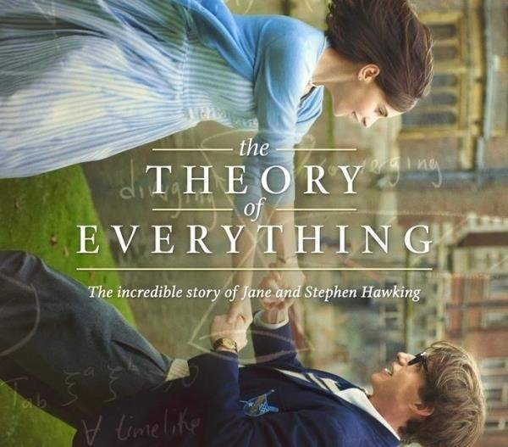

The most remarkable thing about watching Eddie Redmayne as Stephen Hawking is that it doesn’t feel like you’re watching Eddie Redmayne as Stephen hawking, you’re just watching Stephen Hawking. In terms of an actor, it is a great move forward that embarks a metamorphosis which elevates his career to a whole new level. It’s like he folds into himself, shrinks into the role and has the mannerisms that depict joy, charm, sorrow, mischief and the fact that he manages all that is extraordinary. And what is better than that is that it’s not just about him either, it’s about Felicity Jones and their relationship as well. I was initially worried that she might be left out but the movie is as much about her as it is about Stephen Hawking. It’s a movie with stunning performances.

During the course of the movie when Stephen Hawking is diagnosed with an illness, his life is forever altered. But the power of love unlocks one of the most brilliant minds of the 20th century and that’s what makes this movie special. The biopic is enthralling and depicts a compelling drama which is strategic and laudable by the viewer.

The range of emotions exhibited by Redmayne is incredible and honest, especially in that part of the film when he emotes with his body rather than his voice. Redmayne imbues the role with real heart bringing the audience along with an emotional experience. Felicity Jones is equally remarkable as the steadfast and patient wife, who endures more pain and hardship than anyone could’ve asked. She is cautioned early by a concern family member who says, “This will not be a fight, this is going to be a very heavy defeat.”

As with any biopic the narrative sort of meanders from one disconnected milestone to the next with many supporting players popping in and out as required. This is really Eddie and Felicity’s movie though; their passion and chemistry is the undeniable glue that holds this otherwise predictable story together. An early scene where Redmayne compares a brightly lit dance floor to the ultraviolet hues of the cosmos is effective at showcasing their intelligent, yet playful dynamic.

As this is a biographical period drama based on true events, it’s hard not to see “The Theory of Everything as an “Oscar- Bait” picture. Eddie Redmayne has won the lead actor Oscar for his indelible portrayal of Stephen Hawking in one of the most competitive races at the academy awards. Stephen Hawking then congratulated Redmayne on Facebook, writing “Well done Eddie, I’m very proud of you – SH”

Director Marsh’s cinematic style punctuates conventional scenes with somewhat ethereal moments that contain a sort of dreamlike quality about them. All while Johann Johansson’s uplifting piano and string heavy score swells in the background. The PG-13 film doesn’t really make any mistakes, but it never does anything to set itself apart from any other bio-pic. The “The Theory of Everything” may be familiar and depressing, but it’s also an inspiring romance about an influential figure.

This movie reportedly made Stephen Hawking cry. Watch it. You’ll see why.

**हम है लडकी।**

— Pooja Jain

हम है लडकी।

इस िनु नया का गहना।

जो हर एक को सजाये।

जो हर एक को मस्ु कु राना ससखाये। जो हर एक के पलको ां पे छाये।

जो हर एक को अपना बनाये।

फिर क्यों ये िनु नया उसे ही राख बनाना चाहे। जो ये उसकी सजावट को बबगाड।े जो ये उसे रूलये।

जो ये उसे पलकों से गगराये।

जो ये उसे पराया बनाये। हम है लडकी।

इस िनु नया का गहना। जो है लक्ष्मी।

जो है सरसवती।्

फिर क्यों ये िनु नया उसे िगु् ा बनाये। अपना नाश कराये।

चलो हम एक ऐसा ससद््ाांत बनाये। जो गहने को राख बनाये। उसे मार गगराये। हम है लडकी।

इस िनु नया का गहना।

#### Boyhood: A cinematic experience called ‘Life’

**— Abhishek Bele**

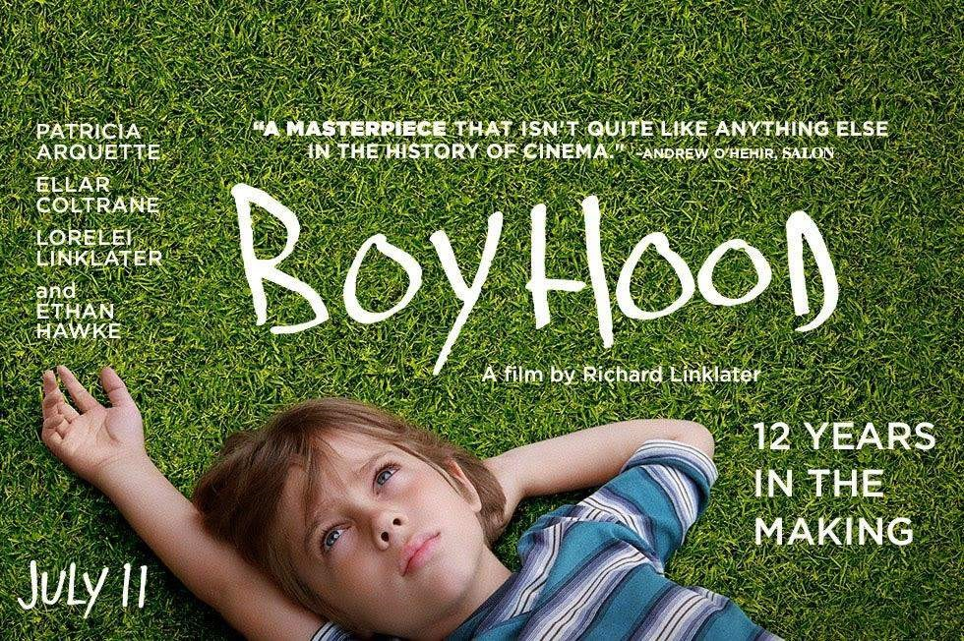

Boyhood, the new film from Richard Linklater, took 12 years to make. It may well take another 12 years to appreciate fully. The coming-of-age drama film was produced on a small budget of only $4 million and has scored back ten times that amount at the box office. Shot intermittently over an eleven year period from 2002 until 2013, we’re treated to a truly unique experience as we watch the talented Ellar Coltrane literally grow up right before our eyes. Co-star Ethan Hawke remarked on this captivating approach by saying “It’s a little bit like time-lapse photography of a human being.” The lengthy 165 minute narrative follows six year old Coltrane until he sets of for college 12 years later. Forced to undergo all of the awkward and embarrassing phases of adolescence and puberty in a feature film can’t be easy, but Coltrane is an endearing and relatable protagonist. Again alongside him is Patricia Arquette as his determined mother, Lorelei Linklater as the typical older sister and Hawke as the absent ex-husband and dad. This core group turn in some excellent performances, which really carry emotional weight as their lives drift from milestone to another. Plenty of other characters flow in and out too, and much like real life: they don’t always get a proper introduction or goodbye, they merely exist as players in the story for a few scenes, never to be heard from again. Thanks to its interesting production calendar, a large majority of the R-rated involved as they filmed, resulting in an organic narrative. Patricia Arquette has won the best supporting actress Oscar for her 12-year stint on Richard Linklater’s Boyhood.

Indeed “Boyhood” is very inconsistently placed; moving through the grade school years within 30 minutes, but spending over 90 minutes when Ellar finally attends high school. Throughout the movie we follow Coltrane as he deals with a parade of dysfunctional father figures, drugs, girlfriends, videogames, moving away from home and discovering his ambitions. No matter how or where you are raised, there are aspects of his character everyone can identify with. He’s not the strongest kid, or confident teenager. He’s just the average American boy experiencing the struggle of growing up. The events of his turbulent upbringing unravel in small vignettes. They’re an honest view of life; perfectly encapsulating the ups and down of childhood.

Unfortunately, the film doesn’t end on a high note, but instead drags for another 15 minutes that fail to add any real value to the story. Linklater’s steady and unobtrusive cinematography allows the talented actors to dictate the energy and direction of each scene. With no original score of its own, the film smartly includes plenty of popular music from across the years; quickly providing context to when each moment takes place. It’s weird to call any story set during the 21st century a “period” film, but that’s precisely what this feels like.

Definitely worth seeing at least once, if not for its incredible film-making methods, than for its compelling characters. Although it lacks focus, this is an effortless narrative that has a nostalgic quality to itself which is hard to ignore. “Boyhood” utilizes unique techniques to craft a wonderful experience about growing up. It’s an emotionally affecting film with a big beating heart, and Linklater shows us that indeed life is in the little details.

##### #CWC15



**— Aditi Ghotikar**



###### #CWC15

The ICC Cricket World Cup is arguably the biggest sporting extravaganza after the

FIFA World Cup. The 2015 edition of the CWC runs from 14th February to 29th March. The minnows have already proved that they’re no pushovers and can cause an upset on their day. Here’s a collection of the best tweets of #CWC15:

India kickstarted their world cup campaign with a high voltage game against Pakistan. Pak captain Misbah ul-Haq had a tough time.

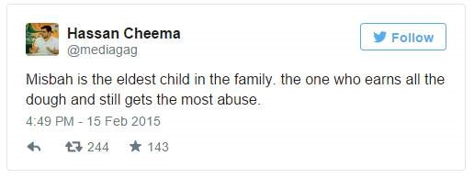

Meanwhile Aussie star Matthew Hayden during the Ireland Vs UAE match.

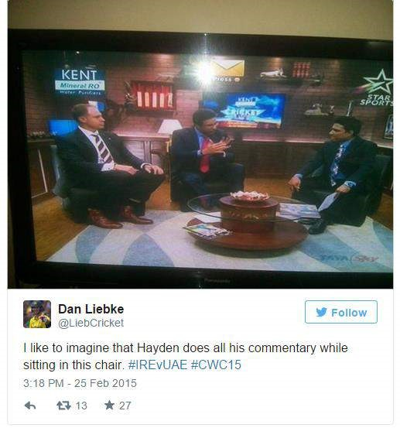

Is AB DeVilliers a superman?

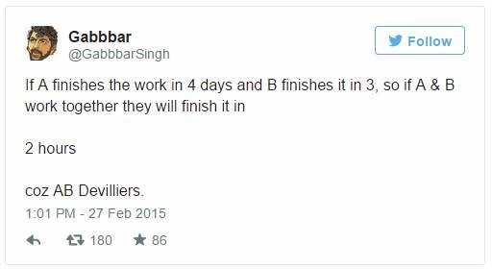

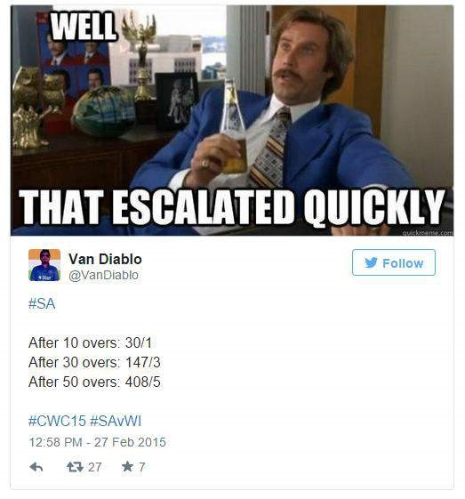

New Zealand opener Brendon McCullum shows no mercy. Poor England bowlers weren’t spared either.

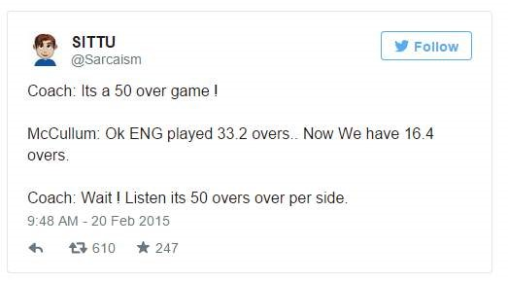

From a war-torn country to a World Cup win. Pure respect.

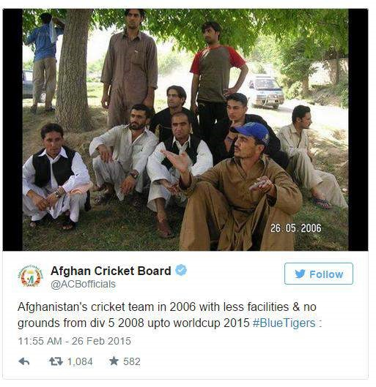

Pakistani Bowler Irfan can reach the moon.

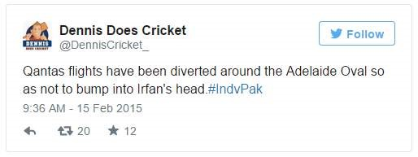

Chris Gayle is pure destruction.

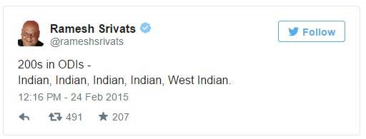

England have played so bad that Scotland winning against them will no longer be called an upset.

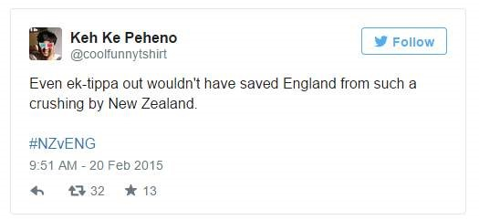

Was it the same Indian team that went winless on its Australian tour that decimated South Africa?

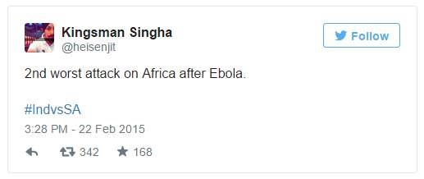

Mitchell Marsh, Mitchell Johnson and Mitchell Starc. Australia’s never-ending Mitches.

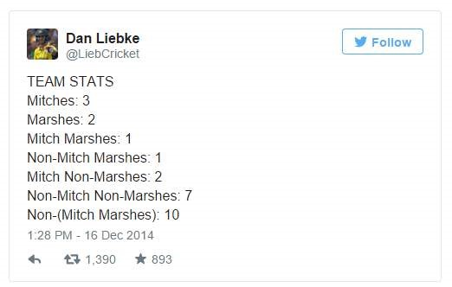

Good dude Suresh Raina is a team player.

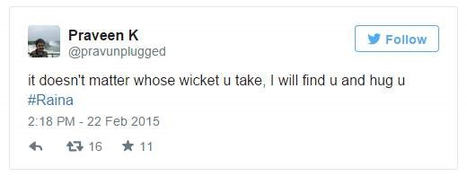

Um…and finally.

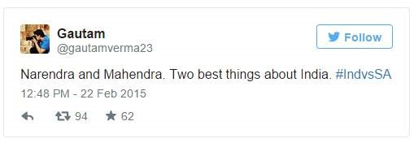

##### My BEC Experience

**— Karthik Raju**

Have you ever wondered how taking an exam can seriously change the way you look at yourself? If you haven’t then think now! Probably that’s not something that we, as students tend to do often. But as we bid adieu to the educational phase of our lives to enter a professional environment where companies and managements are constantly competing with each other to sell their ideas to the people, the need to introspect and devise innovative methods to aggrandize oneself becomes more profound. Taking BEC helped me do just that. Initially the intent behind writing BEC was only to get an idea of where I stood amongst a talented group. But when I started preparing for the test earnestly, I realized that the test had much more to offer. Call it a fear or a lack of confidence or a previous encounter that went horribly wrong, but beginning a conversation with a stranger was something that didn’t come to me naturally. Thanks to my mentor and the frequent discussions we exam takers had in the classes, I am now confident enough to speak my mind when I am with strangers. BEC also helped me get acquainted with the format and etiquette followed in writing emails. Email writing for me before BEC was just like it was for most of my friends – something similar to writing a letter but online.

Preparing for BEC helped me learn the subtle differences in writing letters and Emails and come out of that misconception. Frequent practice along with the valuable inputs from Shweta Ma’am helped me to a great extent in fine-tuning my Email-Writing skills. Improved Analytical writing skills is another takeaway from the BEC preparation classes. The writing assignments given by the mentor and the feedback I received for those assignments have broadened my horizons about analytical writing. Taking BEC and the preparation that goes into taking the test not only made it easy for me to connect to people but it has also helped me answer the questions put forth by the recruiters on the interview panel during campus interviews in a confident manner. Preparation for BEC has also influenced my thought process in the right direction and has helped me communicate better. If honing your skills tops your priority list then BEC is for you. Invest time for a better you – Take BEC soon!



#### Birdman or The Unexpected Virtue of Ignorance

**— Shriram Pydimarri**

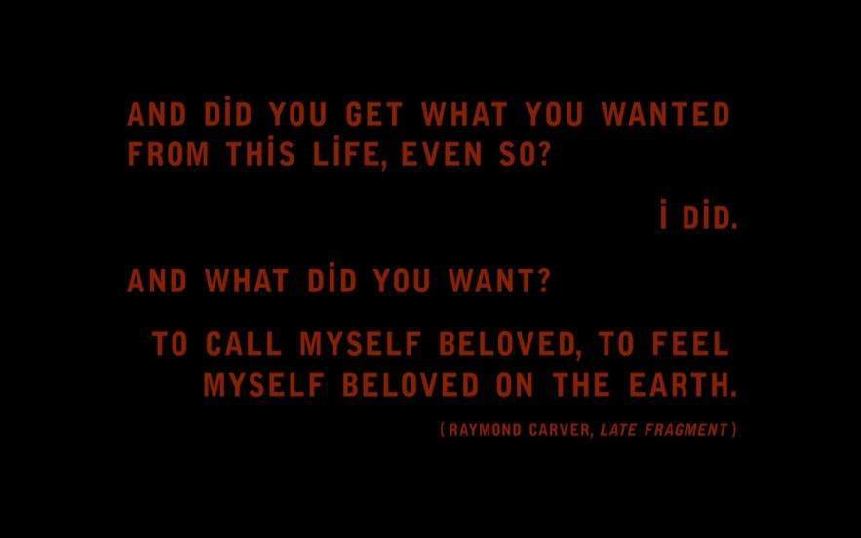

These lines from the first still reveal the underlying basis of the movie. Birdman is a story of an ageing Hollywood actor, Riggan Thompson (Michael Keaton), who wants to revive his fading career by doing a Broadway Production, and in the process also has to fight off his own inner demon (Birdman) who criticizes him mercilessly at every inner confrontation. This introspective battle which is layered throughout the story-line makes it hard to distinguish between the protagonist and the antagonist of the movie. A satirical comedy with spectacular performances from the cast and an offbeat technical stroke makes this movie one of its kind and certainly a must watch.

As the story progresses, Riggan Thompson orchestrates the Broadway play with the help of his friend, Jake who is also producing it, and with the assistance of his daughter, Sam who is a recovering drug addict. Co-starring with Laura, his girlfriend, and Lesley, a first time Broadway actress, and Mike, a brilliant stage actor, Riggan finds it hard to maintain a steady rapport with his crew. In an argument with Sam, she tells him that he’s not doing this play for the sake of art and that he’s just one of the many in the world who are forgotten and are fighting to feel relevant again. During the rehearsals, Riggin faces many hurdles involving Mike and Sam’s admiration for each other, making it up-to Laura, challenging an influential critic and fighting his own mental voice all along. On the opening night, Riggin shoots his nose on stage with a real gun, at the end of play, following which he gets a standing ovation. At the hospital, when Sam returns to Riggin’s room, he’s gone and the window ledge is open. Sam looks down at the street, looks up and smiles.

Birdman seems like a theater equivalent of the movie Black Swan (2011) but with humor and a stirring jazz background score from Antonio Sánchez. The spellbinding screenplay gives the audience a glimpse into the lives of each of the characters. Right from the first shot, the camera never blinks and the movie keeps rolling as a continuous chain of events unfold the movie’s plot centering the lead character’s life. Had it not been for this eccentric technical approach, the movie would have fallen short of giving the viewers a kind of exhilarating emotional experience. Alejandro G. Iñárritu certainly deserved the Academy award for the best director for bringing out the best in the crew with such creative reverence. Emmanuel Lubezki did a marvelous job with the cinematography, given a daunting task of capturing long shots in which the locale moves from indoors to outdoors, from daylight to night time frequently. The whole film was shot in actual theaters in New York which made the job much more tedious. The film won Academy

Awards for Best Picture, Best Director, Best Original Screenplay and Best Cinematography. Some movies are forgotten with time and some remain phenomenal. Birdman belongs to the latter.



##### The Imitation Game

**— Gaurav Patil**



“The Imitation Game” is a story that takes place during the World War II. The Germans have this machine called as “The Enigma”. It was a message encryption machine believed to be uncrackable. It’s like the fate of the free world, the key to defeating the Nazis is cracking the Enigma code. Problem is that the code resets every day. Alan Turing (Cumberbatch) gets this idea “What-If I could build a machine that adapts to every code that enigma ever generates, forever” and that’s ultimately the movie.

Alan Turing was an ultra, mega, super genius and an amazing engineer, perhaps making the single biggest contribution to ending World War II, according to Winston Churchill. Turing helped shorten the war by an estimated 2-5 years by cracking intercepted coded messages from German forces. Sadly he is also known as man whom society did not treat well during his lifetime because he was ‘Gay’ and at that time being so was actually illegal. He was a brilliant mathematician, a war hero and he led a short but full life.

The Imitation Game is absolutely fantastic even though practically no physical action happens in the film, it is enthralling. Benedict is absolutely fantastic as Alan Turing. He is fully flushed out, believable completely different character that actually existed in real life. I know, American Sniper was also about a guy that really lived but Hey! This is the Oscars “We don’t make up original stories we just deal with things that already happened”. Keira Knightley is also in this movie and she also gives a great performance. I have only really seen her in Pirates of the Caribbean. She does a fantastic job in this movie.

I have heard a lot of people say that Amy from gone girl was this strong and powerful women character that women should look up to. No, that is crazy psychopath, that’s like men should be Christian Bale from American Psycho. Keira

Knightley is strong, intelligent, independent woman who girls can look up to and be proud.

The score to the film is beautiful, if I am not mistaken this is the director’s first English-speaking film, everything else he has done is in another language. Just confirmed that on IMDB.

I don’t really have anything negative to say about this film except for this one part where they show a part of Bombed out Britain, I think they lingered on for too long but it’s like, maybe 30 seconds too long.

I don’t really want to tell you what happens in the movie except for that it’s about “Code Breaking” and that’s all I really want to tell you. There are a lots of interesting clichés that this movie takes into a very fun riot. This film very strongly dealt with sexism in a very mature interesting way, it’s really a story that needed to be told. I mean it literally needed to be told, most people don’t know about it. This movie was a true story that was classified for years and years and years and some years ago it was released to the general public. So, most people don’t really know about it. I didn’t know who Alan Turing was, and now I am so grateful that men like him exist It’s incredibly emotional, I cried like two times, the last time I really cried at a movie was “The Woman in Black II” as to how incredibly bad it was. This is a great film and deserves the praise that it is getting. There is one quote from the movie that is very apt for the director.

“Sometimes it is the people who no one imagines anything of who do the things that no one can imagine.”



##### Ruci & Idoni

**— Sagar Patil**

What did I do when it was raining the other day? I decided to go Ruci & Idoni and oh boy! It was the best decision I ever made! Here is my experience:

One of the best restaurants to visit when it’s raining would be Ruci & Idoni Bistro by Ohris. The bistro is set up on the first floor and has a glass wall to give an overview of the Banjara Hills, road 10 that gives this bistro one of the best views when it’s raining. Watching the cold and dusky weather, rain pouring outside, droplets on the glass wall while eating delicious food is an experience to die for. The décor is elegant, sophisticated – a red and black theme, with an open glass kitchen. The place looks like a museum that serves food, equivalent to art.

The staff is friendly and we were quickly shown to our table. The menu looks like a portfolio of a photographer displaying their European and continental delicacies. Since we were only two we decided to order one antipasti, one starter, a main course and two drinks. The food was so delicious that we ended ordering another main course.

The drinks: Pink Lemonade. We decided to order the famous pink lemonade. It was refreshing and tangy as a lemonade is supposed to be and came in a surplus quantity that most bistros don’t provide.

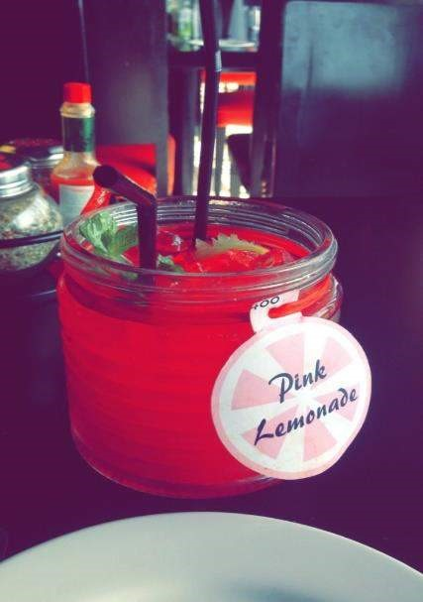

###### The Antipasti: Spinach Dip

Antipasti is the first dish, like a starter, in a traditional Italian meal. We decided to order spinach dip antipasti. The dish had tortillas, nachos, fries and potato wedges to be dipped in a rich and creamy cheese spinach dip.

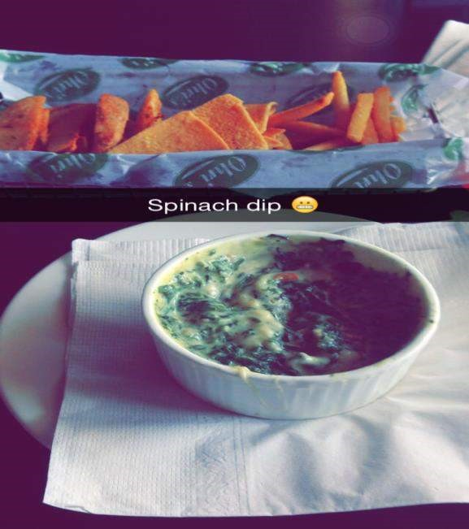

###### The Starter: Paprika Chicken

Paprika is a spice made from chilies and is often associated with Hungarian cuisine and we were excited to see how this spice would be used in a European/Italian cuisine. The chicken was tender with paprika adding a flavor that was irresistible. The dish was served with a southwest sauce which went very well with the chicken.



###### The Main Course: Paprika Chicken Pizza

Since the paprika chicken starter was so amazing we decided to order the paprika chicken pizza. The pizza was thin crusted with a slight wood burn aroma and was an authentic Italian dish in all respects. Other toppings included corn and olives in rich mozzarella cheese.



###### Bonus Main Course: Crepes

As the food was very delicious we decided to order another main course. Crepes is something I had never tried before and wanted to cross it off my list. Crepes is a kind of pancake made out of flour in a rich cheesy gravy. This dish was the highlight of the day. This tangy scrumptious crepes made in creamy tomato red sauce is one of the best delicacies that I had the pleasure of eating.

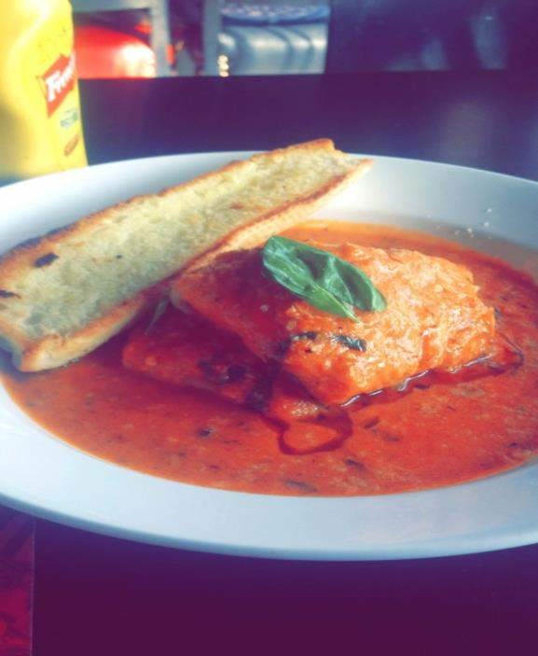

**Rating:** **4.5/5**

**Price: 1600** for two people.

**Value for money: 4/5**

**Ambience: 4.5/5**

**Service: 4/5**

Would I recommend this restaurant to others? **Yes.**

##### Selma

**— Way Ch**

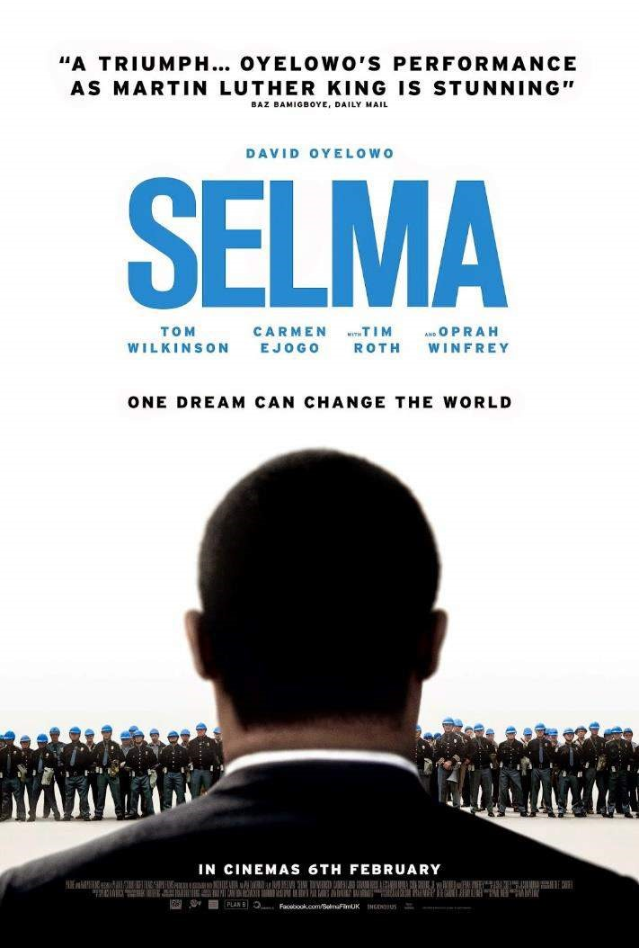



To begin with I’d like to underscore that you looked into the facts of Selma- What is Selma? A place? A person? A what? Why is the movie named after Selma?

Selma is a city in Alabama where the African-American Civil Rights Movement for the voting rights of Black citizens once took place. Now the movie “Selma” is centered around that movement which fomented when the right for the blacks to vote was refuted.

Movie starts with Martin Luther King Jr. accepting the 1964 Nobel peace prize.

When he receives the award, King Jr meets the then President Lyndon Johnson and requests the federal legislation to allow black citizens to register to vote. On hearing this, the President dismisses it as an unimportant thing to do.

King Jr. then travels to Selma and meets the SCLC(Southern Christian Leadership Conference) activists, to lead a campaign demanding the right to vote. The story revolves around these campaigns and King Jr.’s meetings with the President which are shown to have ended up almost always futile.

On the other hand King Jr. faces many family problems along with the criticism from his allies for making impolitic decisions. The campaigns face violent opposition from the Alabama Governor, George Wallace and the Sheriff, Jim Clark. Their one such campaign is telecasted on National television which bolsters the movement, ensuing the President in asking the congress to pass the bill where he gives his famous speech *“We shall overcome”*.

The movie ends with Martin Luther King’s speech in Montgomery implying the successful manifestation of the movement.

The movie in general alludes to the most significant events in American history which changed the lives of millions of black citizens. Director Ava DuVernay did a great job in trying to show the incidents as close to reality as possible. David Oyelowo who acted as Martin Luther King Jr. has done a tremendous job, taking proper advantage of his resemblance to King Jr.

There are a few scenes which give us goosebumps especially the scene where the Marchers cross the bridge.

Nothing in terms of editing or direction is extraordinary, but the portrayal of the incidents is realistic.

The music and the background score go hand in hand to make the experience richer especially the “Glory” which has been nominated as the best original song, for both Academy as well as Golden globe awards

If you are someone who likes movies based on reality or someone who loves to dig into the facts of American history, this movie is definitely worth a watch.

##### Technology 2015 – Innovation

**— Gaurav Patil**



**LG G Flex 2 – Real phones have curves.**

LG closed out 2013 with a smartphone like none we’d seen before and it’s kicking off 2015 with its direct sequel. The feedback LG got on the first G Flex was that people liked the curve and the powerful feature set but what they weren’t stoked about were the low screen resolution, unremarkable camera and the sheer size of the thing. So, LG fixed all that, specifically, the screen has graduated from 720p at 6’’ to 1080p at 5.5’’ that gives it a ppi of 403 pixels every inch vs 245 on the older model while preserving the curve that makes it special. Both panels use LG’s POLED technology but the newer phone doesn’t seem to be suffering from any of the ghosting and the image persistence problem, LG obviously heard those complaints loud and clear. The cover glass on the newer G Flex is stronger while the self-healing coating on the back is extensible repairs damages much faster.

The 15% reduction in mass and the much smaller footprint make it more phone, than phablet that makes it far more manageable in the palm and in the pocket. It looks and feels classy and premium thanks to the fancy trim upfront and the modernized less mushy keys on the back.

The phone comes with a quick charger to zap you from dead to a half charge in about 40 minutes. Some were disappointed LG couldn’t find a way to include optical image stabilization in the last year’s flex. Well, the company found a way with the G Flex 2 bumping the IR port to the top edge and using the added space for a 13MP shooter with OIS, with Laser focus and a dual LED flash. If it sounds familiar it is basically the same rig as the LG G3.

Software is essentially a quantum leap, the older UI atop android 4.4 looks ancient when compared to the new skin with Android Lollipop. A 64-bit Snapdragon 810, 2 or 3 Gigabytes of faster Ram and expandable memory via micro SD upto 2TB of it. It looks like a great sequel poised to introduce the curved concept to whole new segment of the market, The one that wants a Flex but doesn’t want a Phablet.



###### Yota Phone 2 – Two Shades of Grey

The Yota phone concept from the first iteration remains unchanged on the sequel, an Android smartphone on the front made it to an E-ink panel on the back 5 inches v/s 4.7’. The hardware is considerably refined though, much more symmetrical, much more svelte and much smoother in the hand.

The Yota phone 2 is a very comfortable smartphone and the ability to mirror whatever is on the front display on the E-Ink panel around the back makes a lot of sense when you consider the latter is 7X more power efficient than the front panel. Which by the way is 1080p in the IPS. That’s important when you consider when the battery is on the small side but it is compatible with CHI wireless charging so Drip Drop!

The execution has largely caught up to the concept barring a few starts and stutters. The usual examples of boarding passes, maps and photos are the same we have seen for a while but seeing them reminds me of the practicality, readers who absorb a lot of books on the go. This is just screen mirroring for now the more exciting developments will come later when and if Yota phone is able to strike agreements with publishers to release E-Reading apps specifically for the rear screen.



###### Samsung – The prodigal son returns

This year the spotlight is going to be on Samsung. Well, Yes! they incurred 60% loss on profit last year but still the number of phones Samsung sold globally is light years greater than any other manufacturer.

But this segment is not about Samsung Mobiles. It is about their Silicon manufacturing division. Samsung is the first of the ARM processor licensees to figure out how to fabricate a 14 nm chip. In simple terms lower the die size, lower the heat dissipation which means the processor can maintain higher clock speeds without heating up. Higher clock speeds result in greater performance.

Qualcomm the company whose Snapdragon processors power almost 80% of the devices running Android and Windows Phone. Qualcomm’s processors can be found from a low end device to the flagships. So, Sammy beat Qualcomm in their own game, all of Qualcomm’s Snapdragon processors using the 14 nm process will most likely be manufactured by Samsung.

Apple affirmed to return to Samsung for 14 nm A9 chips for Ipads and

Iphones.The main reason being the 14-nanometer manufacturing process, where

Samsung apparently has a leg up on rival Taiwan Semiconductor Manufacturing Co. Apple in an effort to reduce dependency on their arch rival Samsung, made a deal with TSMC for manufacturing the A8 chips but now that Samsung is the only company who has figured out the 14 nm fabrication process, expect a Sammy chip inside the Iphone 6s.



###### Firefox fx0 – Game Boy nostalgia

Firefox jumps out of the Mid-range with a spec’d out smartphone designed specifically for super nerds with the firefox fx0. The firefox OS is known for the mid range and low end offerings the platform is traditionally targeted and the fxo resembles them on the specs sheet. It brings a 4.7’ Ips display LTe and a Snapdragon 400 processor backed up by 1.5 GB of ram, high end for firefox but nothing extravagant otherwise. The real standout here is that you can see all those components thanks to the translucent design by the an artist Tokujin Yoshioka. The plastic isn’t premium, “How could it really!”. But being able to see the phone’s guts like its some kind of bloomingdale Motorola from a decade ago is pretty awesome. There is great attention to detail too, custom made gold color screws holding the casing together. It is a phone for super geeks they love that attention to detail.

It is also a phone you are not likely to see very soon. unless you are living in japan where its currently available. Still, Mozilla tells, it is always working on expanding the footprint of firefox OS this is a sign that the company is not completely content by exclusively serving the lower specs. So hopefully we will see something like this come to our shores sooner rather than later.



##### St. Petersburg Road

**— Manasi Ramani**



There it stands, with its chimneys pointing due heaven

With the Russian flag amast.

With its sailors looking upon those on the pier

Uncertain of their future and yet, holding tight to their past.

It begins its journey with a bellow of certainty and valour

With all its crew aboard

And as the ship vanishes into the freezing fog

I walk back down St. Petersburg road.

I was sitting one fine winter evening on the big fat living room couch, all snuggled up, surfing TV channels. I happened to stumble across a movie called ‘Holiday’ (the Hindi remake of the Tamil and Telugu ‘Thupakki’) and a show on History channel about something related to Russia. Odd combination, though. Anyway, the movie was ending and I caught the scene where Akshay Kumar was bidding farewell to his family from the train as were many other army men. I won’t go into the main cast’s acting (and with good intention!). But what caught my eye was the precise depiction of the pain and sense of nostalgia that our soldiers and their families go through once in every 4 to 6 months. That’s why I penned down this poem.

Most of us take certain things for granted- as day scholars, we see our parents every day, and we fight with our siblings every day. We sometimes take our mom’s food for granted- there are times, when we are brave enough to let her effort go to garbage. I’m not saying we all do that; I’m sure that we aren’t the kids we once were and that we don’t waste food now. But we aren’t perfect. In fact, we are far from it. It struck me that as people, we need to be more appreciative of what we have, than what we don’t. If we compare ourselves with those who have everything in life, then things always seem sunny side down. But one look at soldiers and sailors, like those in the poem- “uncertain of their future, holding tight to their past”- our day seems so much brighter. My point is that everyone gets everything in life. In the end, what matters isn’t what we don’t get- it’s how we see what we have gotten. Be positive, people! We could all do with a bit more of that!

Cheers!



# Whiplash

— Shriram Pydimarri



Caution: This movie isn’t for stereotypes!

Whiplash tells the story of a hard working teenager, Andrew Neiman, who is passionate about being a jazz drummer. He trains at a city band school, whose instructor, Terence Fletcher (J.K.Simmons), is as abusive as he’s knowledgeable. A tad bit away from his tempo and you can see the tyranny of Fletcher’s anger descending upon the poor band artists. Andrew Neiman dedicatedly practices the tempos which he couldn’t master and shortly becomes the core drummer of the band. On the day of competition, Andrew meets with an accident, for which Fletcher is to be partly blamed, yet he makes it back to the venue to perform. As the performance begins, Andrew tumbles and plays off beat and loses grip over the drumstick repeatedly. Fletcher holds the performance and asks Andrew to leave, to which Andrew attacks him violently.

Now that Andrew is out of the band, a lawyer representing Fletcher’s former student, approaches him to give a testimonial against Fletcher. Soon, Fletcher is suspended from the music school. The following summer, Andrew bumps into Fletcher performing at a bar and they talk over a drink. Fletcher invites Andrew to play for his new band at a competition and Andrew agrees to it. Just before performance, Fletcher goes up to Andrew and tells him that he knew that he was the one who testified against him and thumps Andrew by playing a different composition which Andrew doesn’t know. Andrew, who is now shamed in front of the whole crowd, goes back stage sobbing. But then he returns and starts playing a known composition which he learnt at the music school and gives in cues for Fletcher and the rest of the band to play along. Fletcher leads the band to compliment Andrew’s jaw dropping solo drum cover and they both smile at each other at the end of the performance.

Andrew ends up giving the best performance of his life and evolves to a different level altogether.

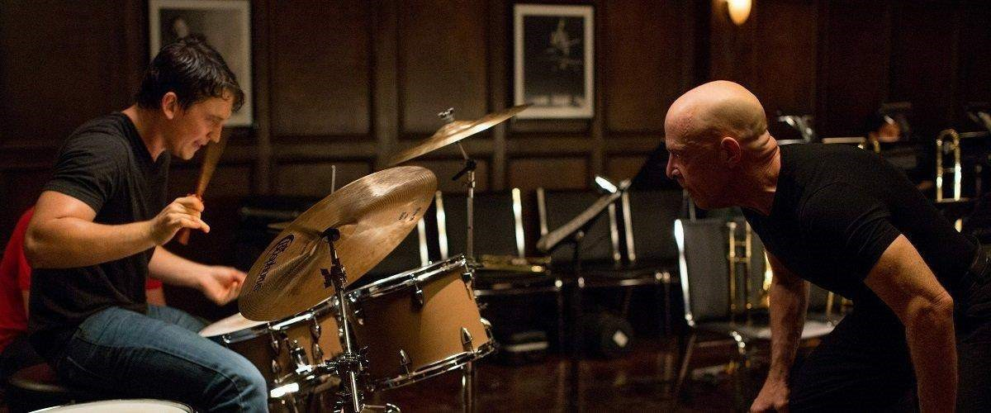

If it weren’t for Fletcher’s unorthodox approach of teaching, Andrew would have never found his inner potential. Andrew’s passion for the music was repeatedly tested and criticized by Fletcher which drove him to be the kind of dedicated artist that he is. But in the eyes of the society, Fletcher is an abusive teacher who is merciless towards his students and by all means punishable under law. But for Andrew, he is just what the doc ordered. Fletcher had the temperament to be the insult which Andrew needed but not necessarily the one he deserved. But that was a risk Fletcher was willing to take. How often do we see teachers losing jobs and risking their lives, in order to teach their students a very subtle point? Fletcher may not be the best of the teachers, but he certainly brought the best out of Andrew. J.K. Simmons won the Oscar for Best

Supporting Actor and the movie also won the Academy Awards for Best Sound Mixing and Best Film Editing.

Ba dum Tss!



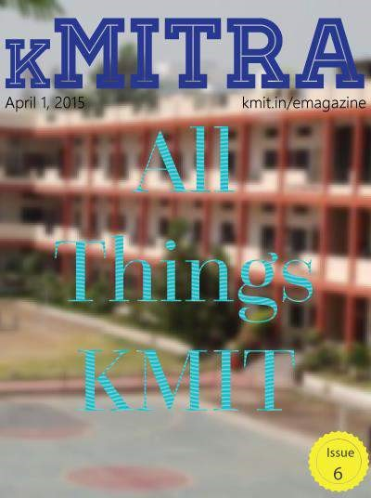

# Periscope vs. Meerkat

— Esha Kandikatti





**Periscope vs Meerkat**

For a few weeks now, Meerkat has been the most talked about new app. Meerkat is a live video streaming service that let’s the world see what you see with just a couple of taps. Twitter however launched periscope just a few days ago to prevent Meerkat tap into its users. This set the backdrop for a battle, a live video streaming battle. The contenders being periscope developed by twitter itself and Meerkat developed by Life on Air Inc.

To start with, the video is known as Meerkast on Meerkat. To begin a Meerkast, all you need to do is fill in a subject box describing what you want to show and hit stream. It’s that simple.

When you hit stream, all your followers receive an alert saying that you are live.

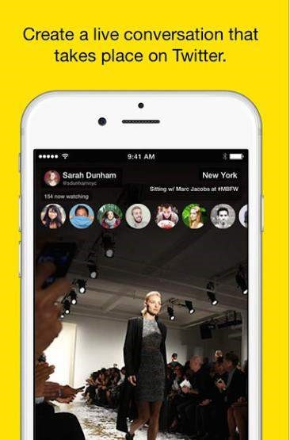

They can watch and send you messages which pop up at the bottom of the screen which is really impressive. You also get to see the number of people watching the stream. You can also save the video onto your phone. Once the streaming has ended, there is no way of retrieving it. In other words, people who arrived late can’t watch the video. This can be quite frustrating at times. Users can retweet any stream to their followers.

Talking about the cons, a big drawback is that you can shoot the videos only in portrait mode. But this doesn’t seem to deter users from using it.

Periscope works in a similar way. But twitter made a significant difference by allowing users to publish their videos so that followers can view them later too. This certainly gives Periscope an edge over Meerkat as this lets your video reach out to more people.

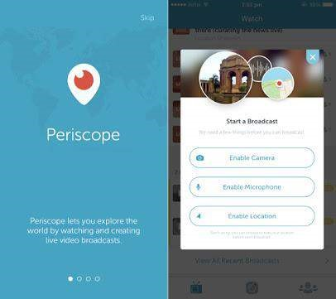

Another crucial difference is that periscope is faster than meerkat, in other words, there is less delay between the viewer and the broadcaster. Followers can also send hearts to the stream. Periscope keeps track of the number of hearts the stream receives and more the number, higher you get in the “Most loved” list.

What truly stands out is the user friendliness of both apps. Both the apps let you go live from your mobile phone very easily. Furthermore, apps like these let celebrities engage with their fans just like they do on any social media platform. These services are not the first of their kind as we have already known about services like live stream, Qik and others that have enabled us do the same for quite some time now.



**10 things you didn’t know about KMIT**

— Aditi Ghotikar and Nithya Gubbala



## 1. Sardar Patel Auditorium is always abuzz with activities

Every Saturday evening, a movie was screened in the auditorium back in 2011, (Oh, those were the days!)

Yoga classes are conducted in this hall, so are many programmes of music, art and dance.



## 2. Keshav Rao Koratkar

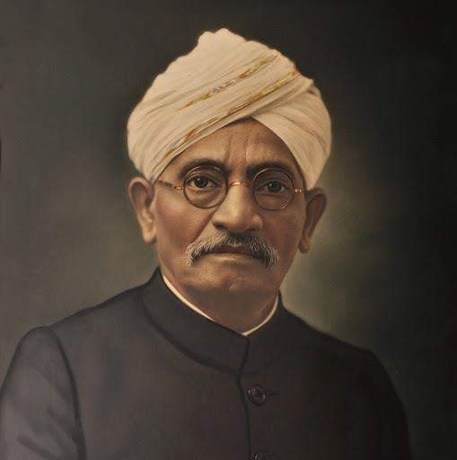

Justice Keshav Rao Koratkar (1867-1932) was an eminent educationist, social reformer and political activist. In 1904 he was elected president of Hyderabad Arya samaj and started a Marathi medium school in Hyderabad.

When Justice Keshavrao Koratkar passed away, Pandit Vinayakrao Vidyalankar wanted to create a memorial in his father’s name. After great efforts, a middle school was started on 20th July 1940, and then in 2007 came Keshav Memorial Institute of Technology.

1. **How the canteen looked back in 2010**

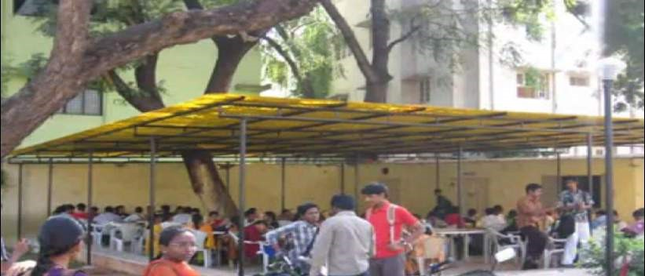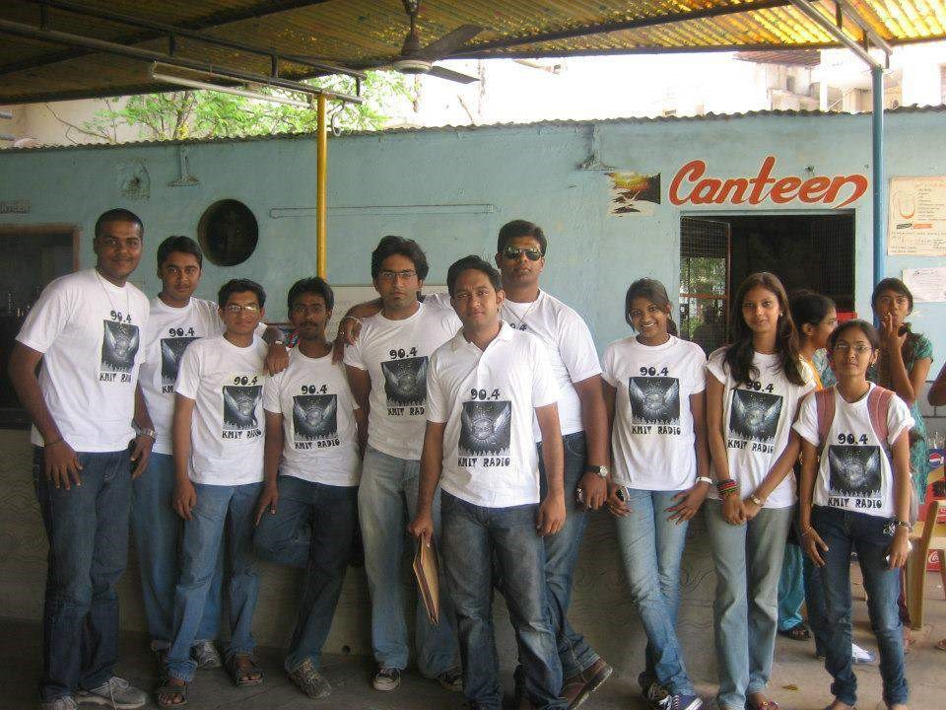

*Team KMIT Tarang in the canteen*

The picture talks amounts of KMIT’s belief in transformation.

1. **An upcoming state-of-the-art badminton court on the third floor.**

**Status: Loading…**



1. **KMIT’S Granthalaya boasts of about 2000 books!**



1. **The trees in KMIT – where according to Neil Sir, a bunch of Java Programmers reside – are a century old.**



1. **KMIT’s tryst with the freedom struggle.**



In 1947, while Hyderabad was still under the Nizam rule it was in Keshav Memorial Educational Society, the first tricolor flag was hoisted.

## 8. The WiFi password is k*******



**9. Here’s an analogy to describe KMIT : From a start-up with handful of lecturers to a full-blown MNC with Gates and Grills that can’t be escaped**

## (we did try!)



**10. Parts of KMIT are always under construction. Apart from learning, we believe in constructing.**

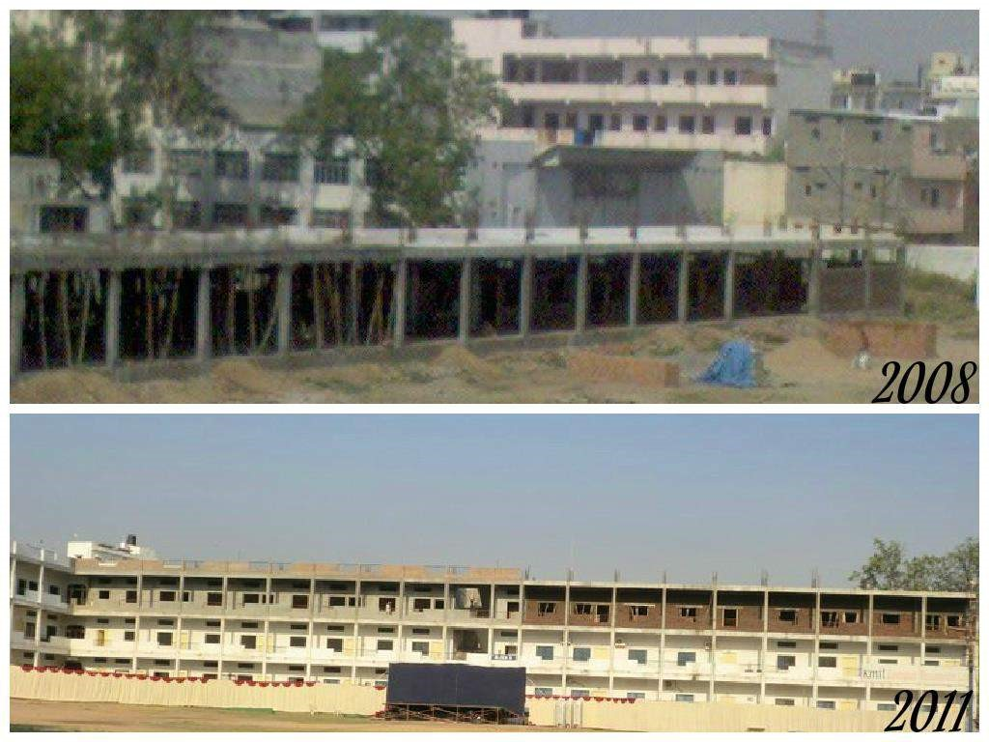



## A story with Jeffery Archer

— Saylee Bhide

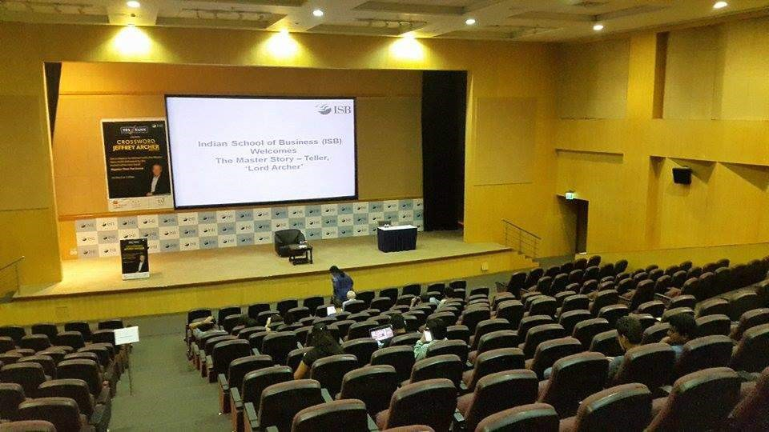



On the 5th of March, Nithya and I had the opportunity to be seated in the same hall as Jeffrey Archer “the master storyteller”. He was on a five-day tour to India as a part of his promotional campaign for “Mightier than the sword”, the fifth book in the “Clifton Chronicles” series.

Jeffery Archer, standing tall and mighty at the age of 74 years adorned the hall of Indian School of Business (ISB) campus in Hyderabad. The auditorium was thronged with eager minds waiting to hear their idol, Lord Archer, himself, who was the keynote speaker for today’s gathering. Jeffrey Archer ambled across the podium jauntily with moderately paced strides while we waited for him to begin his speech. He began, with narrating the story of his “rise to fame” which according to me aptly exemplifies the proverb, “failure is the stepping stone to success.”

Nothing prolix, his speech was no less than a “motivational” jargon, as I call it. His style of talking seemed slightly sardonic and rhetoric ; to the ones who just adore him no matter what, cheered for him relentlessly while the others responded in indifference, with a deferential smile as a mark of respect.

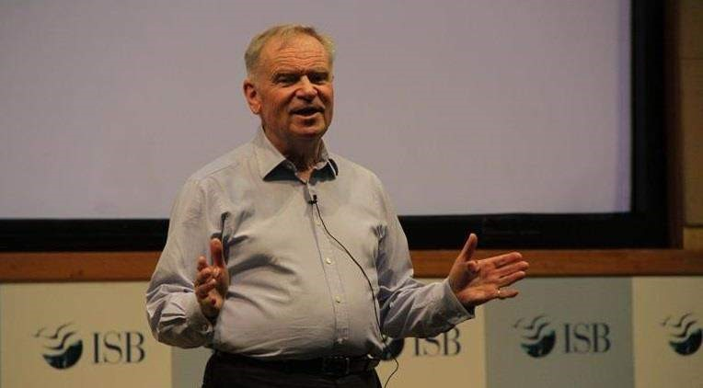

For the fans of “Clifton Chronicles”, he officially confirmed that the series is now going to go till seven books instead of the five books he had initially planned for. So that’s a great news divulged by Archer himself- didn’t really leave any room for doubt there, did he? Also, he made a special mention about one of his impending ideas which according to him is one of his best ideas in his career of writing! Generally, authors tend to be secretive about their books, novels etc. but here Archer being all candid, was a sight to watch!

One more highlight of his speech which was given a resounding applause was when he said “The only difference I have seen in India from the last time I visited, was the Indian women. They are strong, brilliant and no less than the men folks.” It was just the day before his speech the documentary, “India’s Daughter” released and the whole nation was burning in fury over the “atrocities” against Indian women, and the minute Jeffrey alluded to the change in Indian women, the whole auditorium broke out in a euphony of applauds.

Later, he embarked on a Q and A session which lasted for a few minutes. Clichéd questions poured in, nothing out of the box as such!

The event ended with him signing the copies of our books. I must tell you, his autograph is pretty weird, a series of cryptic symbols, remotely resembling his name.

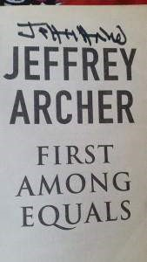

Overall a great event! The brevity of Jeffrey’s speech was the key factor of event. It was motivational and inspiring. As a take home “message”, I bought the book “False Impression” and got it signed by Archer. Looking forward to read the book and fall in love with his work all over again just like I did six years back when I got my hands on “Quiver full of arrows” and “Twist in the tale

Things you didn’t know about Faculty of

KMIT

— Nithya Gubbala and Way Ch



It is the supreme art of the teacher to awaken joy in creative expression and knowledge Albert Einstein

Our teachers made us what we are. While they take utmost care to nurture us, how much do we really know them? Well, being final year students, my co-author Way and I decided to tell you amusing yet inspiring facts about the Lecturers at KMIT.

NEIL SIR

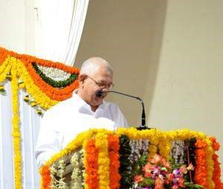

We know him as an ingenious person, but there’s much more!

1. He was the Captain of the Badminton team of Osmania University during his Engineering and he represented O.U. for various National and State level badminton competitions.
2. Apart from KMIT, he runs a Dairy which is completely organic.
3. His interest lies in Astrology as well, he can read the *Jatakam* of a person!
4. His average attendance during his B.E was less than 20% as he believes in all round development apart from academics

VINAY PATANKAR SIR

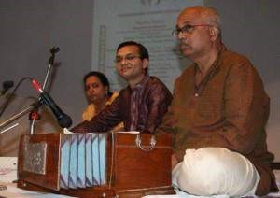

His love for electronics is not unknown to any of us but that’s not all

1. He not just sings but plays the Flute & the Harmonium.
2. He was always among the Top 10 students of his class, but his priorities included sports as well.
3. He was a Weight Lifting Champion for three consecutive years during his Engineering.
4. He likes to paint, here’s one of his master pieces:

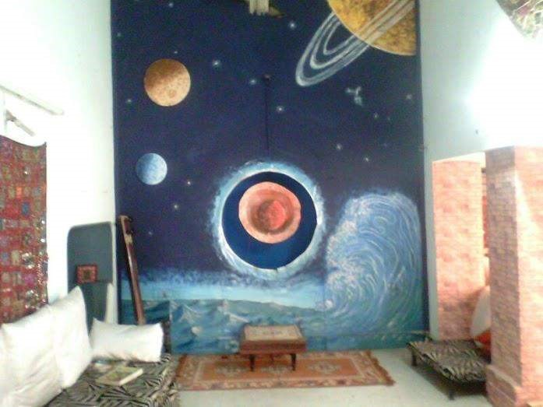

1. He actively participates in Plays (Marathi).

DATTATRAY LATHKAR SIR

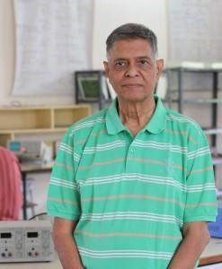

We know that is passionate about teaching. What we didn’t know was:

1. He served in the Army, and after his retirement joined KMIT.
2. He was a first Bench-er.
3. His favorite sports include Cricket, Badminton and Table Tennis

SIDDHARTHA GHOSH SIR

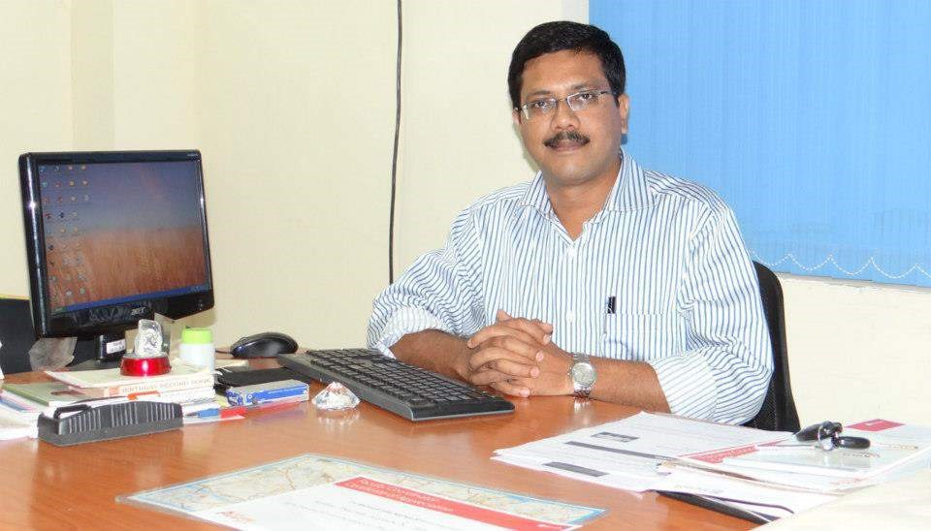

Head of the Computer Science Department, but that’s too less to describe him

1. He runs an orphanage at Agartala along with his friends, called Naba Prantik which is home to 40 kids. He takes time to visit the kids at least twice a year.
2. He holds the Award for IBM’s Best Innovative Faculty (2010) for which he was rewarded $10,000.
3. His hobbies include Digital Painting.



Dedicated to all farmers, workers, daily labours who make our life easy. (creation time – 10mins)

**ASHA MA’AM**

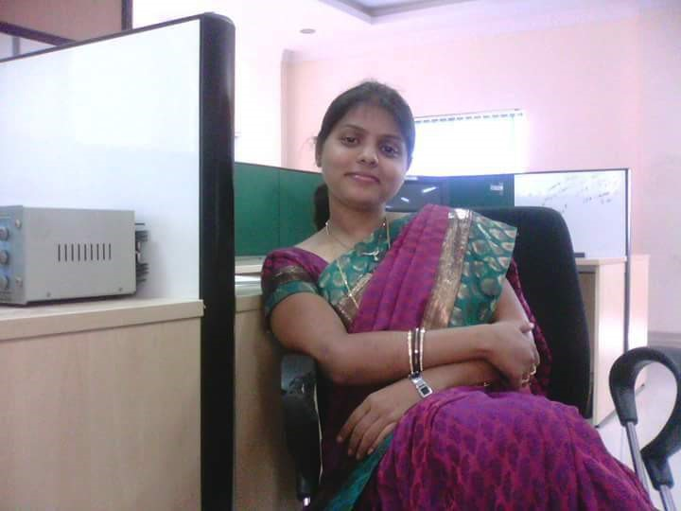

She needs no introduction especially to Electronics students, but she has varied interests.

1. She is a Shopaholic
2. She is Vegan and at the same a brilliant cook.
3. As a student she always used to calculate if her attendance was good enough, to bunk college without hesitation!

### **SUDHARSHAN MURTHY SIR**



He is not a lecturer but can we imagine KMIT without him? While he is stern when it comes to following rules, he is a very fun loving person.

1. He takes pride in being a resident of Old City.
2. He topped every test while at school.
3. He stood 16th in the Intermediate Public Examination for which he was awarded Merit Scholarship for four years of Engineering.

RAMA MA’AM

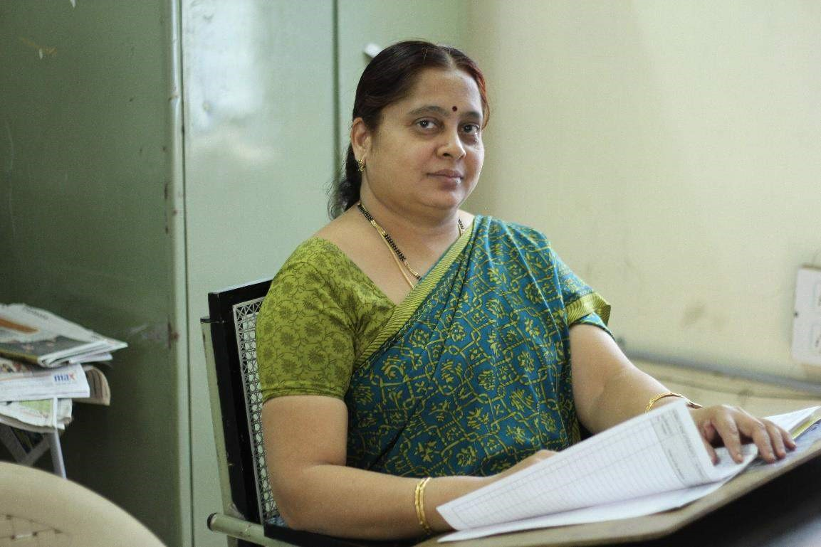

We know her as an Economics expert, but that’s not all she is.

1. She was the ‘gang leader’ during her college life.
2. As a student she was a Running Race champion and loved to play Throwball.
3. Her hobbies include Fabric Painting and Cooking.

SASTRY SIR

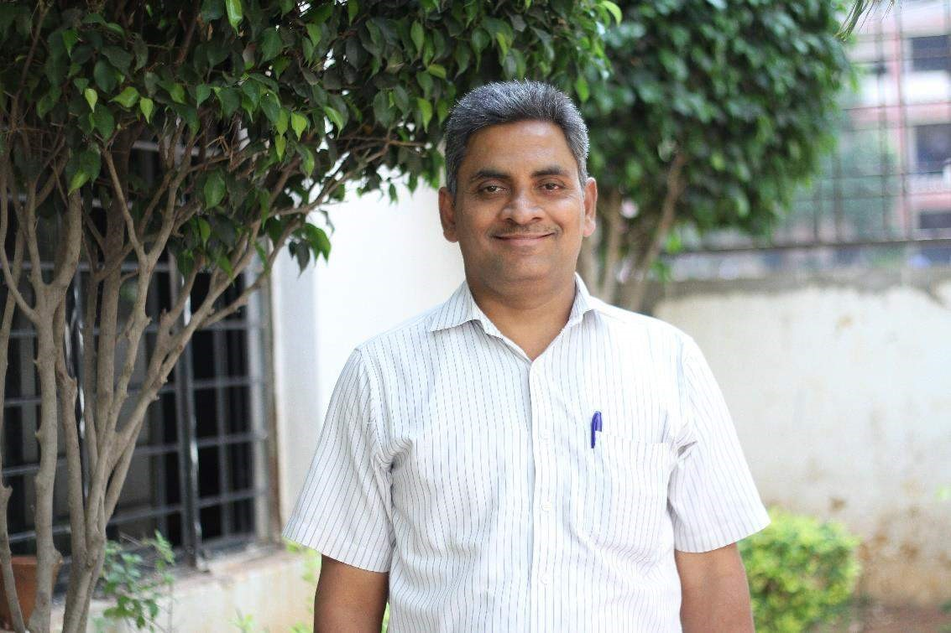

If you think he is just a math wizard, you are so wrong

1. He stood District First in Type Writing.
2. He holds an NCC ‘C’ Certificate.
3. He was a Chess Champion while at School.

As students our lectures were not very different from us, if we take them as our inspiration, I’m sure each one of us can do wonders in life.



## The Sands of time

— Akanksha Bodhankar

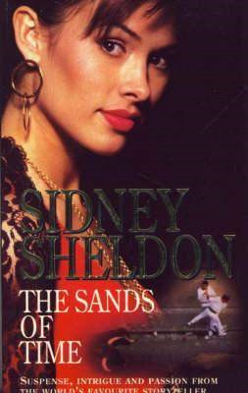



**The Sands of time**

Breath-taking romance, endless adventure and thrilling suspense.

Yet another classic by Sidney Sheldon. The sands of time is a sensational fiction by the famous writer. He has been a master of plot twisting and proves it again. Set in Spain, it revolves around four nuns of Cistercian Convent. They get into the paws of the Basque terrorists and end up getting caught between the battle of Jaime Miro, the leader of Basques and Colonel Ramon Acoca, the head of the Spanish Army. The story has a lot of main characters and the past of each has been disclosed skilfully.

To start with, Jaime Miro is a courageous hero to the Basques and anathema to the Spanish government. Colonel Ramon Acoca, the fierce leader of Spanish Army, thirsty for the blood of Jaime Miro.

And the four nuns,

Sister Graciela, a splendid beauty with a terrible past and her love, the brave freedom fighter, Ricardo Mellado.

Sister Megan, a young orphan who unveils the secret of her life. Her love for the Basque leader Jaime Miro brings an ultimate twist in the story.

Sister Teresa, an old and innocent one, her blind faith leads to a bitter end.

Sister Lucia, whose vengeance chases her all along, and Rubino Arzano, who risks his life for the bold Sicilian beauty.

The sisters live peacefully at the convent near Avila. Life at the convent is serene, but the rules of this place enclosed in the four walls are quite strange. Every sister is given a small cell to live in. They neither speak to one another, nor have they seen each other. One small mistake and they are brutally penalized by the Reverend Mother.

The story begins with the rescuing of Basque prisoners by Jaime Miro. As a consequence of which, Colonel Acoca and his army begin their hunt for the Basque terrorists. The Spanish army attacks the Cistercian Convent in search of the guilty. This leads to the escape of the four nuns, into the world they long ago abandoned. To protect the gold cross they begin their Journey to the Medavia Convent and are chased by Colonel and his men.

As their journey begins, they come across Jaime Miro and his companions. A slip of the tongue occurs and the nuns reluctantly have to travel along with them. They decide to split into three groups and then, the unstoppable adventure begins. Chasing and escaping creates powerful action along every page. The destiny of each nun, the fight of Jaime and the arousal of feelings make the rest of the story.

The landscape of melodramatic Spain is portrayed excellently. The continuous plot changing becomes quite confusing, but it has been cleverly presented by the writer. At times, the story stretches a lot, but, the climax is worthwhile. It is predicted to be a tragic one. Rather, it turns out to be happy and that’s the best part of the novel. Also, it’s quite lewd at some points but, that’s seen in every work of Sheldon. Overall it’s really a book to hang out with. Read it by yourself and uncover the hidden secrets as you go.

# Lasting Impressions

— Praharshita Krishna





A genuine leader is not a searcher for consensus but a molder of consensus.

-Martin Luther King, Jr.

A college e-magazine is not always quite on the list of priorities for any college and it shouldn’t be because if it were to run, it would run solely on student interest and effort.

Take for example “Voo Doo”. MIT’s oldest running college publication was known for running the student opinion on the Vietnam war among other important events that effected the students in those days apart from casting everything in the light of humor,something that is essential in times of crises.

A student run magazine shows the mettle of the community, their opinions, maybe sometimes even helps in forming opinions which is crucial for someone entering the world from the jolly land of regimented studies (Corporate Colleges) and nonchalant ignorance.

A devil-may-care attitude is definitely not the way to go when knowledge is being wielded like the mighty weapon that it is. It is with these thoughts in mind perhaps, that a few fourth year students went forward to make a college newsletter possible.They rallied the troops and got the permissions required while setting up the site and deciding the content.

Many months later dear reader,you are now reading the cumulative efforts of a few seniors who thought that KMIT students deserved a voice.

kMITRA is not just a college e-magazine,but a place where everyone can kick back and have a laugh while discussing everything from politics to the latest movies.It brings to this college something that is indispensable -character.

And so it is a privilege to thank all the fourth years who have ever contributed to this effort in anyway. Also we bid you farewell as you won’t be with us the next semester while wholeheartedly promising you that this e-magazine will continue running over the years like a baton passed down with each batch as they figure themselves out in the process of voicing the student opinion just like you did.

# Indian Premier League 2015

— Karthik Raju



The 8th edition of the IPL is back this year and the madness surrounding the event has already peaked even before the matches start. Here is my take on the teams and what can be expected from them this year.

**TEAM 1 : CHENNAI SUPER KINGS**



The two time champions led by M.S. Dhoni, the captain of the Indian cricket team is one of the strongest teams in the competition. The owners of the team have made significant purchases at this year’s auction by adding Irfan Pathan, Andrew Tye and Kyle Abbott to their squad. One surprise came in the form of Michael Hussey as he was recruited by the CSK owners after he was released to Mumbai Indians in the previous season. With **M.S. Dhoni**, **Brendon**

**McCullum**, **Ravichandran Ashwin**, **Francois du Plessis**, **Mohit Sharma** and **Ravindra**

**Jadeja** clicking at the right moment in the WC2015, this unit will surely give nightmares to the other teams.

**TEAM 2 : DELHI DAREDEVILS**



Luck doesn’t seem to be on their side as this team, in spite of being strong on paper couldn’t reach the finals of the league even once. The owners of the team tried to do a squad revamp by releasing most of its players ahead of the player auctions and have made a few interesting purchases in **Yuvraj Singh**, **Albie Morkel** and **Amit Mishra**.

This will be the team to watch out for as they have also bagged some of the in-form players like **Mohammed Shami** and **Quinton de Kock** in addition to **JP Duminy** and **Imran Tahir** who played a crucial role in South Africa’s successful run in the WC2015. With Yuvraj Singh and Zaheer Khan in their arsenal, DD fans will surely pour in to see their heroes battle it out at the FerozeShah Kotla.

**TEAM 3 : KINGS XI PUNJAB**



The team showed great promise last year by securing their spot in the finals with impressive performances one after the other. But the dream run ended on a sad note as they lost to the Knights from Kolkata in a dramatic fashion! All the firepower in their batting line up couldn’t help them lift the trophy.

This will be another team to watch out for as they have some huge names like **Glenn Maxwell**, **George Bailey**, **David Miller** and **Mitchell Johnson** who have made big contributions for their national sides in the WC2015. The presence of Indian players like **Virender Sehwag**,**Wriddhiman Saha** and **Murali Vijay** adds balance to their side and makes their batting line up almost impenetrable!

**TEAM 4 : KOLKATA KNIGHT RIDERS**



Beginning IPL2015 as the defending champions, this team has a balanced squad with Indian players making significant contributions in the team’s success. This team relies on its domestic talents who have stepped up to the occasion and performed brilliantly every single time! Being led by a talented but much underrated player in **Gautam Gambhir**, having a decent batting line up with batsmen like **Robin Uthappa**, **Yousuf Pathan**, **Andre Russell** and **Suryakumar Yadav** along with experienced bowlers like **Sunil Narine**, **Umesh Yadav** and **Morne Morkel**, the team will be tough to beat.

The team recruited two big names at this year’s auction in **Brad Hogg**and **K.C Cariappa**. The strategy behind spending an astonishing amount of Rs 2.4 Crore to purchase K.C Cariappa in the auctions even when the team has specialist spinners in Sunil Narine, Shakib Al Hasan and Piyush Chawla remains a mystery! Chris Lynn’s epic catch at mid-wicket remains one of the highlight moments of IPL 2014 and the fans will be expecting a similar performance from the team this year as well.

**TEAM 5: MUMBAI INDIANS**



Being led by a man who has two entries in the 200 club, the “Paltan” from Mumbai looks like a formidable unit this year. The owners have been active in this year’s auction as well and have made a few big recruits. **Aaron Finch** who was instrumental in the success of Sunrisers Hyderabad in the last season will be donning the blue jersey in IPL 2015. This team has one of the best opening pairs in the tournament in **Rohit Sharma** and **Aaron Finch** and the presence of **Ambati Rayudu**, **Corey Anderson** and **Kieron Pollard** bolsters their middle order immensely. They have a decent bowling attack with the likes of **Lasith Malinga**,**Harbhajan Singh**, **Pragyan Ojha**, **Vinay Kumar** and **Josh Hazlewood**.

The team relies on its foreign talent greatly but if the team has hopes of making it to the playoffs then the onus will also be on the domestic talent to rise up and deliver.

**TEAM 6 : RAJASTHAN ROYALS**



This squad has one of the best combinations of domestic, foreign and uncapped players in the league yet, they have not qualified for the finals since 2008 when they won the inaugural edition of the IPL. Their batting is pretty strong as they manage to chase down huge totals even if their top order fails. The team has exceptional domestic players in **Ajinkya Rahane**, **Stuart Binny**, **Sanju Samson** and **Pravin Tambe** who have played key roles in winning important knock out matches for their team in the previous editions. **Shane Watson**, **Steve Smith** and **Tim Southee** look to be in great form in the WC2015 and the fans of RR will hope that they carry their form going in to IPL2015.

**TEAM 7 : ROYAL CHALLENGERS BANGALORE**



With big guns like **Virat Kohli**, **Chris Gayle** and **AB de Villiers** in its armory, this team is one of the strong batting sides in the tournament. The bowling department also looks decently strong with **Mitchell Starc**,**Varun Aaron**, **Adam Milne** and **Yuzvendra Chahal**. The domestic section of their squad is not well equipped when compared to teams like Rajasthan Royals and this can prove to be a weakness for them. The owners have made few good recruits in **Darren Sammy**, **Manvinder Bisla**,**Sean Abbott** and **Dinesh Karthik** who will surely add value to the team.

The only thing that can go against the team is that there are no Indian players apart from Virat

Kohli and Dinesh Karthik who can contribute for the team if their foreign talent fails to deliver, and so the burden of scoring runs to a great extent will be on the trio of Gayle, de Villiers and Kohli.

**TEAM 8 : SUNRISERS HYDERABAD**



The Sunrisers from Hyderabad who were considered the underdogs, shed their tag by qualifying for the playoffs in their first season itself. With the flamboyant **Shikhar Dhawan** and **David Warner** as the Top 2 in their batting line up, this is the only opening pair that can match the firepower of the Mumbai Indians. The domestic talent of the team is also strong with the presence of **Karan Sharma**, **Naman Ojha** and **Lokesh Rahul**. With **Dale Steyn** leading the bowling attack, this team undoubtedly has the best bowling side in the tournament with the likes of **Bhuvaneshwar Kumar** and **Ishant Sharma**. The addition of **Praveen Kumar** and **Trent Boult** – one of the leading wicket takers in the WC2015 will be a shot in the arm for their bowling department.

The middle order which was considered the Achilles Heel of the team till last year will be strengthened considerably with the addition of **Ravi Bopara**, **Eoin Morgan** and **Kane Williamson**. With David Warner captaining the side this season, the team will be looking to give other teams a tough fight for a place in the playoffs.



## Handmade Papier-mâché Bowl

— Manasi Ramani



There are so many things you can gift a friend, but the best gifts are those you make yourself!

We all face the problem of not being able to figure what to give someone on their special day. Instead of going for something bought from a store, you can always tread the path of your creativity and still have your friend love what you give. Here’s a simple gift that anybody can use any day- a simple, yet creative papier-mâché bowl! Dump your utensils, keys, or stationary stuff in it- whatever you want. You can even make it look however you like! Here’s what you need to make your creative do-it-yourself bowl:

1. A balloon
2. Newspaper and coloured paper
3. Fevicol
4. A vessel (any vessel with a medium sized mouth would do)
5. Water
6. Tape, scissors and a paint brush



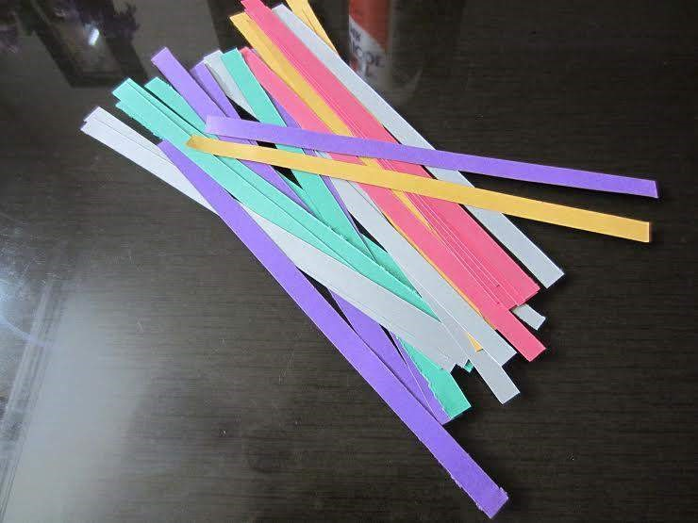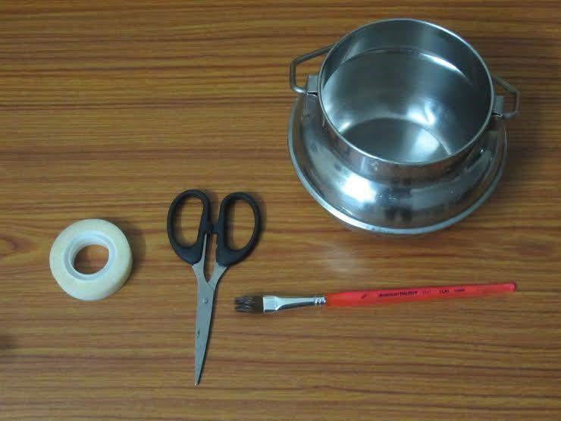

Now that you’ve got everything you need, you have to just follow these easy steps!

1. Blow the balloon till it becomes as big as it can be. Knot the end of the balloon and secure it onto a vessel, with the knotted end in the vessel, using some tape.



1. Pour a good amount of Fevicol into a bowl and dilute it by adding little water. Don’t make the mixture too thin otherwise it will become too runny.
2. Cut newspaper into several strips, each about two fingers wide and the length of your palm.
3. Using a brush, apply some of your diluted Fevicol mixture to one side of a newspaper strip and stick it the top of your inverted balloon. Apply more of the Fevicol mixture onto the strip after placing it on the balloon.
4. Continue the 4th step for all your paper strips. For convenience, you can draw a line with a permanent marker on the balloon indicating how deep your bowl will end up.

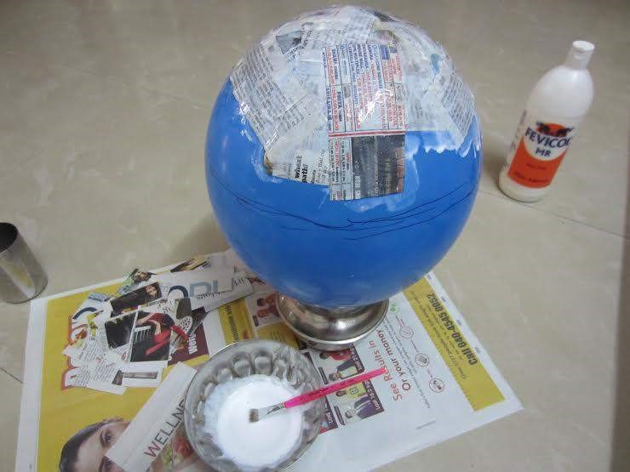

1. Once you’ve finished with one full layer, repeat step 4 and add another 2-3 layers of newspaper strips. This will make your bowl thicker and stronger. After completion of about 4-5 layers, the balloon should like this:

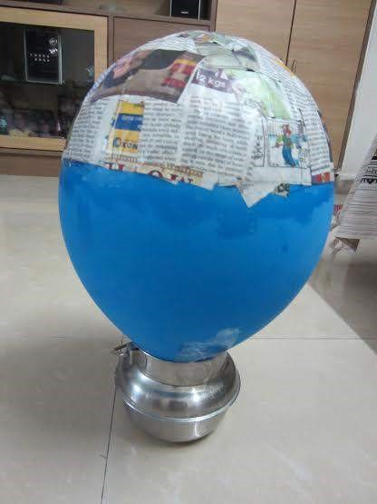

1. Layers dry over a few hours. If you wish, you can also add layers using scrapbook paper for a colourful look.
2. After the newspaper is completely dry, pop the balloon. (My favourite part!) Your bowl should fall in its finished shape, fully dry. Peel off any remaining parts of the balloon still stuck to the inner part of the bowl.
3. The finished base for your bowl will be stiff and perfectly curved.

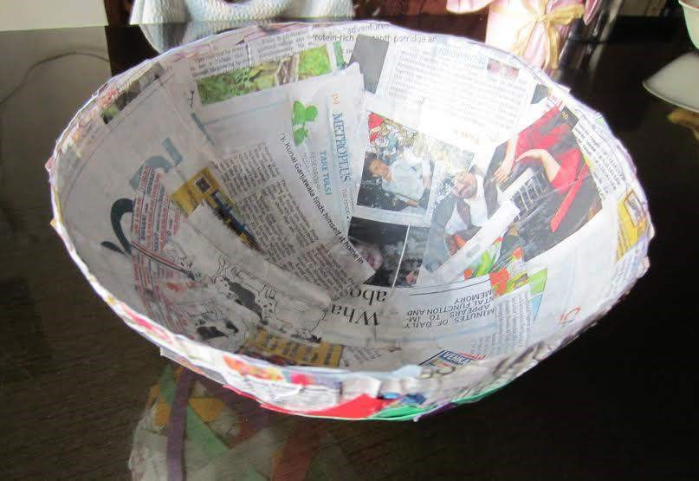

1. Use your imagination, now! Cut and shape the rim, or leave it rustic! Paint it or colour it however you like!
2. In addition, you can also make a base/stand using coloured paper strips to support your bowl. To do so, cut thin strips of coloured paper, glue them end-to-end and wind them into a circular shape, so that it looks like a thick bangle.

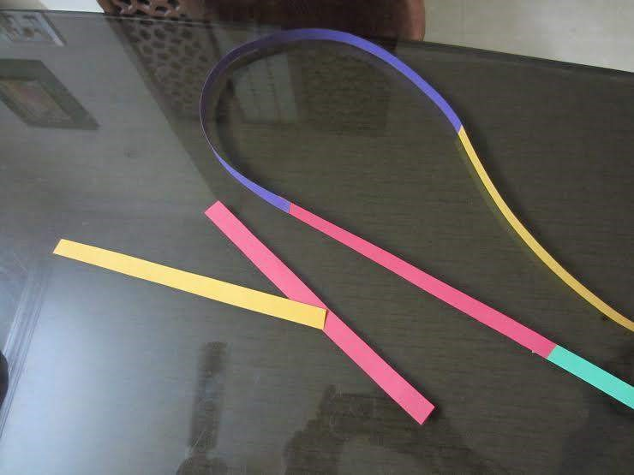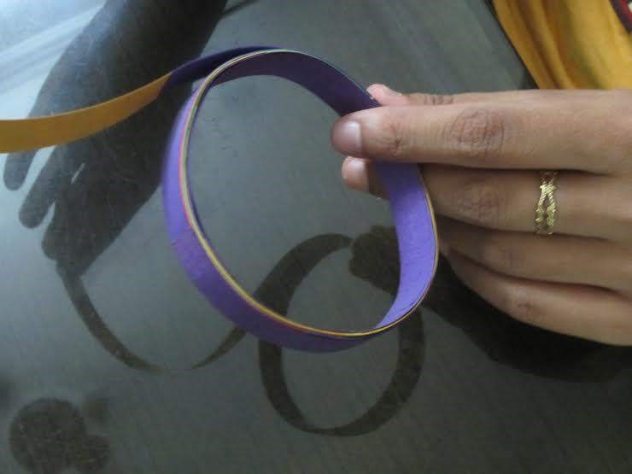

1. Glue your base to the bottom of the bowl and VOILA! Your handmade papier-mâché bowl is all set to gift!





## From The Editor

— Shriram Pydimarri



The previous month in KMIT was full of co-curricular activities with students actively participating and showcasing their talents.

Debates, Story telling, Product launch competitions were held and students enthusiastically participated. Improvising communication skills and reasoning abilities was the driving force for many of these events. While students were busy participating, kMITRA team was equally occupied with covering these events.

Deloitte, just like every year, had come to our college to have an interactive session with the third year students. Mr. Manoj Bhale , Director of ERS (Enterprise Risk Services), spoke about the importance of ” Diversity, Inclusion and Leadership ” and how Deloitte implements them at every level. The third year students showed a lot of enthusiasm and took away many goodies Deloitte had to give for active participation.

Jeffrey Archer – The master story teller , was in Hyderabad as a part of a five-day campaign for his upcoming book. He interacted with students at ISB, Gachibowli and we, kMITRA team, were fortunate to cover the event. Also, there are many more interesting articles in this edition that you’d love to read.

This edition is dedicated to our beloved seniors. This is their last academic month and we wanted to make it a very special fare-thee-well for all of them. In a dedicated article, seniors speak about their journey so far and journey ahead. It was a nostalgic trip down the memory lane for all the seniors who spoke to us.

The kMITRA team wants to bid a special farewell to those few seniors who are leaving behind a legacy. A legacy worth following. Though the college magazine was developed by seniors and juniors together, it is essentially the brain child of these seniors who have, out of their own interest, worked days and nights to give us all this wonder platform.

To all seniors, this is an epitome of gratitude for all that you have done for us. We will remember this in all the ups and downs which are ahead of us.

Shri Ram Pydimarri , Editor.



## Samsung Galaxy S6

— Gaurav Patil



# Samsung Galaxy S6- Software and Hardware

This isn’t just any smartphone – this is the device setting the pace for Android smartphones and

2015 and it just might be the most exciting Samsung smartphone since 2011. Samsung calls the

S6 a totally new design; this fact doesn’t really click until you pick it up. The S6 is exceptionally thin at 6.8mm and exceptionally lightweight at 138gms and while Samsung might have been content to stop there with previous iterations here it pushes the visual front as well.



The Gorilla Glass 4 covering the front and back sides is a haven for fingerprints but it is also quite striking with flowing rounded edges and the refracting layer that gives the illusion of depth and subtly changes the color tone depending on the angle at which you look at it. Samsung claims the metal frame is 50% stronger than its competitors. J.K Shin took an opportunity to make a jab at the iPhone while he was at it. But what is more significant is that it finally feels like a premium phone and not a cheap plastic plate, same goes for the new fingerprint scanner which is now a press and hold sensor instead of the cumbersome swipe pad. The Super AMOLED display is just what you’d expect 5.1” with a resolution of 2560×1440(Quad HD) and 577ppi, of course it looks fantastic but Samsung’s screens have looked great for a while.

The real story here is about the things displayed on that gorgeous screen, the new version of

Samsung’s user interface. Once again the changes aren’t noticeable, those stock home screen icons still have reminiscence of the old Touch Wiz but Samsung went out of it’s way to promise a lag free user experience no less than 3 times in the MWC launch event.



A layer or two beneath the home screen some stuff has been tightened up. Themed color highlights give app categories a unified feel. The settings screen has been tightened up and classic shortcuts like double tapping the home key now lead to something useful like the camera instead of something useless like S-Voice.

Speaking of the camera, Samsung really impressed everyone with the NOTE 4 in this regard and it looks like they are primed to build on that here with 16-Megapixel sensors and F 1.9 lens, a start up time of less than a second and object tracking auto-focus. The software simplification extends to the viewfinder, you don’t need to scroll to get around the interface and the front facing camera gets a 5-Megapixel sensor with that F 1.9 lens as well, which could mean great things for your low light selfies.

To bring it all home Samsung hit us with a few nice surprises in the power department, a renewed and surprising focus on wireless charging with both PMA and WPC supported and fast wired charging inline with what we have been seeing on recent phones elsewhere. That’s good news! But with a non-removable battery of only 2550mAh those kind of charging options are also essential. The S6 also breaks with the long-standing Samsung tradition in another respect; there is no micro SD card expansion here. Samsung brings new storage technology for the three capacities available but you are struck with what you buy, you can’t expand it.

Despite these sacrifices breaking with tradition is just what Samsung need to free itself from the disappointing returns from last year’s S5 and it’s got me pretty excited for the potential of the Galaxy S6 as we head into spring 2015. Whether the phone lives up to that potential remains to be seen.

# Samsung Galaxy S6 v/s iPhone 6

On one side we have Samsung’s latest and greatest for 2015 and the other we have the smart phone it is trying to beat. This is a short overview between the Samsung Galaxy S6 and the iPhone 6.



Samsung spent couple of hours comparing the Galaxy S6 to the iPhone 6 at MC 2015, and the reasons why are clear. Apple sold 75 Million iPhones matching all of Samsung smartphones for the first time ever last quarter. So Samsung really needed to do something about it. When you see them side by side there are just as many similarities as there are differences between these two looking at them it’s hard to tell them apart from the side or even from the bottom something which I know will gather mixed publicity for Samsung.

Even their aluminum construction, 64-Bit proprietary processors, Fingerprint Scanners, Nonremovable batteries, lack of expandable storage could easily tell you that both these devices are siblings, but, the similarities end there. The Samsung Galaxy S6 has large 5.1’ display compared to 4.7’ inch on the iPhone 6 almost 200 more pixels per inch in its Quad HD display, three times more Ram, twice the mega pixel count in its primary camera, Optical Image Stabilization and a bigger lens aperture compared to the iPhone 6. It even has four times more pixels in the front facing camera with far better aperture compared to the iPhone 6 again.

The Galaxy S6 is almost 5mm taller, 3mm wider and barely 0.1mm thicker than the iPhone, something that makes all the sense in the world when you have a phone with wireless charging and a much larger battery as well. Even the construction of the Galaxy S6 looks more premium with its glass on glass aluminum act compared to the ugly antenna carvings on the back of the iPhone.

Samsung clearly raised the bar when it comes to design of the Galaxy S6 for the most part but that doesn’t necessarily mean that everything is positive the Galaxy S6 is the worst fingerprint magnet that I’ve ever seen by far, a problem that a iPhone 6 user doesn’t really need to suffer at least in the back. That being said both devices feel premium in the hand and only time will tell how the materials last in a long run. Overall you don’t seem to have a lesser phone on either side.

Probably the only disappointing part of the Galaxy S6 is that the Touch Wiz couldn’t look more similar to its predecessor. Surely, the company has invested in making it more intuitive but it looks like a rushed product where skew morphism is more predominant in the home screen and then gone in the settings menu a lot of inconsistencies. iOS 8 may not be everyone’s cup of tea but Apple’s flatter design is more consistent and available through out the UI even though that’s not necessary better. So far the first impressions of the Galaxy S6 are that it is a far better contender to the iPhone then any previous Galaxy ever was.



## Night at the jungle

— Ramya Walthati



Date: 19|08|96

Today I joined at work as an ASP at Karimnagar district. I hope I have a successful journey. Its 11’0’ clock in the night and my phone is ringing; I think it is an emergency.

Date: 20|08|96

Yes, it was an emergency call on day one of my service. I have been surprised by the mysterious death of the forest officers nearby. At the night we reached the spot after searching for three hours facing many obstacles and overcoming them .We couldn’t get any clue because it was too late and the light was insufficient to look over the case.

I went again to see if there were any clues .

After seeing the clues my mind was confused I couldn’t conclude whether it was an attack by the animals or a murder …..?????!!

The first clue of the case was that there were scratches on the body of the officers like that of animal paws but there were also some prints of the bullock carts at some distance. Examining the prints we concluded that the bullock cart which may be involved in the crime is one used for special purposes and there were only three bullock carts of this type in the village.

I immediately called the villagers who were staying nearby and enquired about this, the reason given by two of the owners were reasonably good but the answer of the third owner raised a suspicion and led to another twist in this case.

Date: 21|08|96

“Sir, some people came from the town and asked my bullock cart for one day. Since the amount they paid was also huge, I did not ask them the purpose”, this was the answer of one of the owners. I immediately examined the cart where I found blood marks on the rope, when asked about it the owner replied that “This is summer, so there will be bleeding from the bulls nose”. Being suspicious sent the blood sample to Hyderabad forensic lab so that I could get further more clues in the case.

Date: 28|08|96

After a week of long wait and successful investigation we got a confirmation from Hyderabad that it was not the blood of the bull but the blood of one of the officers. Then I took it as a challenge in solving the case. When I informed this to the villagers there was no response, no one ran away from the village giving another twist in this case.

Upon, inquiring the youngsters in the village I came to know that the murderer was not one but the entire village, all of the villagers planned and killed the officers for harassing them and taking bribes. This case is one of those cases that I couldn’t solve and do justice to my work.

I didn’t know whether I should fight for the officers who work day and night very hard to protect animals from danger and forest from smugglers by risking their life…….

Or

Should I help the villagers by letting them go who are so untied and stayed together as one when they were about to be arrested and helped each other in troubles…!!!

I am unable to understand what to do. Let me leave this to ……….

*Winning entry for the Short Story Writing Contest by Walthati Ramya Sri, CSE G, I Year*



## Furious 7

— Abhishek Bele



**This time it ain’t about just being fast**



Continuing the global exploits in the unstoppable franchise built on speed, Vin Diesel, Paul Walker and Dwayne Johnson lead the returning cast of Furious 7. James Wan directs this chapter of the hugely successful series that also welcomes back favorites Michelle Rodriguez, Jordana Brewster, Tyrese Gibson, Chris “Ludacris” Bridges, Elsa Pataky and Lucas Black. The April 3, 2015 release also features Jason Statham, Tony Jaa, Kurt Russell and a cameo by Iggy Azaela.

**Raising the bar when it comes to stunts**:

When you think of “The Fast and the Furious” franchise, your first thought should be about cars. Lots and lots of beautiful and fast cars in all shapes and sizes. The part that makes these cars so magnificent is the death-defying stunts performed in each of the six films. Make no mistake – Furious 7 will not be any different. In fact, it will take the insane stunts to a whole new level.

Director James Wan, best known for Saw and The Conjuring, steps out of his horror film shoes to blow us out of the water with the heart-racing action flick, Furious 7. The film’s production budget of around $250 million was spent to impress fans and the trailers clearly indicate what depths they would go to, all into a condensed thrill ride.



One of the most noted stunts involves a scene in Dubai where a $3.4 million supercar is driven through a building and straight out of the window and into another building.

The beautiful red sports car at the center of it all is the Lykan HyperSport — the car is produced by a Dubai-based company, W Motors, and features a 3.7-liter twin-turbo engine and can hit 60 miles per hour in a cool 2.8 seconds. The car may not have actually been driven through Etihad Towers in Abu Dhabi, but it was driven through the side of a mock-up building and right over the edge.

If that wasn’t enough to give you heart palpitations, the thought of skydiving with your car should. In one scene, the entire “family” parachutes from a plane with their vehicles. Jumping out of a plane with nothing more than a backpack would be too simple so Dominic (Vin Diesel), Brian (Paul Walker), Letty (Michelle Rodriguez), Roman (Tyrese Gibson), and Tej (Chris ‘Ludacris’ Bridges) drive out of the back of a plane miraculously landing in just the right spot to take off in a high speed chase, inevitably after a girl.

Just two weeks short of its Easter weekend release, many industry estimates are projecting Universal’s Furious 7 with a $115M opening. That figure would crown the film the largest April opener ever, easily topping last year’s Captain America: The Winter Soldier ($95M). It would also be the third largest pre-summer bow ever, behind 2012’s The Hunger Games ($152.5M) and 2010’s Alice in Wonderland ($116.1M).

A tribute to Paul Walker:

The film will mark the final film appearance of Paul Walker, who died on November 30, 2013 with filming only half-completed

At an advanced screening of the film in Los Angeles, Walker’s friend and co-star Vin Diesel reflected on that sentiment with a touching tribute to his late pal. “This was a labor of love. It was in some ways the hardest movie I ever had to do,” Diesel said. “Because the relationships that you see on film are so real. When the tragedy happened, I lost my best friend. I lost my brother. ”

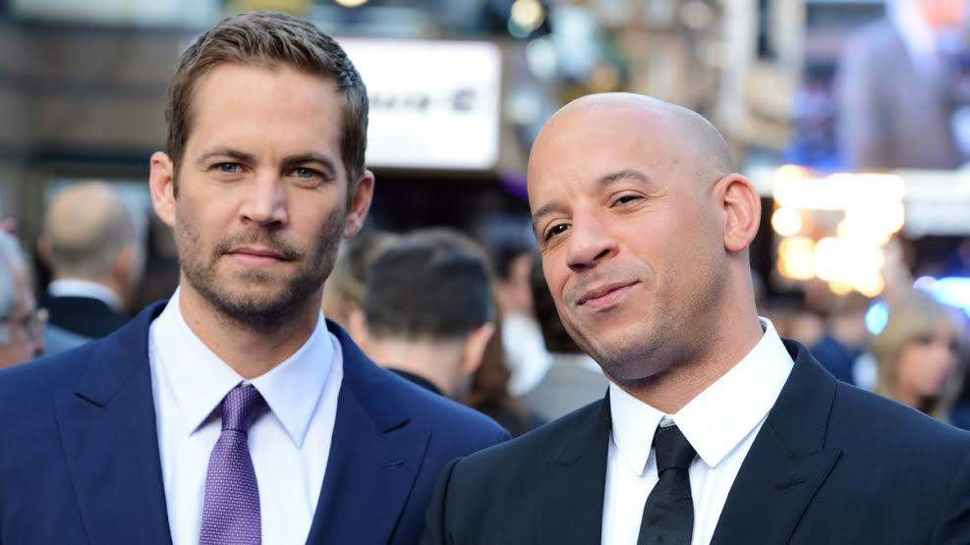

It was reported that Walker’s character would be retired instead of killed, and that new scenes would be developed to retire his character, allowing the franchise to continue. Later Walker’s brothers Caleb and Cody Walker were used as stand-ins to complete his remaining scenes.

**Exotic locations**:

The film has been shot in exotic locations like Abu Dhabi, Toronto, Tokyo, Atlanta and Los Angeles.

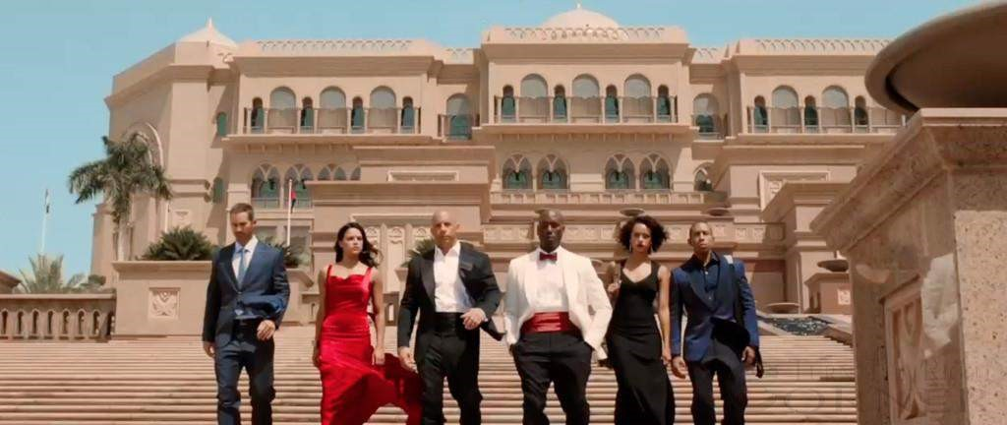

*A still from the film, shot in Abu Dhabi*

The trailers alone are enough to send someone straight into cardiac arrest but a three-minute preview is just a taste of the absolutely insane stunts that will take place. James Wan and the cast will undoubtedly get your adrenaline pumping at full force when Furious 7 is released on April 3rd.

**Talents Inside-out.**

— Medha Ch



The college had yet again come up with three interesting competitions for the students! Storytelling, Debate and a Product Launch competition were conducted this month. Though it was the first try to get students involved into such activities, there was a fine participation in the events.

The **Story- Telling** competition was held on 7th March. Though there were not many participants, each story was more interesting. After a tough combat, Shanmukha from 1st year CSE B was announced as the winner. “I feel great to be participating in events where expressing plays a good role. Thank you KMIT for conducting the competition.” He says.

“For good ideas and true innovation, you need human interaction, conflict, argument, debate.” said Margaret Heffernan.

The **Debate** competition passed hot between 5 teams, taking 2 teams to the finals. The finalists had to debate on the topic **‘India’s daughter’** and Shreyas and Mohak from 1st year CSE B were announced winners. “We hope there are more participants next time” said Mohak, one of the winners.

Keeping in mind the skills students need to have during recruitments, the college had come up with a **Product Launch** competition, where the interested students were asked to launch a nontechnical product of their own imagination. This event had fourteen teams enrolled and three of them could make it to the finals. The winner was a team of three, Sagar Varma, Aashish K and V Ravi Chandra from 1st year. They launched the *ecolite*, an eco-friendly windshield for automobiles.

All in all, it was good to see the juniors so active and talented. The events went smooth and successful and we hope that the college hosts more such events in future.



## Finishing School, Beginning Life

— Akshay Chandra L



Final year, the most important year to an Engineering student, to any UG for that matter. It’s not just about ‘graduating this year’, it’s more than that. It involves emotions, plans, expectations and many life changing decisions. Seems like everything escalated so fast, feel like just a short time ago you were attending the Orientation Session and here you are about to attend the farewell. And now, you’re ready to face the world of workforce. Just four years in the college and you’re not just a Graduated student, you’re more than that. Here you learn to win, you learn to lose, you learn to fly, you learn to fall. It’s only an understatement to describe college as one’s real ‘home’.

*There is a time and place for everything, it is called College.*

– Bill Cosby

2011 batch students will be leaving the college soon, surely known as one of the most stunning batches KMIT has ever had. This 2011 batch has arguably covered all the aspects of the college. Be it placements, academics, extracurricular activities(Not to mention 3 KFL Championships) and the list is fairly long, completing the true definition of an ‘Engineering Student’. It is actually sad for us to see such a bright group of people, such energy leave KMIT but also excites to look at them accomplish things the juniors inspire to do.

Many of them had sweet experiences where some saw bitterness. Some feel it was good, some say it was great. Many were thankful for letting them know the real meaning of friendship, love and trust. And few were happy to know how they can become the next Mark Zuckerberg. Just academic growth was never the motive of KMIT and the KMITians, so the college has always came forward with new programmes and events that made it a fun place to learn and enjoy. Some say, “I am what I am because of Neil Gogte’s Vision”. And some feel that the ‘Finishing School’ programme was a turning point of their lives.

Seems like only yesterday you were walking into the campus for the first time with the bewildered faces and chaotic minds. Being nice to people, learning to be good at what you do, hoping to be the best in the end, well now is the end. So many memories, little things that changed you so much, making you understand what failure or success is like, taking with you some of the coolest people you’ve met in your life. Making you realize that every single day in the past four years mattered. Now is the time to cherish all the moments that made you the person you are now. Also to remember that Graduation is not just finishing school, it’s the beginning of life.

Here is a short video of what some of the 4th years have to say:

<https://www.youtube.com/watch?v=snWN4dVmnaI>

### Check your Vocabulary & Quant Skills

— Sagar Patil

**Vocabulary**

Synonyms

1. Elicit : a) Blissful b) to provoke c) to adorn d) illegal
2. Incursion : a)Junta b) divergent c) sudden invasion d) precursor
3. Stentorian : a) Extremely loud b) sparing c) Stanch d) Insouciant
4. Innocuous : a) Naïve b) Harmless c) Stigma d) vacuous
5. Remonstrate : a) Compliant b)Extrinsic c)Intangible d)Protest
6. Fidelity : a) Fervor b) egoism c) coalesce d) loyalty
7. Minutiae : a) Petty details b) very small c) courage d) work against
8. Neophyte : a) Illiterate b) Novice c) Educated d) Expert
9. Extrinsic : a) Unrehearsed b) Extraneous c) Essential d)Humorous
10. Pallid : a) Lacking color b) Showy c) Disgrace d) occult

Answers :

1. To provoke [B]
2. Sudden invasion [C]
3. Extremely loud [A]
4. Harmless [B]
5. Protest [D]
6. Loyalty [D]
7. Petty details [A]
8. Novice [B]
9. Extraneous [B]
10. Lacking color [A]

**Quantitative Ability**

***Directions: Compare Quantity A and Quantity B, using additional information centered above the two quantities if such information is given, and select one of the following four answer choices.***

* **Quantity A is greater.** • **Quantity B is greater.**
* **The two quantities are equal.**
* **The relationship cannot be determined from the information given.**

**A symbol that appears more than once in a question has the same meaning throughout the question.**

1.

Quantity A : (x^2)+1 Quantity B : 2x-1

1. Quantity A is greater.
2. Quantity B is greater.
3. The two quantities are equal.
4. The relationship cannot be determined from the information given.

**Answer: 1**

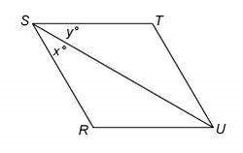

|  |  |
| --- | --- |
| *2. RSTU* is a parallelogram. |  |
| Quantity A: *x (degrees)* | Quantity B: *y (degrees)* |

1. Quantity A is greater.
2. Quantity B is greater.
3. The two quantities are equal.
4. The relationship cannot be determined from the information given.

**Answer: 4**

1. Each employee of a certain company is in either Department *X* or Department *Y*, and there are more than twice as many employees in Department *X* as there are in Department *Y*. The average (arithmetic mean) salary is $25,000 for the employees in Department *X* and $35,000 for the employees in Department *Y*. Which of the following amounts could be the average salary for all of the employees of the company? Indicate all such amounts.

1. $26,000 2. $28,000

* 1. $29,000
  2. $30,000 5. $31,000 6. $32,000

7. $34,000

**Answer: 1 and 2**



1. The figure shows a circle with center *C* and radius 6. What is the sum of the areas of the two shaded region?
2. 7.5*π*
3. 6 *π*
4. 4.5*π*
5. 4 *π*
6. 3 v

**Answer: D**

1. The cost price of 20 articles is the same as the selling price of *x* articles. If the profit is 25%, then the value of *x* is:

**A.**

15

**B.**

16

**C.**

18

**D.**

25

**Answer : B**

1. If selling price is doubled, the profit triples. Find the profit percent.

**A.**

3

2/

66

**B.**

100

**C.**

3

/

105 1

**D.**

120

**Answer: B**

1. In a certain store, the profit is 320% of the cost. If the cost increases by 25% but the selling price remains constant, approximately what percentage of the selling price is the profit?

**A.**

30

%

**B.**

%

70

**C.**

%

100

**D.**

250

%

**Answer: B**

1. A vendor bought toffees at 6 for a rupee. How many for a rupee must he sell to gain 20%?

**A.**

3

**B.**

4

**C.**

5

**D.**

6

**Answer: C**

1. The percentage profit earned by selling an article for Rs. 1920 is equal to the percentage loss incurred by selling the same article for Rs. 1280. At what price should the article be sold to make 25% profit?

**A.**

Rs. 2000

**B.**

Rs. 2200

**C.**

Rs. 2400

**D.**

Data inadequate

**Answer: A**

1. A man buys a cycle for Rs. 1400 and sells it at a loss of 15%. What is the selling price of the cycle?

**A.**

Rs. 1090

**B.**

Rs. 1160

**C.**

Rs. 1190

**D.**

Rs. 1202

**Answer: C**

